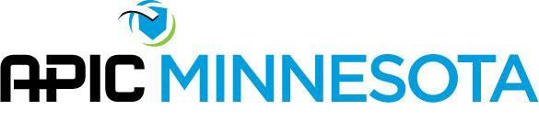

Policy/Procedure
Policy # 03

Subject: Requests for Membership Contact Information from non-APIC Organizations

Effective Date: 2/7/1996 Reviewed by: Secretary
Approved by: APIC MN Board of Directors Revision Dates: 2/2021
POLICY
- All requests for membership addresses/lists/ contact information must be approved by the APIC MN Board.
- Granting requests for addresses should be in alignment with the goals and mission of APIC MN.
- Professional associations will be given a copy of the membership roster free- of-charge, if approved by the APIC MN Board.
- Vendors will be charged an established fee, if approved by the APIC MN Board.

PURPOSE
To ensure a uniform process for providing membership contact information.

PROCEDURE
- Request for membership contact information is made to the Secretary.
- The Secretary brings the request and request details (i.e. what list will be used for) to the next scheduled Board meeting for approval.
- Electronic mailings will only be used for time sensitive materials and not be the primary method of communication.
- Vendors may request an electronic contact list. Vendors will be charged
$100.00 for the electronic contact list and include a note stating that the membership roster may not be copied nor reproduced in any manner.
- APIC MN members who do not want their names to appear in APIC MN distribution lists should edit their profile on the APIC National website.
- At the Fall Conference, vendors are provided with a paper copy of conference attendees which generally includes name/facility/email address.

ATTACHMENTS & RELATED FORMS
None

