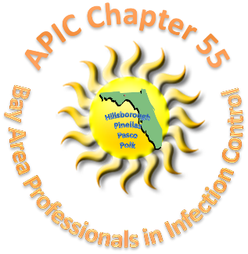
December 1, 2017
Location: Shriner’s Children’s Hospital
12-2PM

Agenda
Chapter Meeting Sponsor: BuckEye – Thank you Travis McLeod & Bob Petrone
Thank you to Shriner’s Hospital for hosting this annual meeting.
Business Meeting:
- Welcome Stacy Martin
Please remember to register for the BAPIC Annual Conference, speakers have been finalized and the location has very good parking. If you have a credit card, reach out to Miriam Headley, Treasurer. Please pay by check if possible so we can avoid fees. We have space for 20 more vendors.
- Approval of Minutes (approved) Stacy Martin
- Announcements: Election Results final as of November 30, 2017 The following have been elected to positions within the APIC-Bay Area Chapter 55.
President Elect, Kimberly Atrubin; Nominating Committee Chaz Rhone; Treasurer, Amanda Rutter.
All will begin terms Jan 1, 2018. M. Headley agrees to continue as acting Treasurer through Q1 of 2018 due to the Chapter sponsored event: 2018 Annual Educational Seminar.

a. Hillsborough County: DOH encouraged to obtain CIC.
b. Pinellas County: Same.
c. Polk County: Increase in Flu, RSV, Norovirus, legionella, Hep A, zika pretty much gone, VISA and HUS cases being investigated.
d. State: No report.
- Presentation: Gift exchange game
Next Meeting: BAPIC Annual Conference
January 19, 2018
USF Embassy Suites 3705 Spectrum Blvd. Tampa
Please Visit the BAPIC Chapter 55 Website: http://community.apic.org/bayarea/home/

