April 26, 2019
Location: St. Anthony’s Hospital
St. Petersburg, FL
Meeting Minutes
Start time: 1200 End time: 1400
Chapter Meeting Sponsor: Eloquest Healthcare
Minutes
Minutes were approved as written
Guest Presentation
Michelle DeVries “Addressing the Dressing”
President’s Report
- FDOH HAI “how to handle novel organism” tabletop
- FDOH can do tabletop exercise (Nychie) possibly Sept. 3 Hour long practice, we have a sponsor. Need consensus: Evening/week day? & Location.
- AJIC is looking for an editor. Apply online by 5/15/19 if interested.
- Multiple chapter leader meetings at APIC we will attend including website training.
- Hep A update & changes in cleaning practices/hand washing & isolation.
- Annual conference – hotel booked. Possibly 2 speakers, might have a physician panel discussion. Working on letter for potential speakers and vendors.
- BAPIC scholarship announcements – Carolyn Perry and Leslie Montalvo-Gonzalez
- APIC National Conference – list started so members who are attending can meet up.
- Maria Greskowiak’s poster presentation
- Paula Fritsch poster presentations at APIC x 2
- Any other presenters or awards from our membership?
- CDC 2017 HAI report
    - Decreases in CLABSI, CAUTI, VAE, smaller decrease in SSI but not for HYST and COLO.
    - Decreases noted in LabID MRSA & C. diff.
    - Florida improved significantly w/all metrics except for HYST, MRSA bacteremia.
    - 1 in 31 patients develops HAI w/in hospital care.
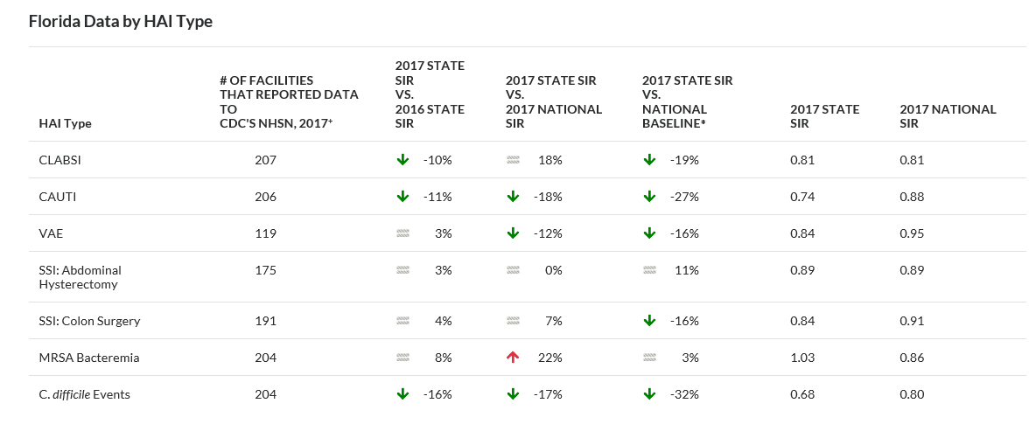
Legislative Report
- To proposed Bills. 1. Office space surgeries liposuction. 2. AHRQ Patient Safety Culture (HAI rate, 15 day re-admit rate, ACHA wants info. submitted to them to make available to the public.
Treasurer’s Report
- See financial report on file
Department of Health Reports
- Pinellas: Measles 1 in Pinellas this week. Only 2 measles this year in Florida in Broward and Pinellas Counties.
- Hillsborough: Two handouts. Hep. A in Pasco, Hillsborough, Pinellas, seeing in drugs (Meth), homeless. Outbreaks usually run 18-24 months.
- Polk: 10 Hep A YTD. 6 in month of March. Retirement community cluster, have not seen any more cases. 2 recently in prison. 1 IVDU.
- State: DOH Guidance for the Use of GeneXpert Assay in Making Decisions to Discontinue Airborne Infection Isolation for Suspected Infectious Tuberculosis
Open Agenda
- Consider scholarship category for committee members.
- Consider national level role in APIC
- Stacy will be speaking at APIC National Conference
- Project Link – Vaccine preventable disease. 5/15/19 for community at HCC Campus
- CBIC question and answer
Next Meeting: June 28, 2019
12:00pm – 2:00pm
Florida Department of Health Laboratory Tampa Spectrum Blvd, FL
Please Visit the BAPIC Chapter 55 Website: http://community.apic.org/bayarea/home/
APIC Mission: Spreading knowledge. Preventing Infection

