CA-APIC Quarterly Meeting- Hybrid
November 7,2025
Jessica Alicdan, President
Meeting details
Attendance | As per attendance record.
Old business | None
Welcome Introduction | Jessica A. started meeting at 930.  Summary of the agenda, housekeeping, bathrooms and QR code for attendance.  Today’s event was hosted by Kurin, Clorox and Shyld AI.  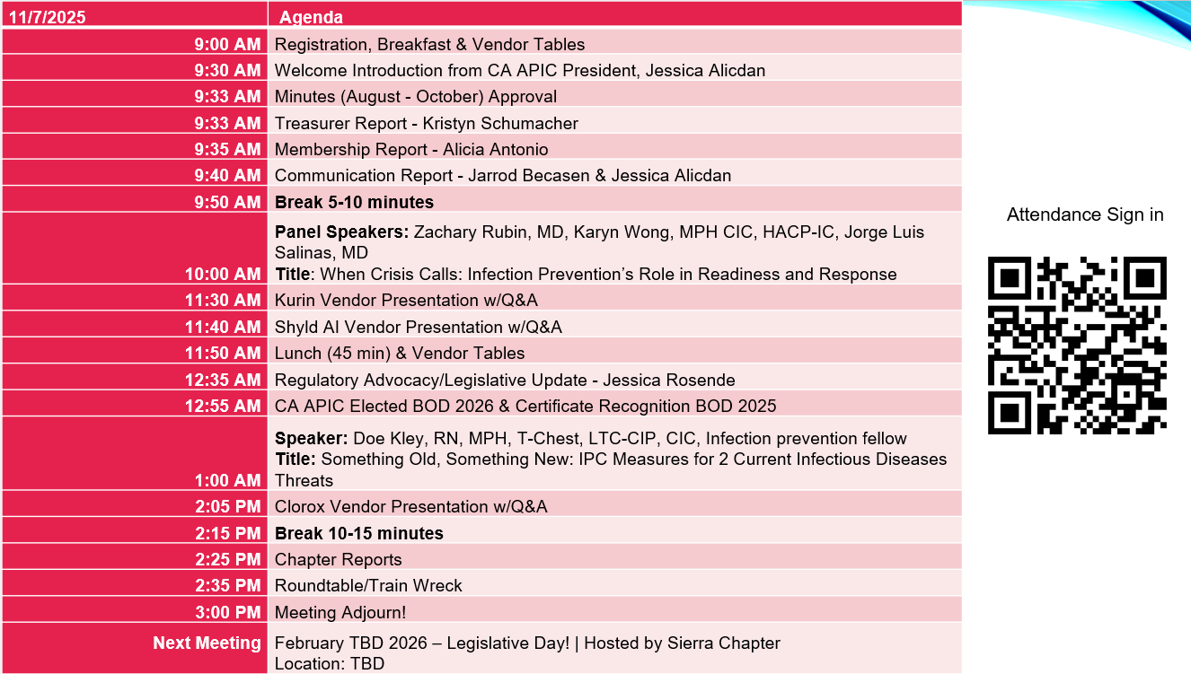
Quarterly and Monthly BOD Meeting Minutes | Aug. 8, 2025, quarterly CACC meeting minutes Krystal approved, Alicia seconded.  Aug. 28, 2025, CACC BOD monthly meeting minutes – Emily approved, Kristen seconded  Sept. 25, 2025, CACC BOD monthly meeting minutes – Stephanie approved, Alicia seconded  Oct. 23, 2025, CACC BOD monthly meeting minutes – Jarrod approved, Stephanie and Alicia seconded  No objections.
Treasurer Report: Kristyn Schumacher | Stephanie Leong will be the treasurer for 2026, her name needs to be added in the Wells Fargo bank account as an authorizer, then Kristyn name will be removed in 2026.  Checking Balance:  Sept. 2025: Balance $27,853.24  Oct. 2025: Balance $27,853.24  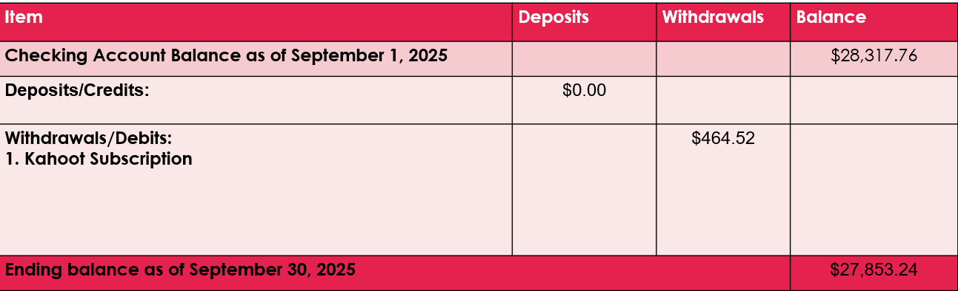  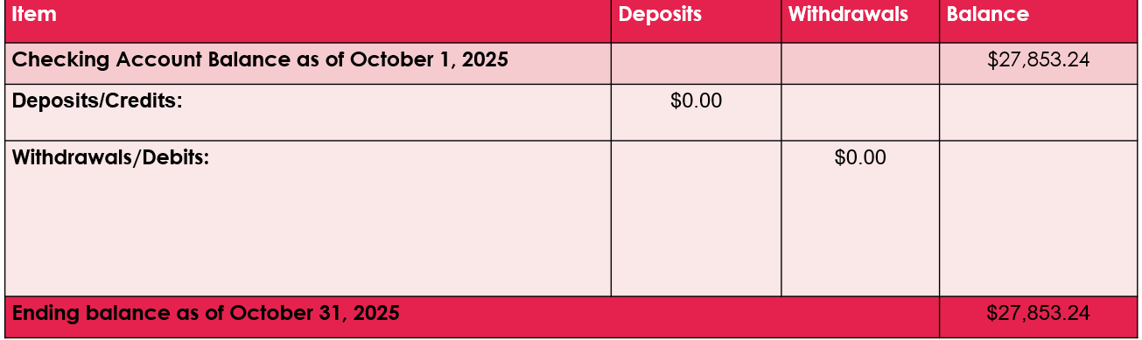
Membership Report: Alicia Antonio | Oct. Members: 1019  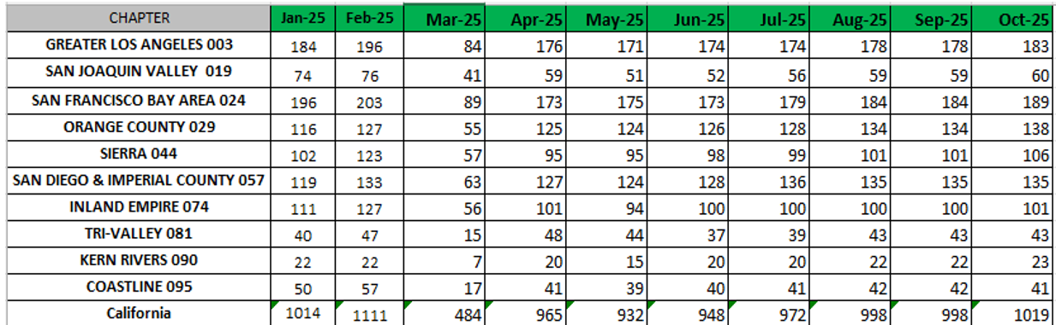  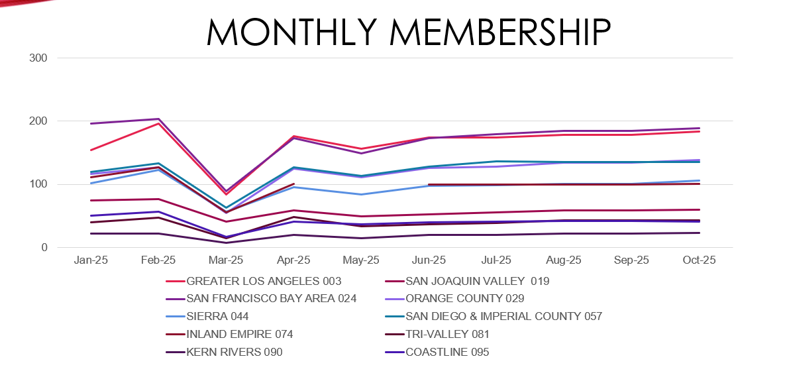  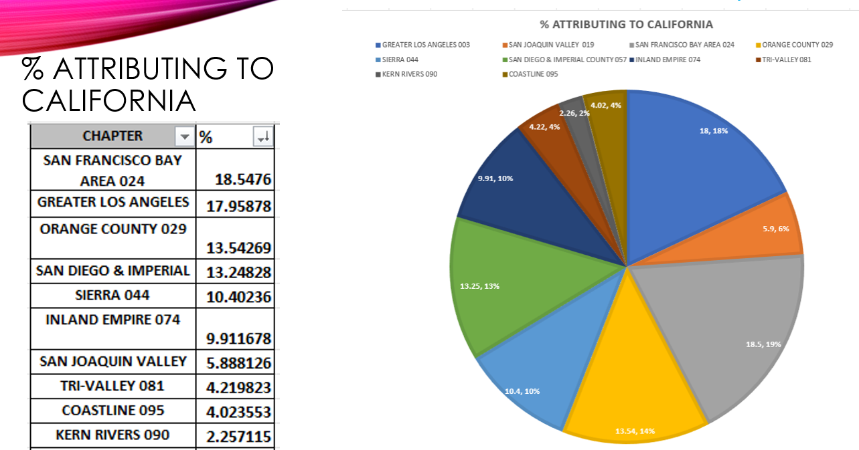  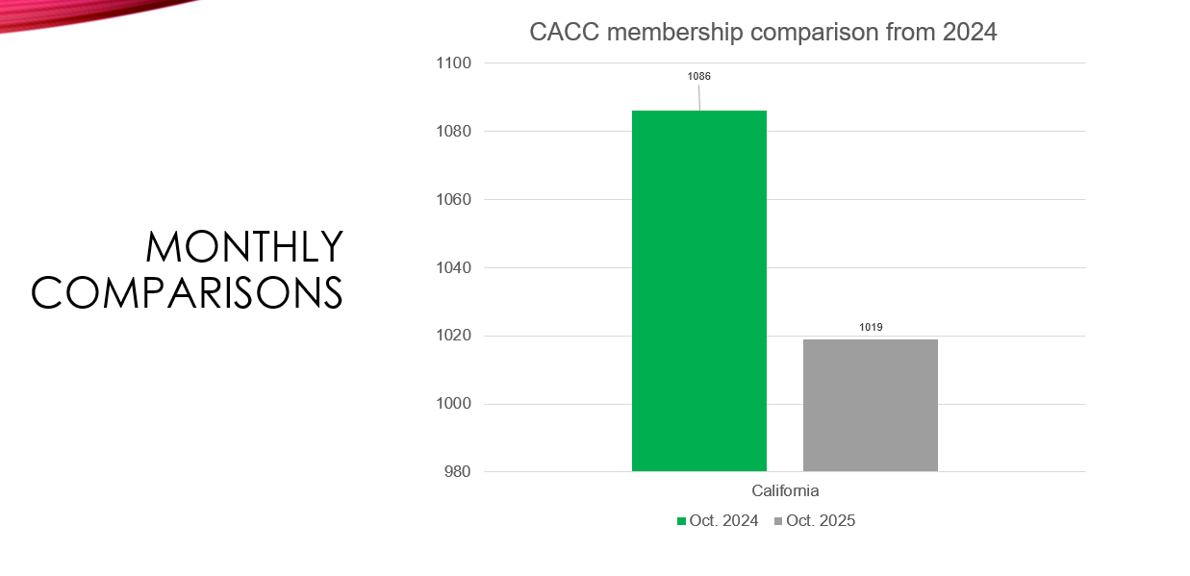
Communication Report:  Jarrod Becasen | Jarrod shared chapter website are public and at meet the board section with names and emails written in text, it will help if it is converted into image or photo like San Diego Chapter vs text that can be searched.  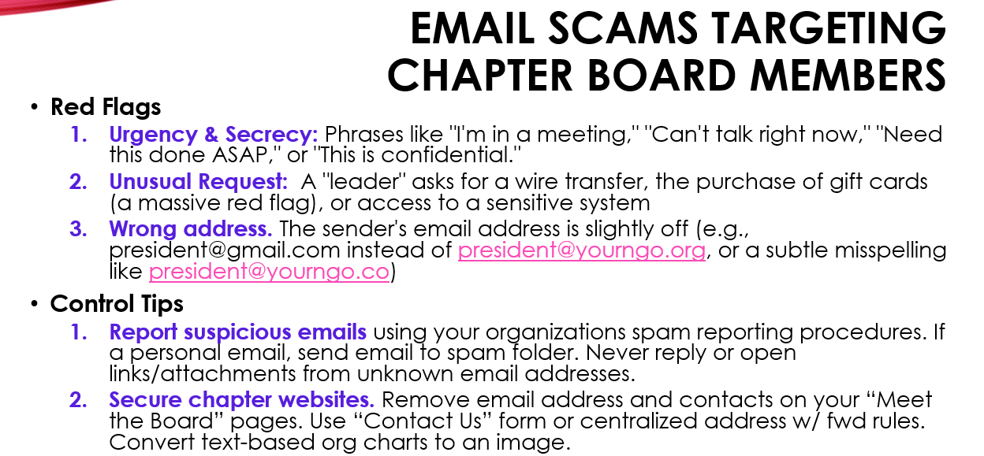  Chapter to vote if they want annual Kahoot subscription- free for chapters deadline extended until 12/5/25. It is a great platform application that builds high engagement, little bit of competitiveness if you’re playing games .  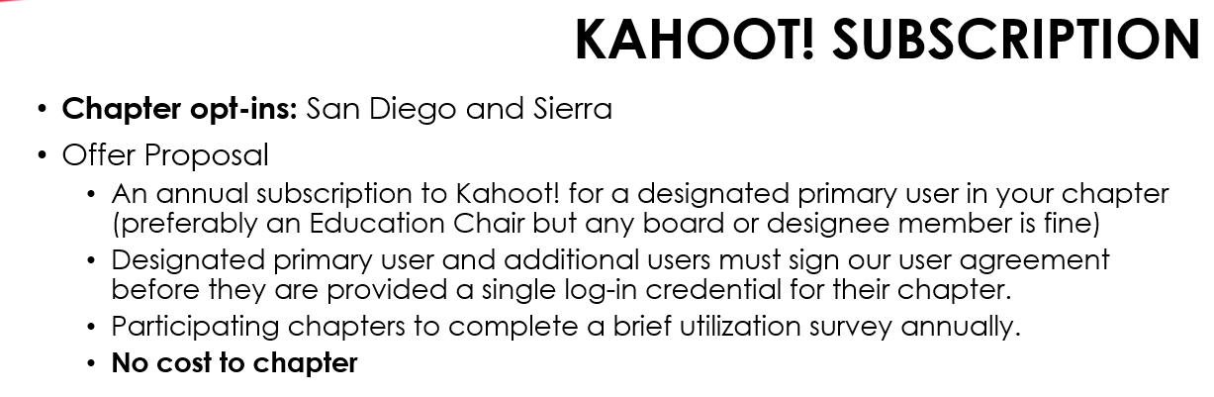
National APIC Updates: Jessica Alicdan |   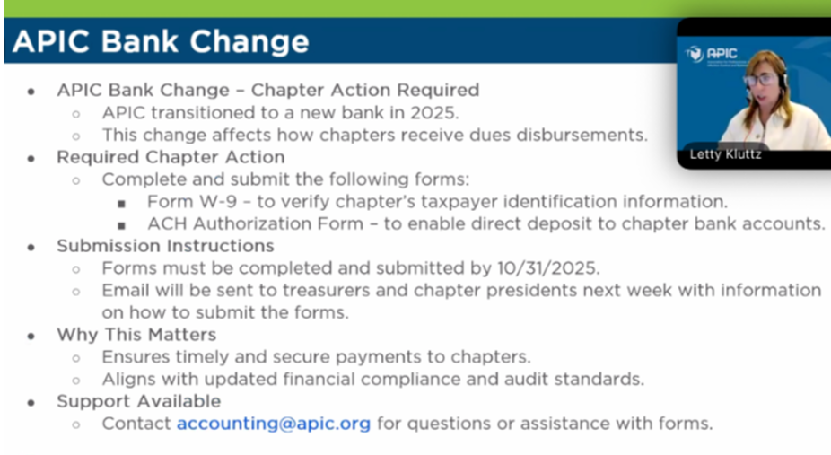  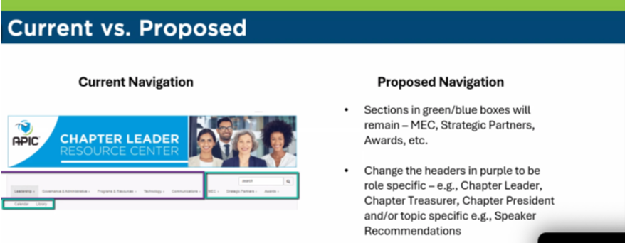  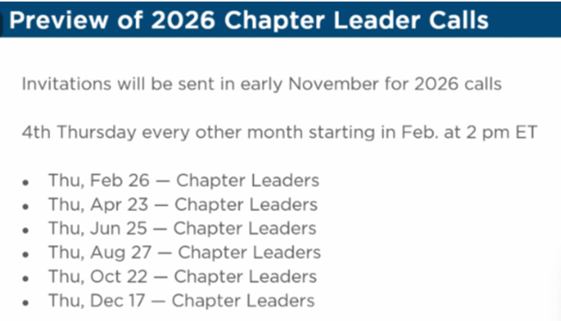
CACC Updates:  Jessica Alicdan | 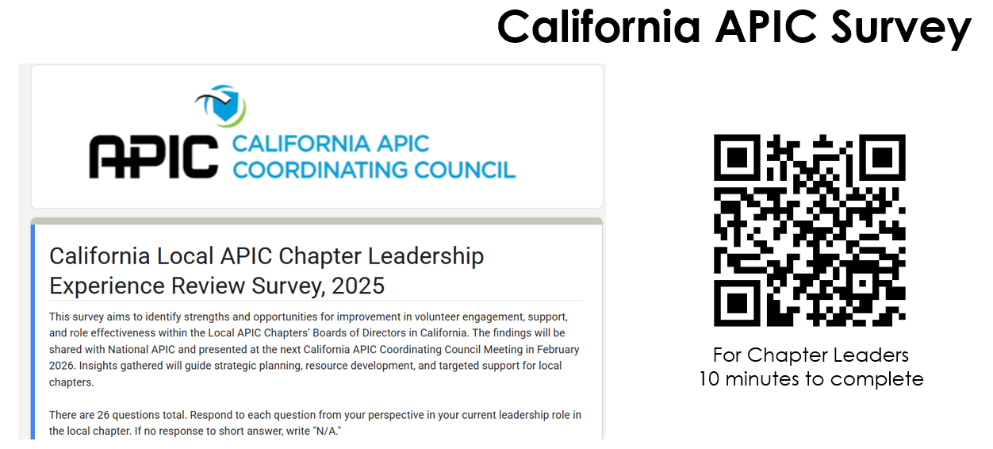  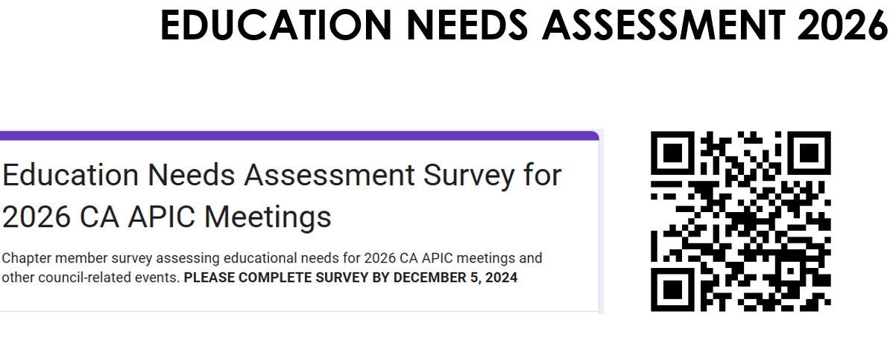  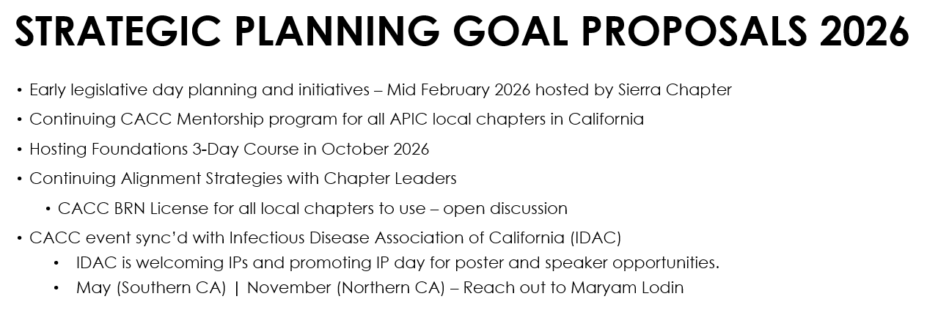
Panel Speaker Session: | Emily introduced the panel speakers . Facilatator : Krystal Smith  Topic: When Crisis Calls: Infection Prevention’s Role in Readiness and  Panel Speakers :  Zachary Rubin, MD Acute : Communicable Disease Control (ACDC)  Los Angeles County Department of Public Health  Karyn Wong, MPH, CIC, HACP-IC :Infection Preventionist  Children’s Hospital Los Angeles  Jorge Luis Salinas, MD: Hospital Epidemiologist  Stanford Medicine
Vendor Presentation | Kurin presented by Mary Obot and Shyld AI presented by Moh Noshad, PhD
Regulatory advocacy and Legislative Updates:  Jessica Rosende | 2026 Legislative Day . A revised CACC Legislative Day interedt form which date of either 2/11/2026 or 2/25/2026. Lot of members are interested to come and members does not need to be CLR to come and idea is to try to pair new attendees to those who already attended Legislative day .  Health committee was also so mentioned if we are interested and they meet every Weds and that is the reason that we provided Weds options.  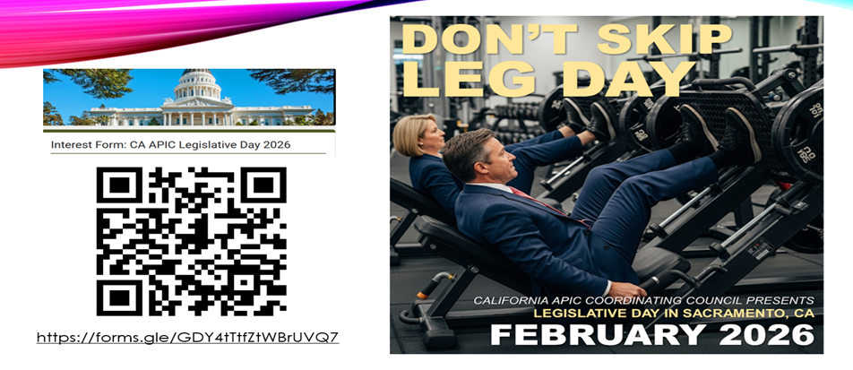  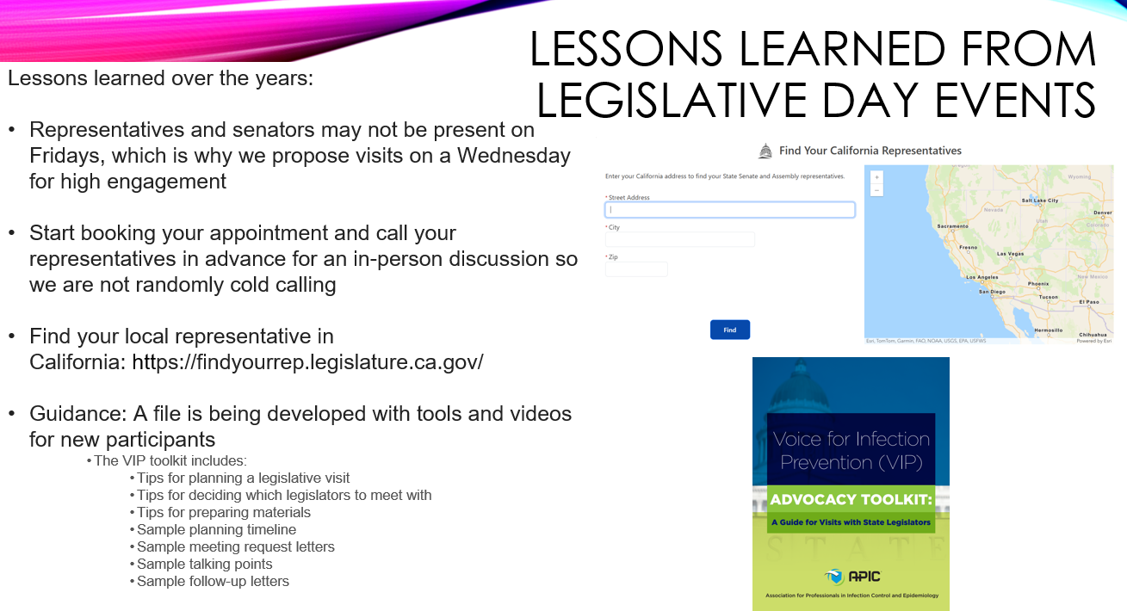
Speaker: | Speaker introduced by Emily.  Topic : Something Old, Something New: IPC Measures for 2 Current Infectious Disease Threats  Speaker : Doe Kley, RN, MPH, T-Chest, LTC-CIP, CIC, Infection Prevention Fellow
Vendor Presentation | Clorox presented by Manya Stanciu
2026 New Board Members and BOD term ending and transitions | 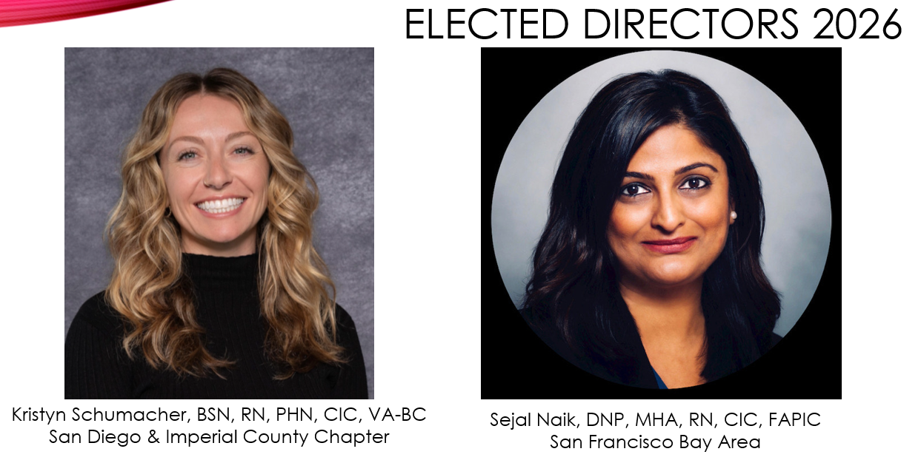  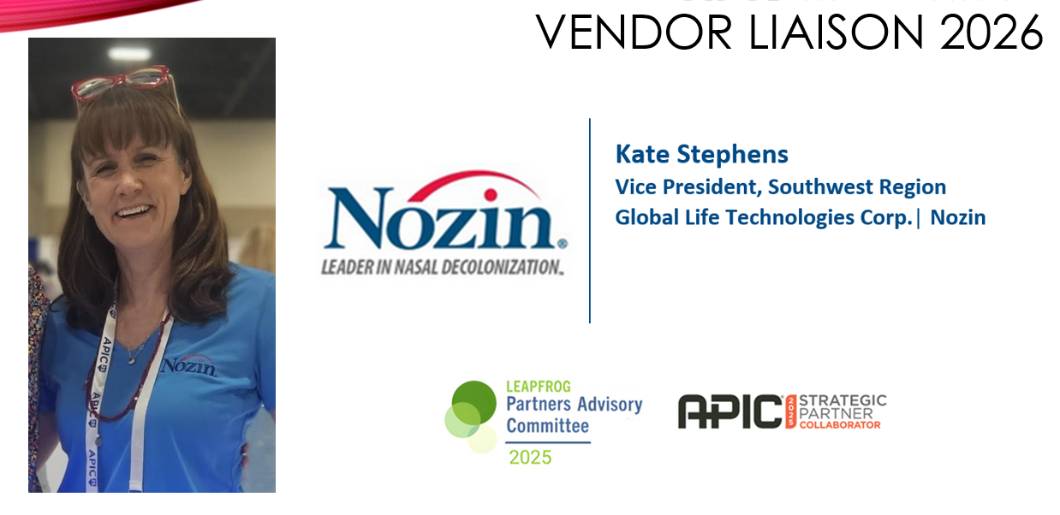  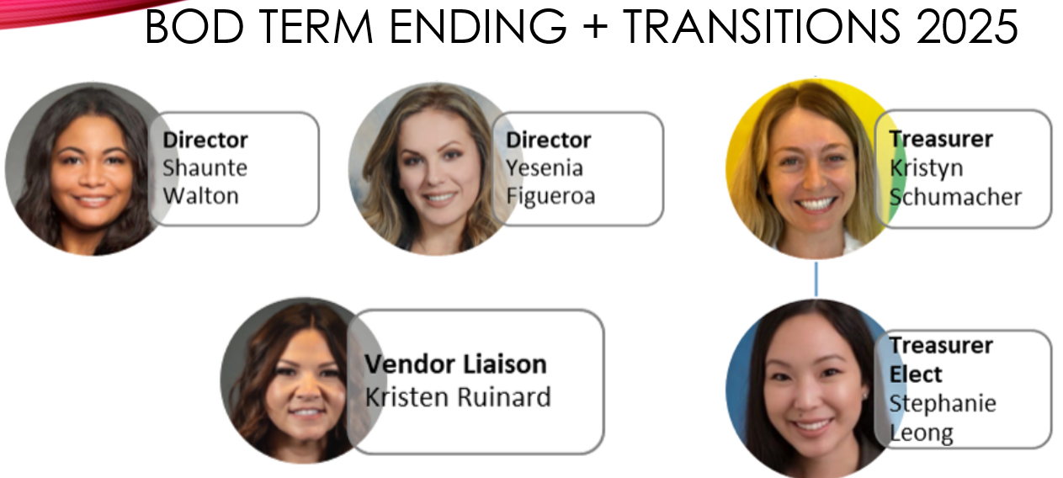
Education: Emily Barnard | Educational needs assessment is due 12/5/2025.  Next board meeting will be 12/9/25 and CACC meeting will be Feb. 2026 hosted by Sierra Chapter .  
Chapter Reports | Coastline: no report  Greater Los Angeles – reported by Katie Lancaster  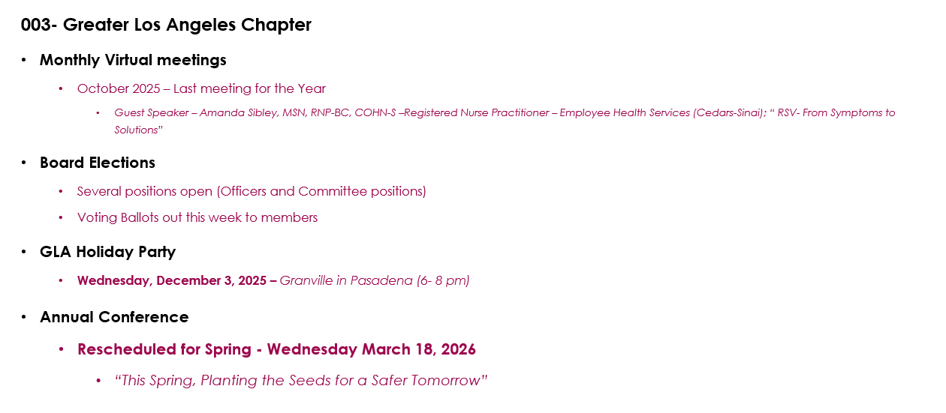  Inland Empire – no report  Kern Rivers- no report  Orange County – reported by Emily Barnard  OC actively promoting and recognizing CIC, or CBIC recognition through certification, putting out something every month for spotlight thru social media , providing pins for newly certified, done some mebership engagement by offering gift card giveaways for those that attend in person, continue monthly meetings that includes HAI review, micro-learning which is nice way to engage our community and get people to share what they are doing. On Feb. OC will offer canva workshops etc. Every year they recognize leaders this is with Donna Law Memorial Award .  San Diego and Imperial County – reported by Jessica .  Annual conference was completed on 10/10/25 almost 100 attendees and 30 vendors total . A survey was sent to get an evalaution of the location and all the other details . There is a discussion maybe doing a giant conference in Northern Cal and Sothern Cal more discussion is needed. No LTC conference that usually occur in Nov. will try next yeat and do more outreach to LTC partners. December holiday aprty is coming.  San Francisco – reported by Priya Orozco  Needs assessment are done and we are looking for a full-day conference for next year where it will be either a minimal cost or no cost. Currently looking for a location like a nice retreat /getaway and rest of edcuation will be offered virtual . Product Fair on Dec. 10,2025 and new board members will be announce.LTC-CIP review class was offered around 50-60 attendees .  San Joaquin Valley- no report  Sierra Chapter – no report  Tri-Valley- reported by Nina Yates    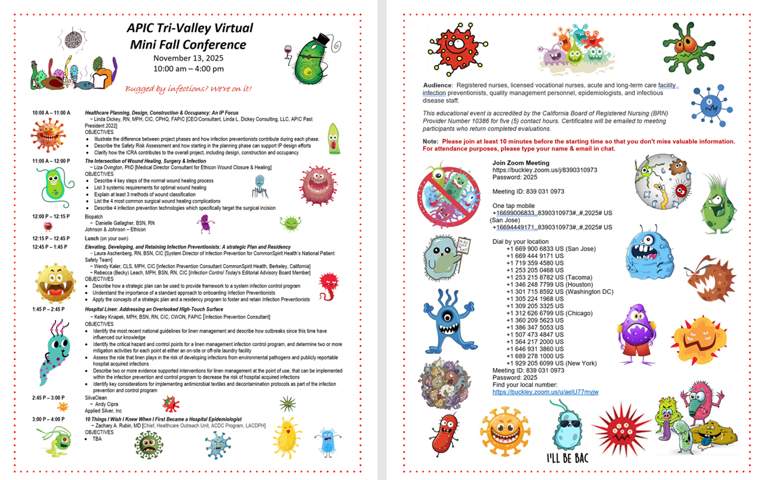
Trainwrecks | - Biohazard Waste Process – Jessica shared only CDPH responded Thomas Homer they acknowledged the letter but basically saying that they don’t have any authority over the district attorneys. There are a lot of side conversations with hospital leaders in building a coalition and for IPs to bring more awareness to leadership.  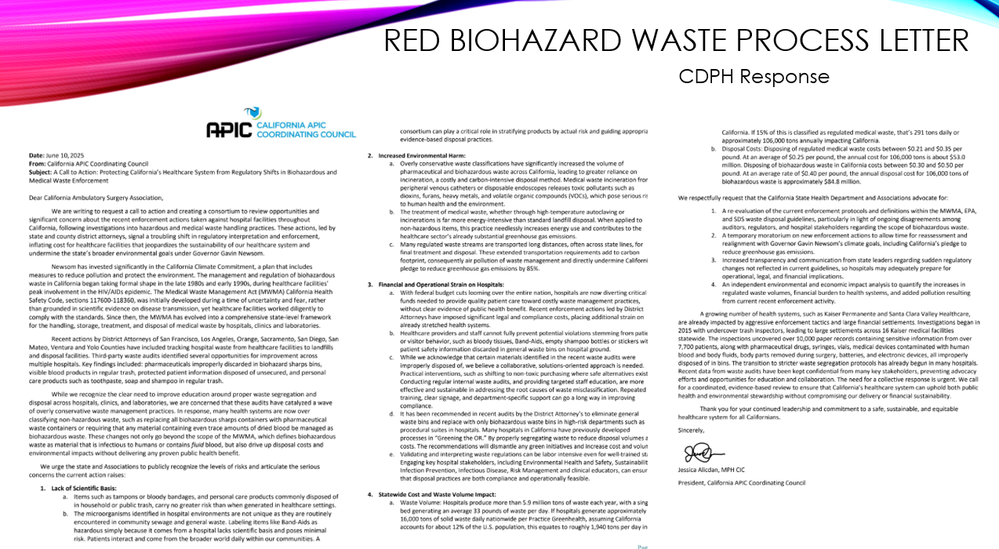  - 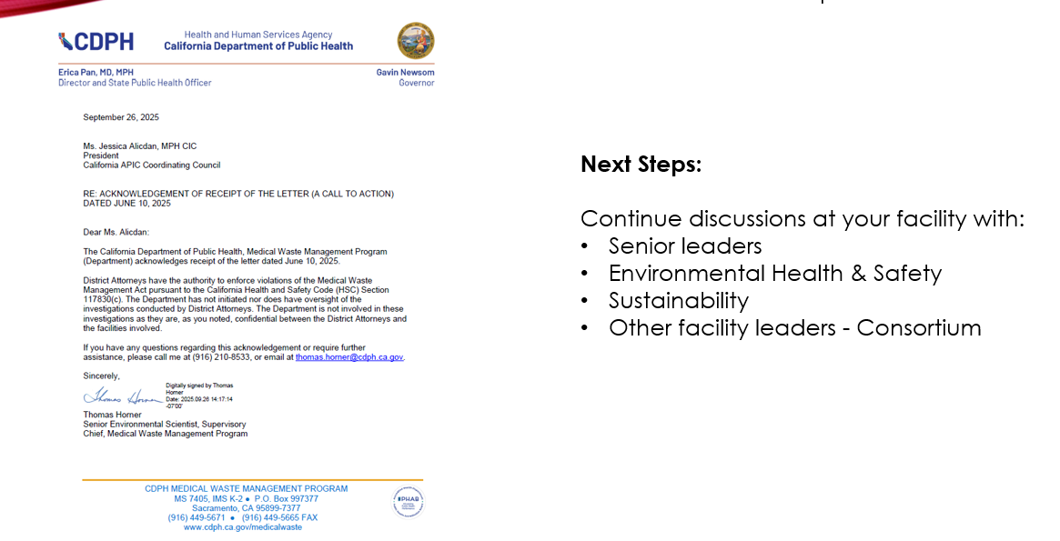Norovirus – Krystal shared around May sudden spike of cases 69 started in outpatient oncology then inpatient oncology – it was the issue on the GI panel false positivity, so they started dual testing with GI panel and PCR confirmation and around Oct 36 positive GI panel and only 2 PCR confirmed, collected same day and time. So, it was a pseudo-outbreak but cost a lot of resources, hours burned, working with public health and will try to file a complaint with the FDA. It started with staff reporting it to employee health.  - Alaris Pump – Kristen shared during SD conference it was presented on the challenges with certain products, misuse adherence and shared a great tool we could adopt on how to create a risk assessment.
CEU/IPU | 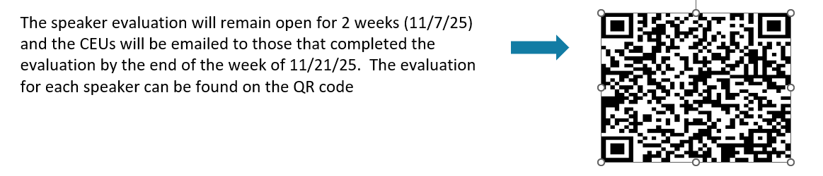
Meeting adjourned | The business meeting ended @ 2:36pm
Next Meeting | Feb. 2026 Legislative Day, hosted by Sierra Chapter

Submitted by Maricar Telmo 11.14.25

