CA-APIC Quarterly Meeting- Virtual
May 2, 2025
Jessica Alicdan, President
Meeting details
Attendance | As per attendance record.
Old business | None
Welcome Introduction | Jessica A. started meeting at 0900.  Summary of the agenda  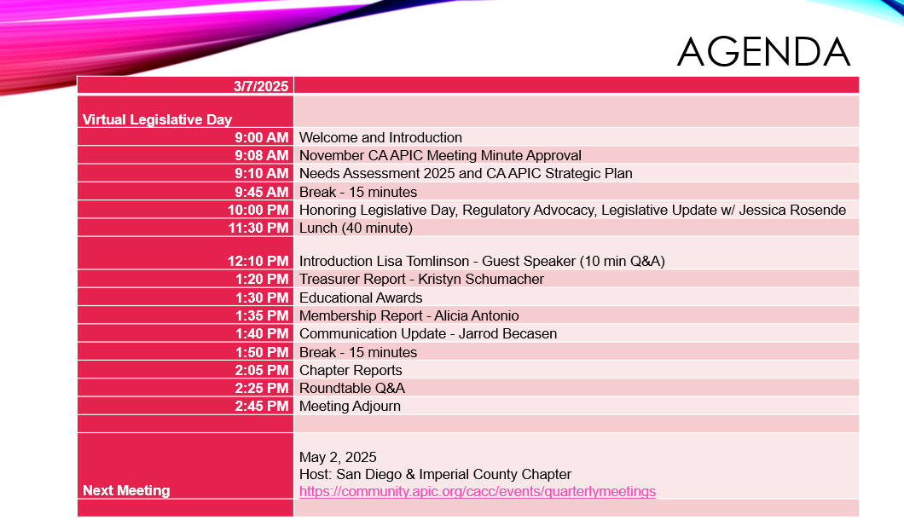
November Meeting Minutes | Reviewed and approved.  Emily Barnard made motion to approve, Krystal Smith seconded.  No objections.
BUSINESS REPORTS
Treasurer Report: Kristyn Schumacher | Checking Balance:  February balance: 31,847.50  March balance: 33,840.55  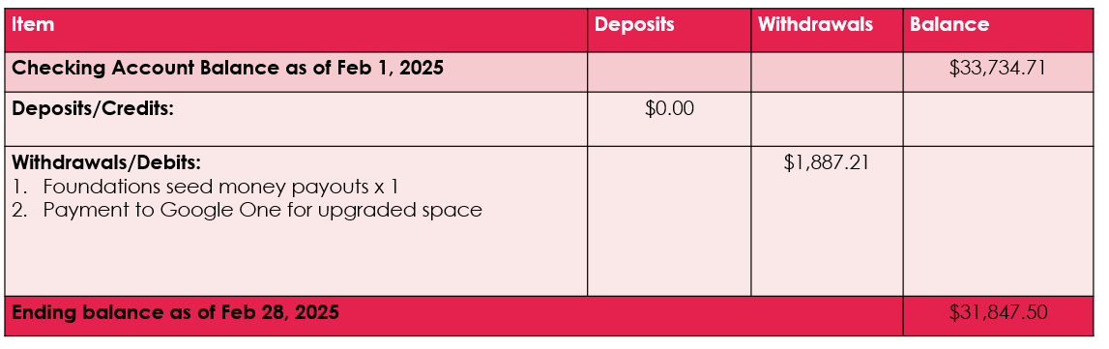  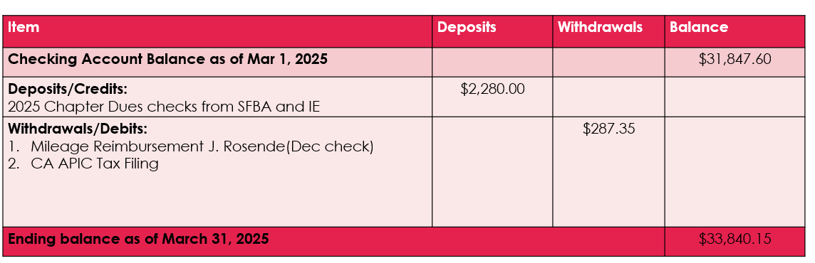
Membership Report: Alicia Antonio | CACC March members: 965  Alicia reported that with big improvement with the numbers compared last March but still not sure if it is accurate, encouraging each chapter (Pres. &Membership Director has access of their members) to double check .  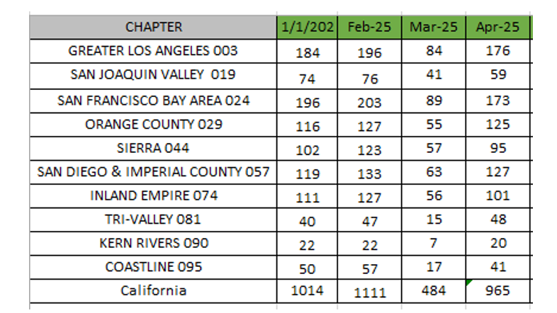  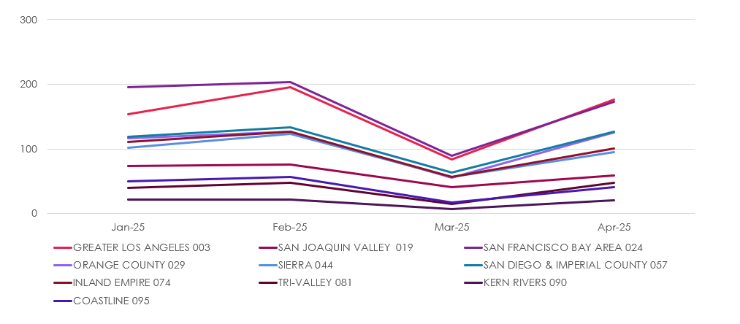  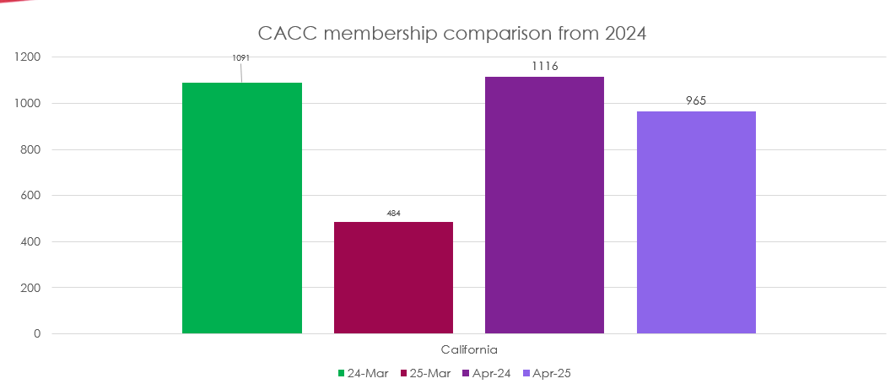
Education Report: Emily Barnard | August 8th OC APIC Host Chapter Presents in Conjunction with CACC  Topic & Speakers: Beyond the Bundle for Infection Prevention & Control presented by J. Hudson Garrett Jr., Ph.D., , AORN Guideline for the Implementation of ERAS presented by Dr. Lisa Spruce DNP, RN, and TB in Orange County by Dr.Helene Calvet MD  November 7th SF Bay Area APIC Host Chapter Presents in Conjunction with CACC  Topic & Speakers: Emerging Pathogen Threats presented by Doe Kley RN, MPH and Navigating National Disaster Preparedness and Recovery presented by Sejal Naik DNP,RN  Education Awards – 8 applicants  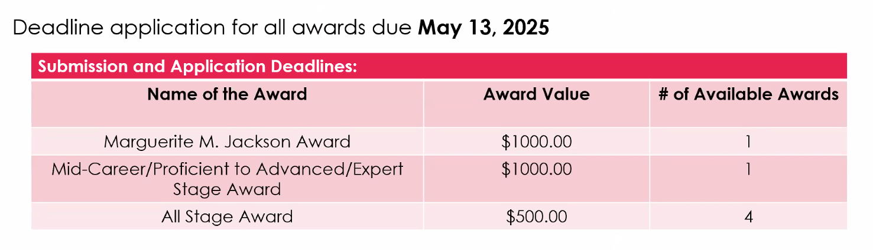  APIC National Conference- June 16-18 Phoenix, Az  CACC hosting Happy Hour June 16,2025 4-5:30pm  
Regulatory Advocacy/Legislative Update: Jessica Rosende | May 12 Join Representative Luz Rivas for a 1-hour meeting with APIC representatives. Monday at 4:00pm hosted by Anu Sood, LUV Systems, Inc.  Location: EPC Western Plaza 18726 South Western Avenue, Suite 407.Gardena, California 90248  CACC Advocacies:  Alaris Pump Cleaning IFU and Red Biohazard Waste Process Letter  National Advocacies:  - APIC, SHEA, IDSA and the Pediatric Infectious Diseases Society (PIDS) sent a joint letter to HHS Secretary Kennedy opposing the possible elimination of HICPAC. The letter identifies the many ways HICPAC makes healthcare safer by providing evidence-based guidance on infection prevention and control practices. Read the APIC/SHEA/IDSA/PIDS letter supporting HICPAC.  - CDC’s Healthcare Infection Control Practices Advisory Committee (HICPAC) is under consideration for elimination. Please write to your federal policymakers to let them know how important HICPAC guidelines are to IPC practices in your facility and your state. Numbers matter – the more messages Congress and the Administration get from their constituents they more they pay attention. Go to the APIC Action Center and click on the first box “Prevent Elimination of HICPAC.” This will take you to a pre-written, editable letter. By entering your name and address, your letter will be automatically sent to the President and your federal Representative and Senators asking them to protect HICPAC from elimination.  - APIC, SHEA, IDSA and the Pediatric Infectious Diseases Society (PIDS) sent a joint letter to HHS Secretary Kennedy opposing the possible elimination of HICPAC. The letter identifies the many ways HICPAC makes healthcare safer by providing evidence-based guidance on infection prevention and control practices. Read the APIC/SHEA/IDSA/PIDS letter supporting HICPAC.  Legislative Day 2026: around Feb. 2026  Reference: APIC_VIPAdvocacyToolkit_Updated23.pdf
 | NEW BUSINESS
Mentoring Pilot Program | Mentoring Pilot Program: https://community.apic.org/cacc/resources/mentor-program  Target start date: May 5th opening application to June 2025 closing application. Cohort to start in July  Discussion regarding IP’s that are not member of APIC and Jessica and Krystal suggested to partner with CDPH HAI to advertise the program.  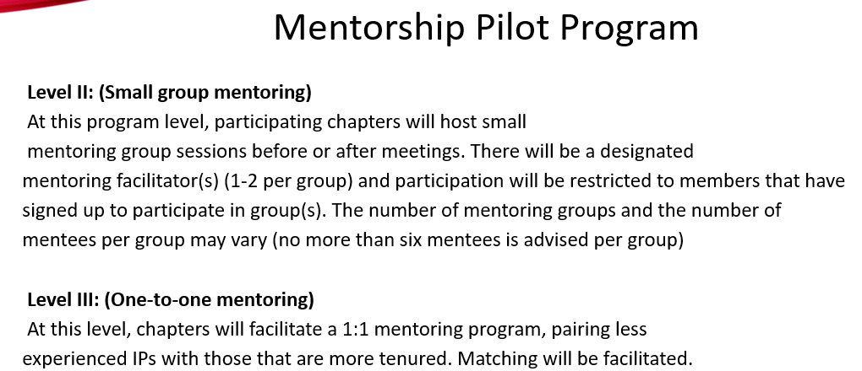  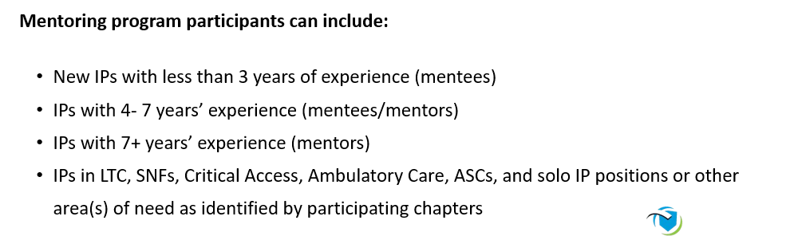  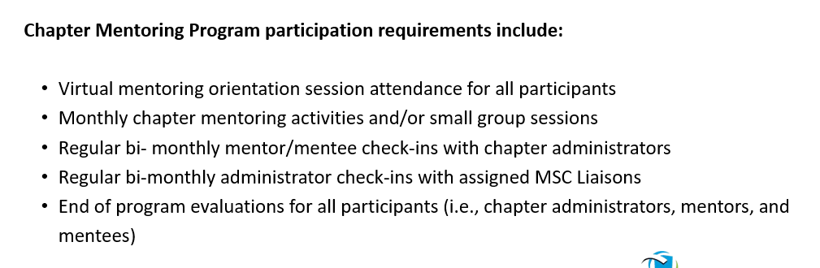  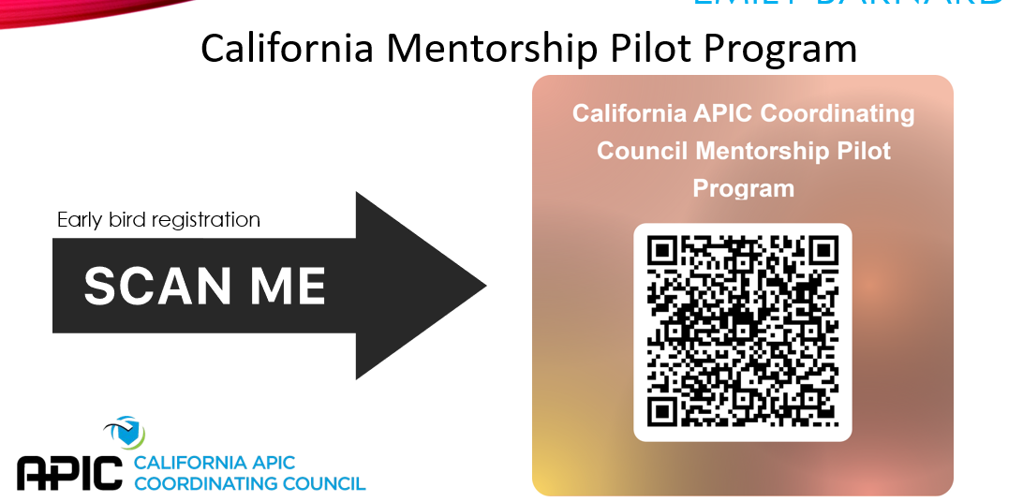
Alignment Strategy | 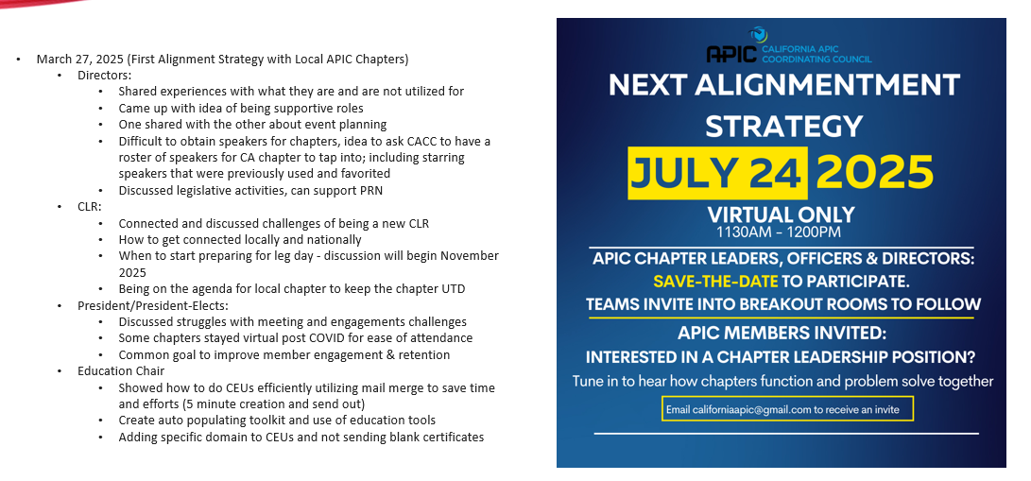
Vendor Presentation | Phigenics, Nanosonics and Nozin
Speaker | Speaker Topic: The Hidden Crises : Evaluation Drug Diversion and It’s Impact on Patient Care  Speaker: Mary Reilley,MHA,BSN,RN,HACP,CIC
Speaker | Speaker Topic: First Do No Harm? Environmental Impact and Sustainability in Infection Prevention and Antimicrobial Stewardship  Speaker: Mary Reilley,MHA,BSN,RN,HACP,CIC
CEU/IPU | 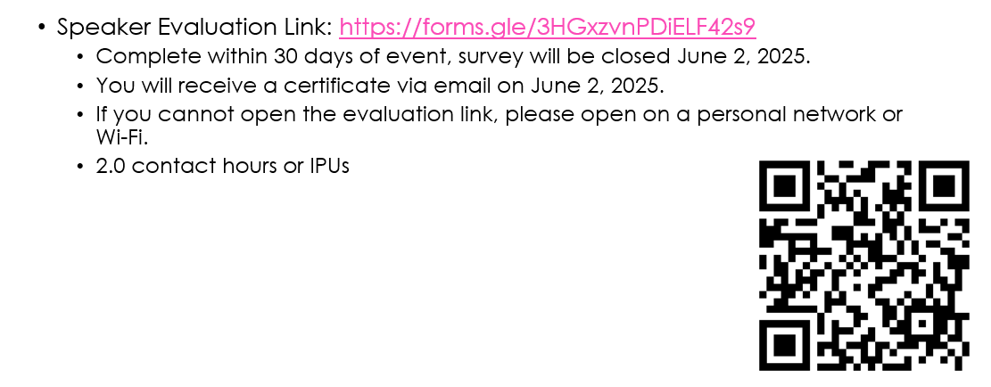
Chapter Report-outs | - Coastline- no report/no representation  - Greater Los Angeles- Wanda reported -monthly virtual meeting, Microbiology 101presentation 4/22/25, quarterly SNF Happy Hour education next meeting June 10, 2025, educational award closed 04/30/25 (few applicants)  - Inland Empire- Karina – nothing to report  - Kern Rivers- no report/no representation  - Orange County- Emily reported monthly hybrid meetings- in-person attendance is low (gift cards offered) , IP spotlight , 4 educational awards ( 2 selected), Summer social picnic  - San Diego & Imperial County- Jessica reported Summer Social on July 25,2025 and Annual Fall Conference 10/10/2525 HAI’s Should Never be Par for the Course  - San Francisco Bay Area- Alicia reported next hybrid meeting on May 14, 2025, and LTC-CIP Review Class for SNF IP on May 10, 2025  - San Joaquin Valley- no report/no representation  - Sierra- no report/no representation  - Tri-Valley- no report/no representation
Round Table /Trainreck | - Cidex temperature for HLD. Encourage IPs to create a risk assessment, reviewing all chemicals and HLDs with temperature range parameters  - Air Condition units inside resident room in SNF  - Pessary – understand the process. Pessaries are designed for single patient use” with cleaning instructions to use mild soap and warm water. Upon further investigation into every pessary device, the IFU states “single patient multiple use” meaning these devices can be used multiple times in a single patient. Items should not be sent to SPD  - Glaucoma eye devices (e.g., Yag) – devices need HLD at eye centers. Consider Spaulding classification. If eyeballs have cuts, need to sterilize devices  - Foley catheter placement in imaging centers (e.g., CT, IR, MRI). Where do staff hang the Foley bag? Often, Foley bags with urine are placed on top of patients, increasing the chance for UTI. Reinforce emptying the bag and before transporting patients
Meeting adjourned | The business meeting ended @ 3pm
CA APIC 2025 Meeting Dates | August 8, 2025, hosted by Orange County Chapter – City of Hope  Nov. 7, 2025, hosted by San Francisco Bay Area Chapter – El Camino Hospital MV
Next Meeting | August 8, 2025, hosted by Orange County Chapter – City of Hope

Submitted by Maricar Telmo 5.2.25.

