CA-APIC Executive Team Meeting
May 19, 2026
Meeting @ 11am PDT

Meeting details
Attendance | 2026 Board Members  President: Jessica Alicdan- not present  President-Elect: Krystal Smith  Secretary: Maricar Telmo  Education Chair: Alex Massey – not present  Communications Chair: Jarrod Becasen  Director: May Riley – not present  Director: Sejal Naik  Director: Kristyn Schumacher  Vendor Liaison: Kate Stephens -not present  Treasurer: Stephanie Leong– not present  Past President and CLR: Jessica Rosende- not present  Membership Chair: Alicia Q. Antonio – not present
Agenda | 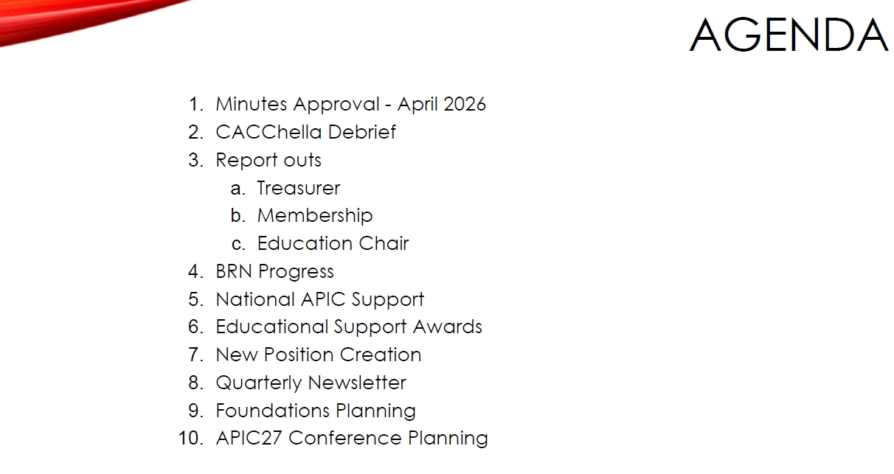
Meeting Minutes | April minutes not approve due to not enough members
CACCHELLA | Krystal thanked Kristyn and Aryeh for the good presentation. We received positive feedback in-person, online, and on the side messages. IE was a fantastic host. Can add photos to the google drive photo album: https://photos.app.goo.gl/ssFS7UHz5ji7PfmZ8  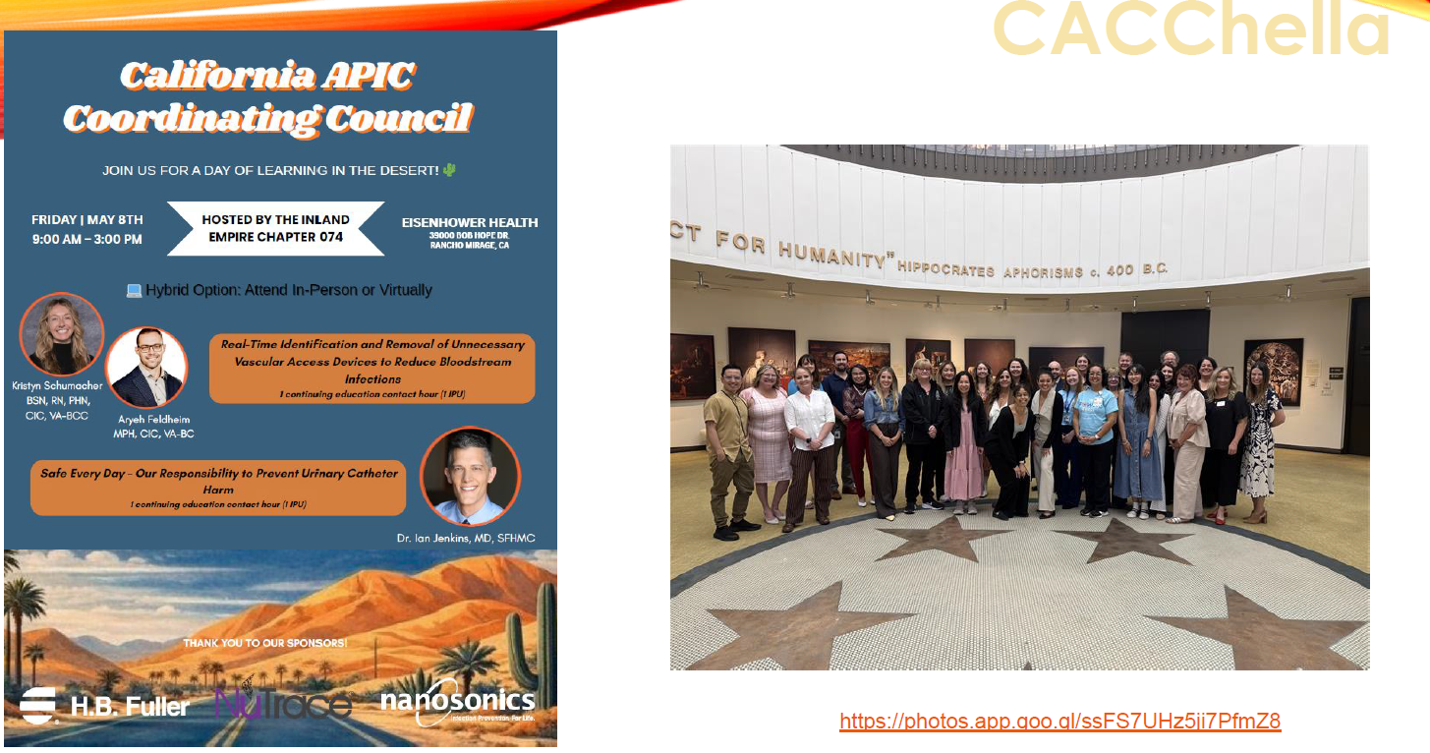
Treasurer Report | No report update but Stephanie wants to remind board to submit reimbursement from Palm Spring meeting.
Membership Report | Kern is back, no activity last year but now back to being active. Prioritizng the bylaws and increase communication . Aiming for 1st meeting July or Aug.  
Education Report | Kate is arranging the dinner before the meeting on Aug. 14. Kristyn suggested to Kate Common Theory Restaurant .  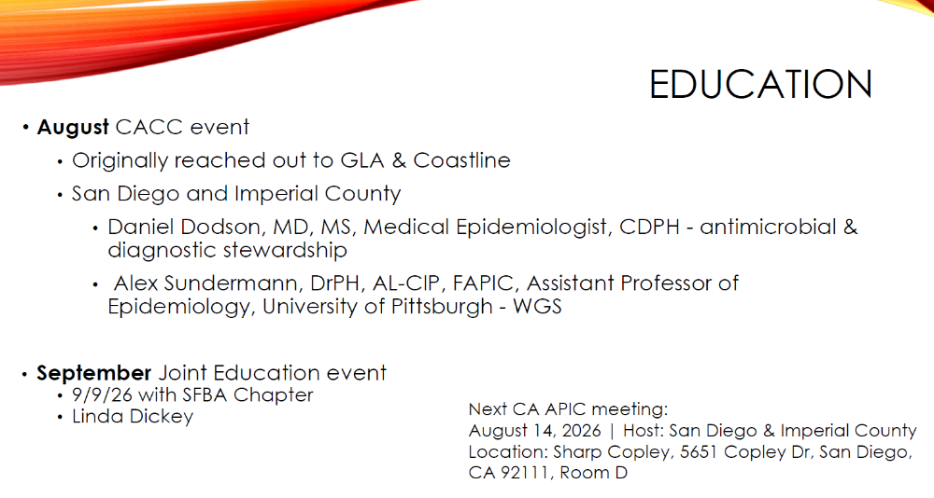
BRN Application Updates | Deferred on next meeting
National APIC Support | National does not recognize CACC as a chapter, and CACC leaders are restricted from Chapter Leader Resource Center (unless they serve as a board member on their local chapter). We inquired about formally registering as a chapter. Senior VP Cindy Ziegler will discuss options at National’s Membership Engagement Committee. JA shared CACC’s decades-long history. Jarrod brought up the need for us to consider any consequences for registering as a chapter. E.g., people cannot serve on board of >1 chapter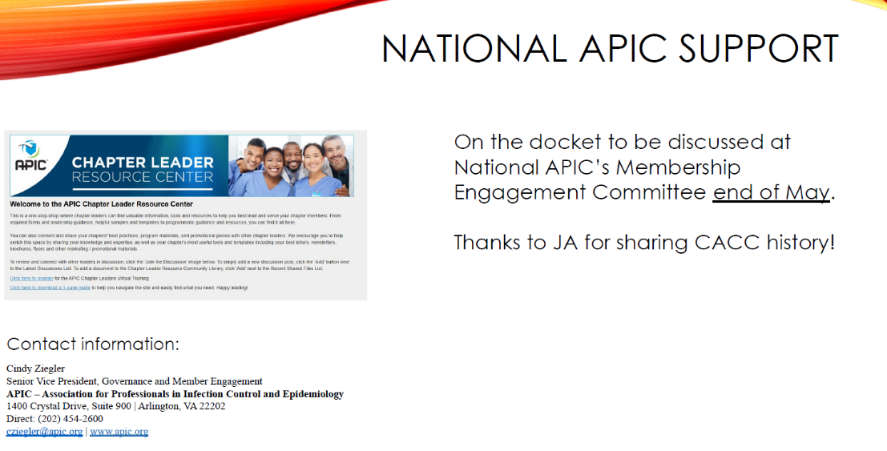
Educational Awards | Jarrod volunteered to review and send the applications. Jarrod will send the ballot today and BOD will vote by May 22. Recipients will be informed same day or 5/26 (after Memorial Day) at the latest.  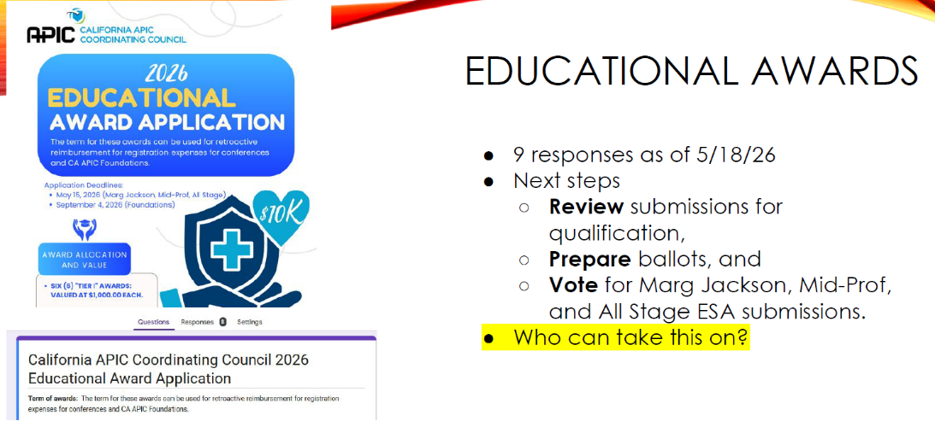
2027 BOD Open Positions | Foundations-Elect (2) nominations are open, close end of June. They will shadow current Foundations Planning team. Krystal asked the board to follow the google document link and review your current position description, then add any changes you would like to suggest. E.g., including responsibilities that you currently have, but are not listed in the bylaws or nomination forms or suggesting new/different duties. Question from Maricar: do new positions receive travel incentives? If so, what does budget look like? Decided the board should discuss options and then standardize the language in bylaws. Maricar pointed out that we can add a standing rule to add onto bylaws, where we can elaborate more details.  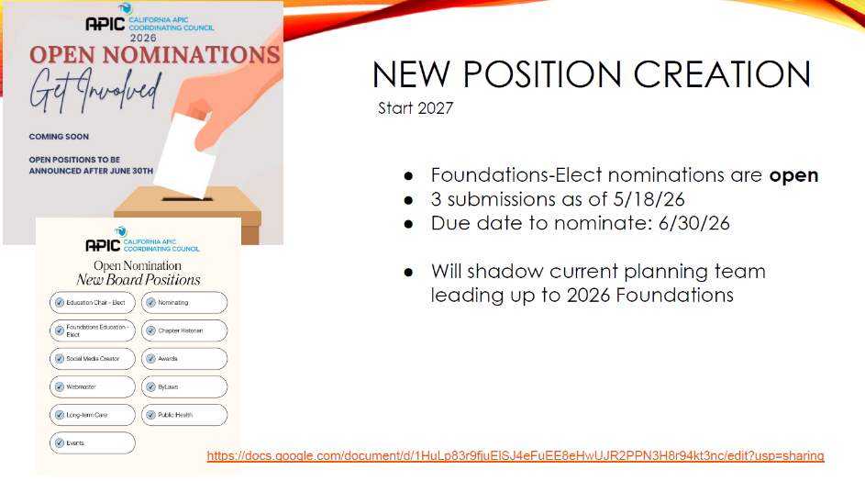  Krystal will send an email to all BOD to review the bylaws of each current postion.  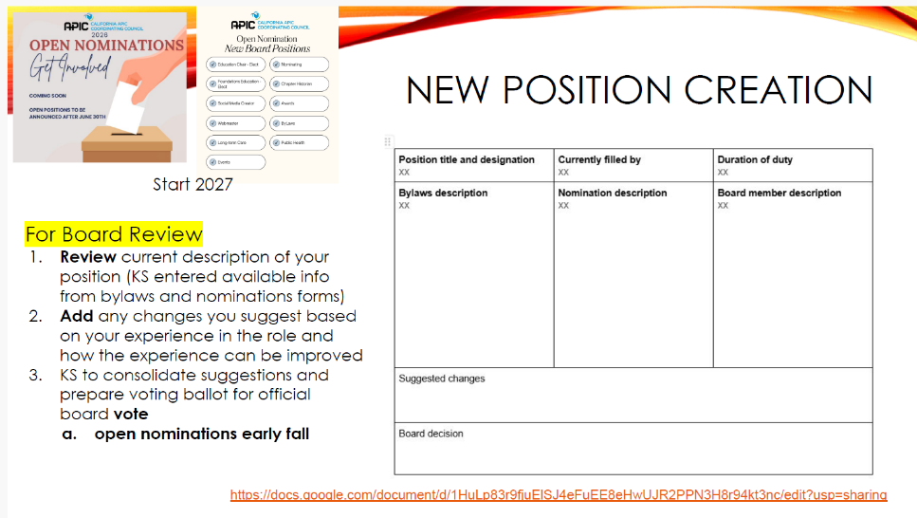
Quarterly Newsletter | 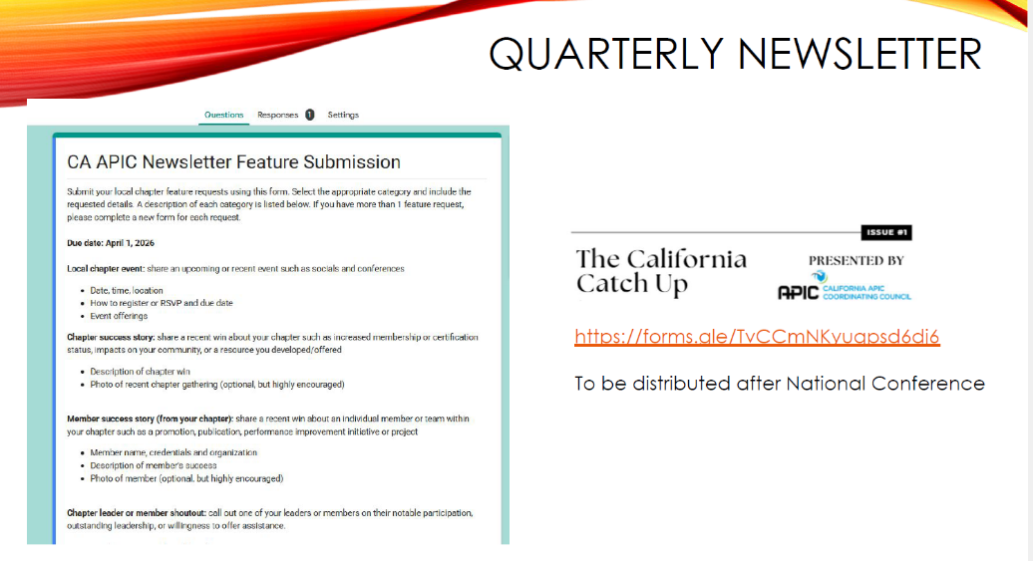
Foundations | Jarrod recommend to change K-Pop Infection Hunters  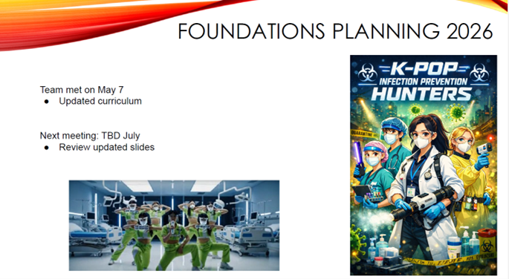
APIC 2026 Conference | Acme was reserved by Kate. Needs 1 more sponsors and to communicate with the chapters. RSVP was already created with 10 respondents as of 5/19/26.  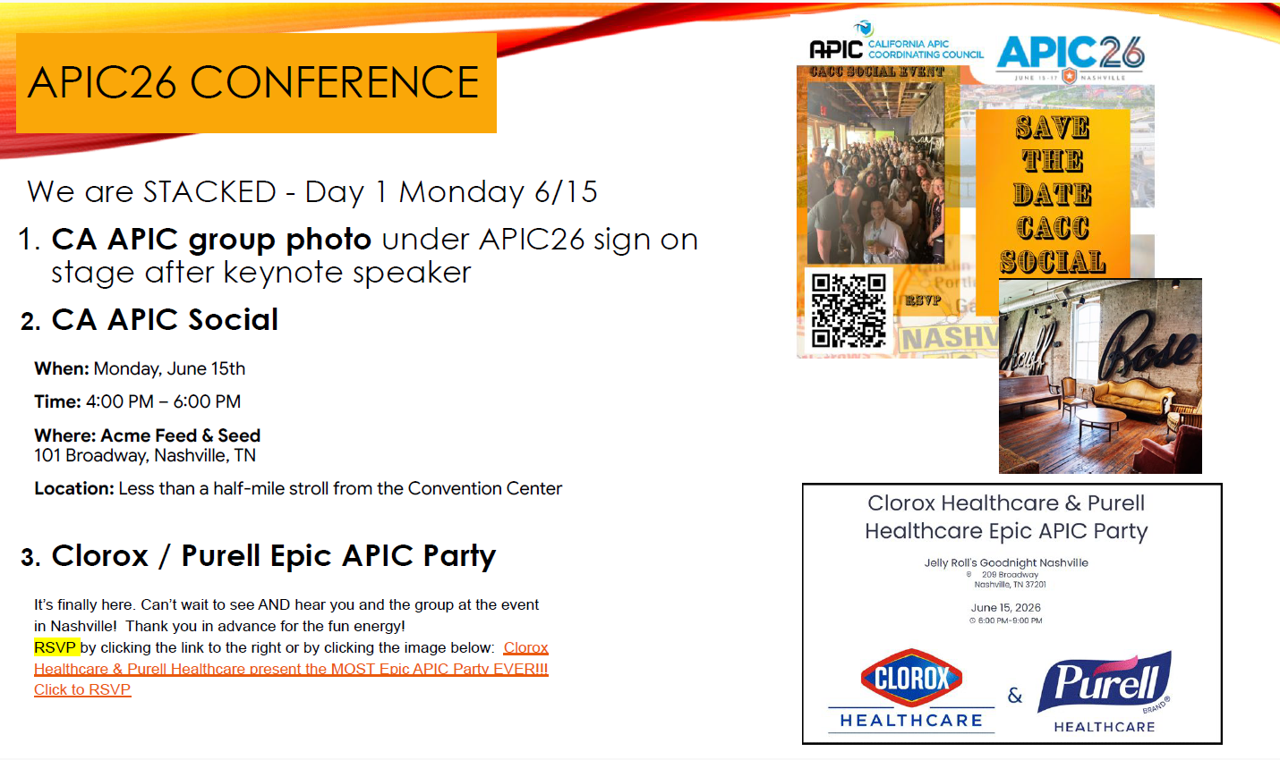
APIC 2027 Planning | Discuss more after Nashville conference .  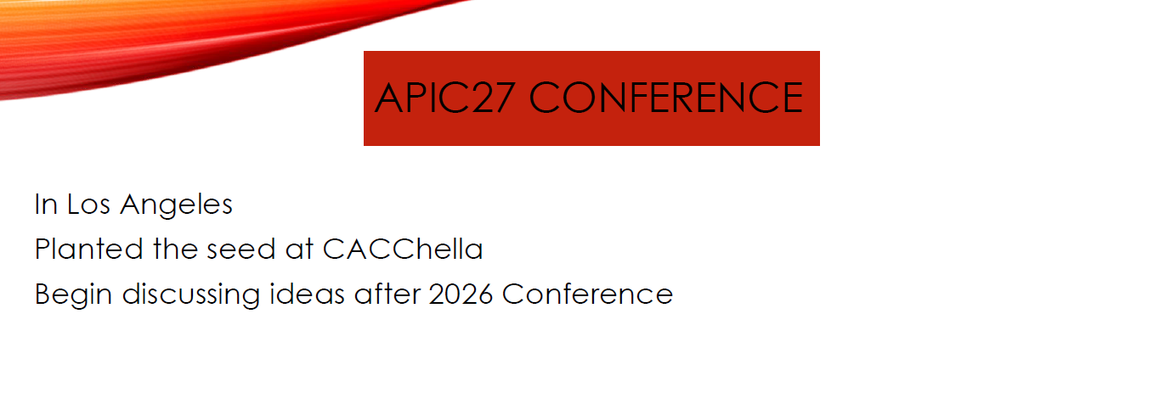
Meeting Adjourned | Meeting ends 11:35 am
Next Board Meeting | June 23, 2026 11-12PM
Submitted by: Maricar Telmo Secretary
Reviewed by : Krystal Smith President

