CA-APIC Executive Team Meeting
Feb. 17, 2026
Meeting @ 11am PDT

Meeting details
Attendance | 2026 Board Members  President: Jessica Alicdan  President-Elect: Krystal Smith  Secretary: Maricar Telmo  Education Chair: Alex Massey  Communications Chair: Jarrod Becasen  Director: May Riley – not present  Director: Sejal Naik- not present  Director: Kristyn Schumacher  Vendor Liaison: Kate Stephens  Treasurer: Stephanie Leong  Past President and CLR: Jessica Rosende – not present  Membership Chair: Alicia Q. Antonio
Topics | Discussion
Agenda | 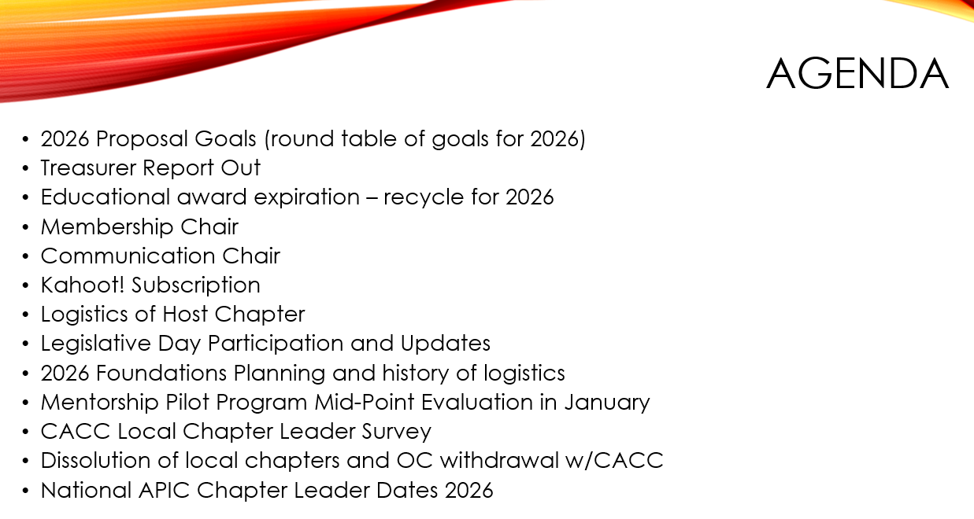
2026 Goals | Jessica discussed the upcoming events and confirmed proposal goals set in January. The BOD agreed nothing to add or remove. Approved by Krystal and Stephanie.  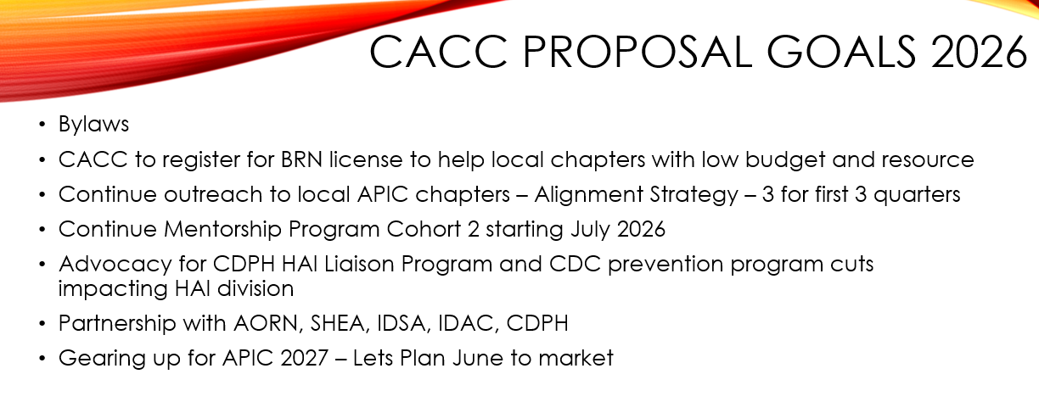
Treasurer Report | The board approved a 20% repayment incentive on chapter dues, which would total $858 if all criteria were met. They agreed to require at least one board leader attendance at three alignment strategy meetings per year and five member attendances per local chapter at CAC quarterly events. The board also approved an educational award of $10,000 from foundations. Approved by Stephanie (first), Krystal (second) and Jarrod (third).  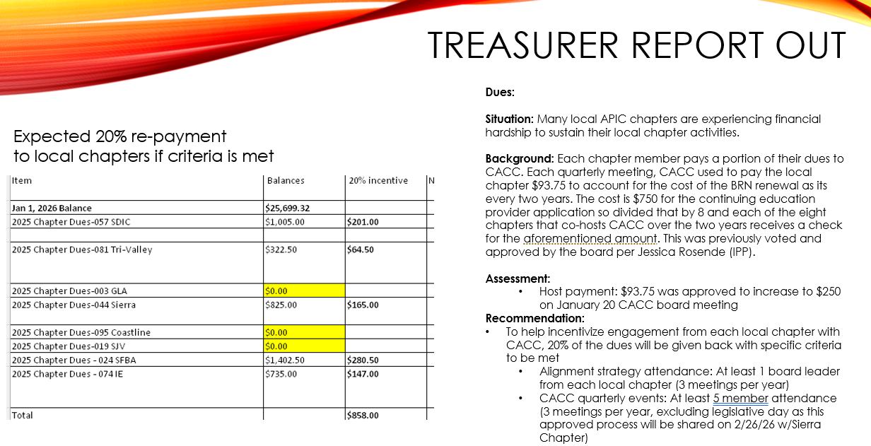
Educational Awards | The board approved an educational award of $10,000 from foundations. Jessica discussed the naming of awards for next week's event, noting that only one is named after Marguerite Jackson. The rest of the award can be named “Foundations Education.” Approved by Kristyn (first), Stephanie (second) , Krystal (third)  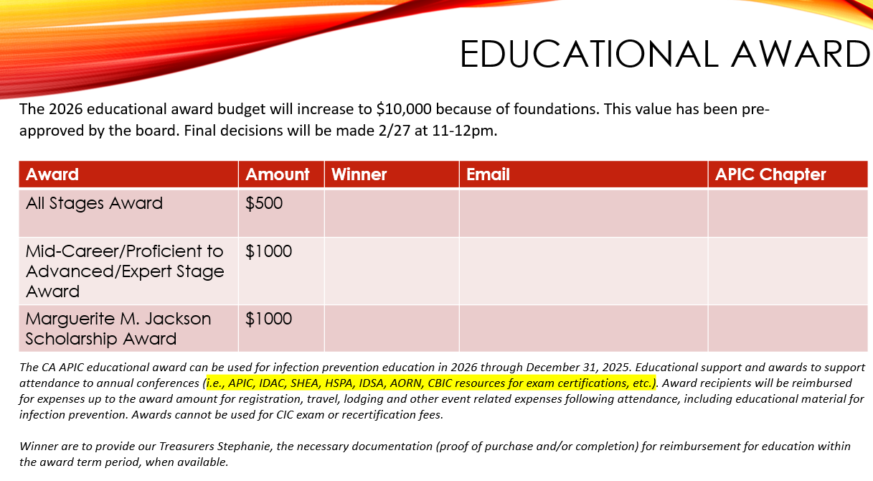
Membership Report | Alicia sent the roster member report some updates are needed.  Jessica and Maricar will work on the email distrubution list for members. Email updates for local chapters will be sent on Tuesday or Wednesdays for high response and view rates.  Jessica addressed the issue of Orange County members wanting to remain connected with California APIC, deciding to provide them with newsletter updates and event information, but not access to educational awards, CEU/IPU, mentorship programs. Jessica and Krystal discussed enhancing communication with local chapters and praised Jarrod for updating the website, though they needed clarification on how the mailing list link functioned.  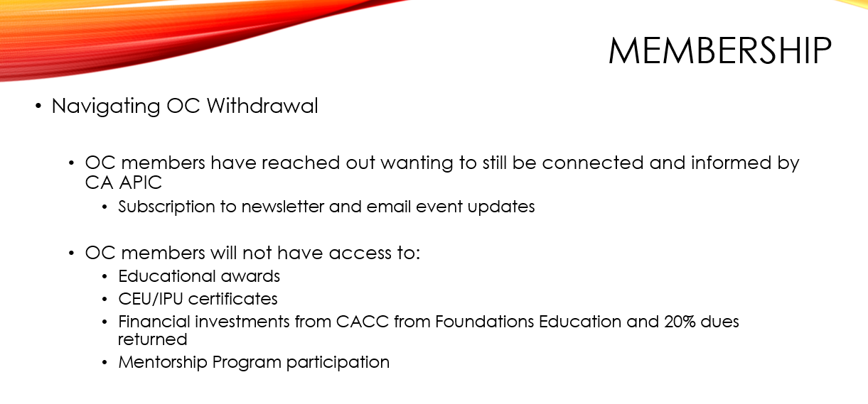  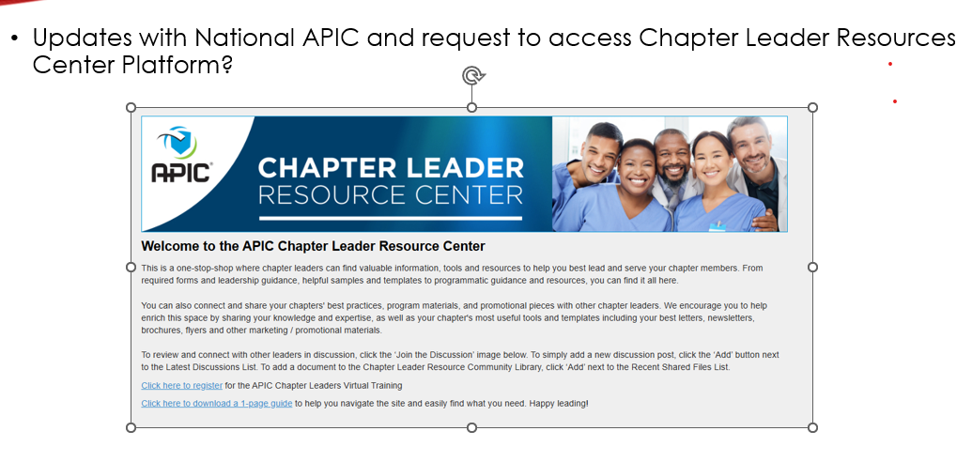  Jessica updated the group on the dissolution processes of Tri-Valley and San Joaquin chapters, noting challenges in obtaining guidance from National APIC. CACC are not to announce chapter dissolution until the chapters confirmed, per their request.  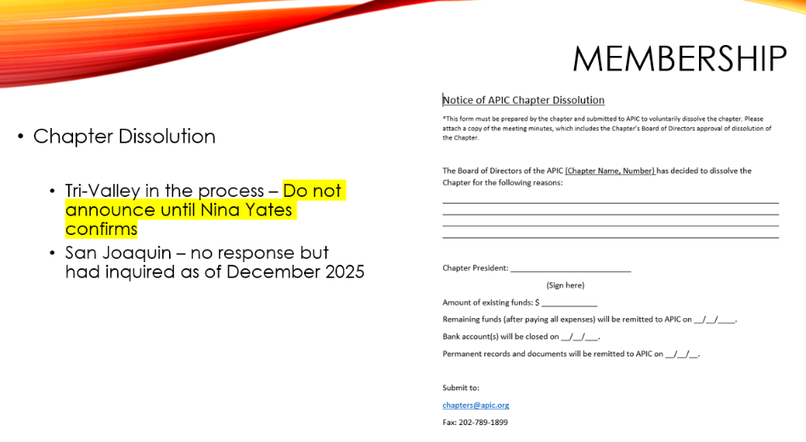
Communication | The team discussed updating distribution lists for local chapters and agreed to have Maricar reach out to Alicia for member information. Jessica proposed changing the email distribution day from Friday to Tuesday or Wednesday, citing research that emails are more likely to be read on those days.  
Kahoot | Jarrod was tasked with following up with Sierra regarding the user agreement for Kahoot. Jarrod to follow up with Christina if Sierra chapter is still interested  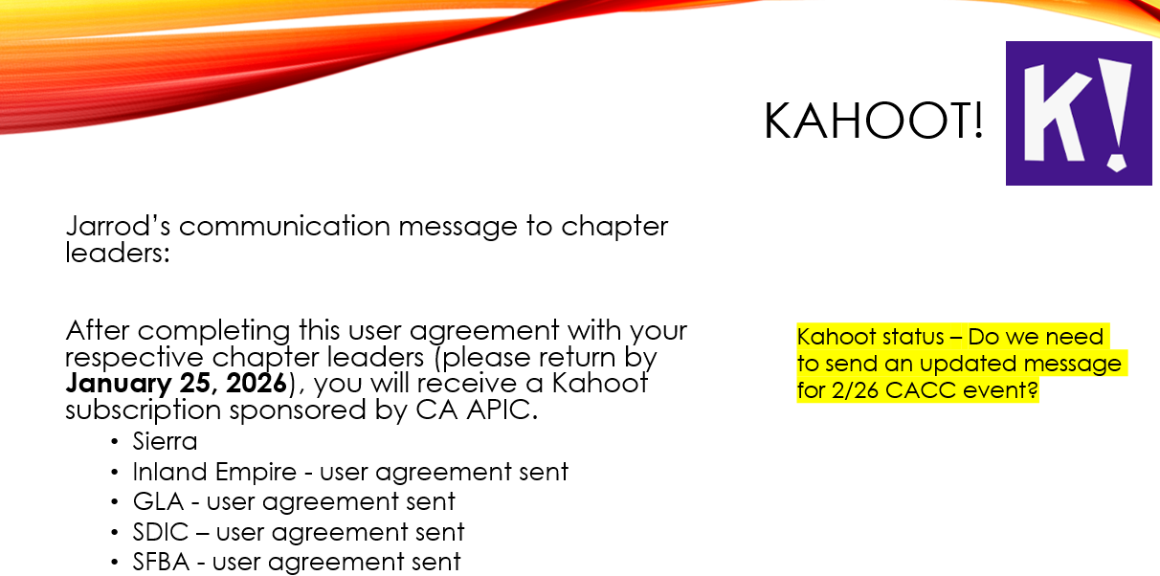
Legislative Day | The group also reviewed plans for Legislative Advocacy Day, including Dr. Epson's invitation for HAI program leadership and Jessica Rosende's promise to provide participant updates by Thursday.  Jessica also mentioned that Krystal will be her backup for the legislative day event (Jessica will confirm if TJC will conduct survey at their hospital by Monday morning 2/23) , and Sejal will lean in to co-lead as Jessica Rosende cannot attend.  Kate was asked about dinner and breakfast arrangements for the 24th. The group discussed dinner arrangements for an upcoming event, with Kate suggesting Zocalos for the venue. Jessica agreed to connect Kate with Christina to confirm which board members from the host chapter would attend, with an estimated attendance of around 15 people.  Kate presented the current status of vendor sponsorships for 2026, noting that most slots are filled with only two remaining for August 14th. She confirmed receipt of a $500 sponsorship from Bravida Medical and mentioned that she would email all sponsors with finalized information.  Jessica clarified that breakfast would be provided at the Capitol steps, with vendors bringing food in a wagon as historically table setups were discouraged. A quick “grab-n-go” to eat for breakfast is best.  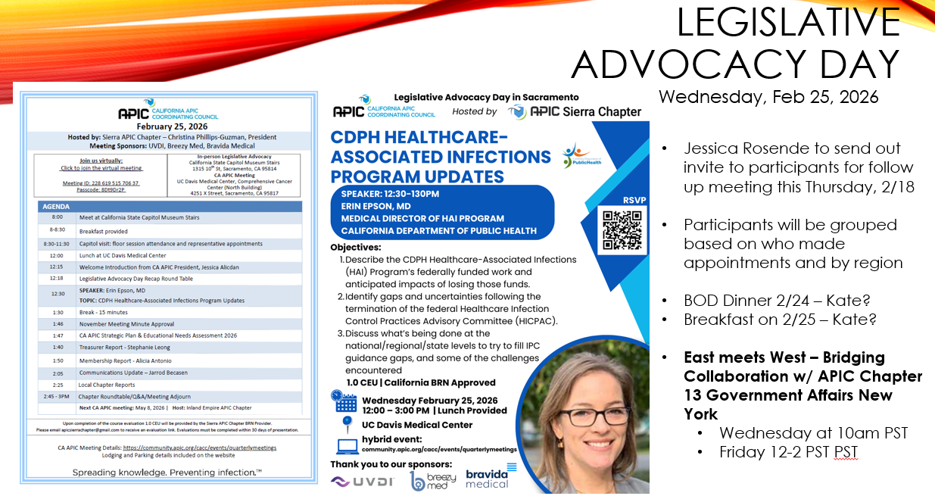  New York Chapter 13 Government Affairs would like to collaborate with California APIC Coordinating Council. Meeting to take place week of 2/23.
Foundations | The team discussed the upcoming Foundations planning event, which will be led by Anjali and Jonathan for the first time. Frank, Anne-Marie, Maggie, Mamta, and Jared will support the event, with Frank, Anne-Marie and Maggie teaching for the last time. The team plans to hold an open nomination on March 2nd. The Foundations course will be a 3-day virtual event spread across 3 weeks, likely scheduled for late September or early October, avoiding holiday planning conflicts.  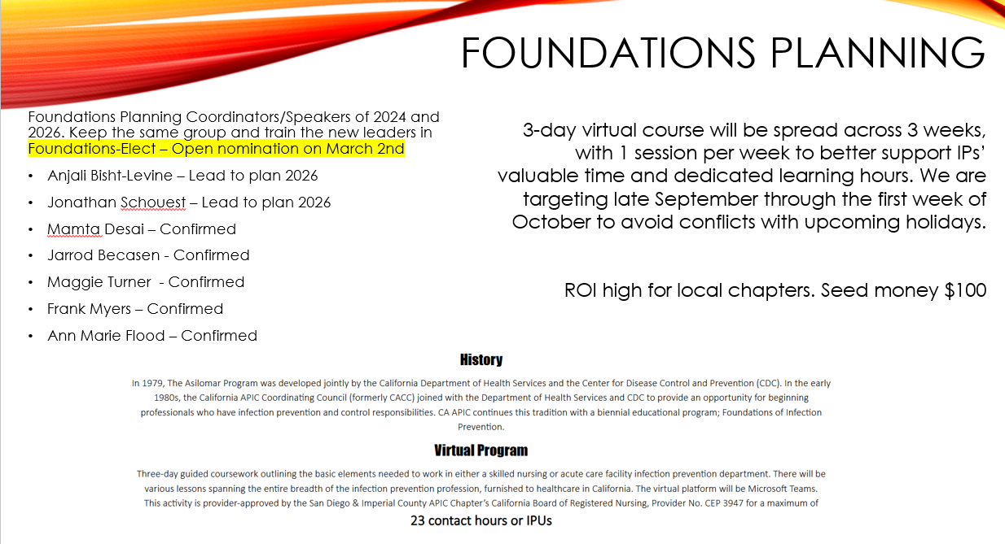
Mentorship Program | The meeting focused on the midpoint evaluation results of the mentorship program, which started in June/July 2025. Krystal presented data showing that while most participants rated their experience positively, there were challenges with mentor-mentee connections in some groups. The team discussed potential improvements for future cohorts, including providing clearer structure and examples of meeting schedules while maintaining flexibility. They also considered ways to better screen and select mentors, noting that participants who signed up to be mentors generally wanted to participate.  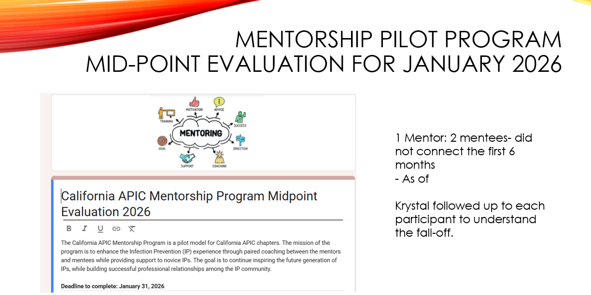  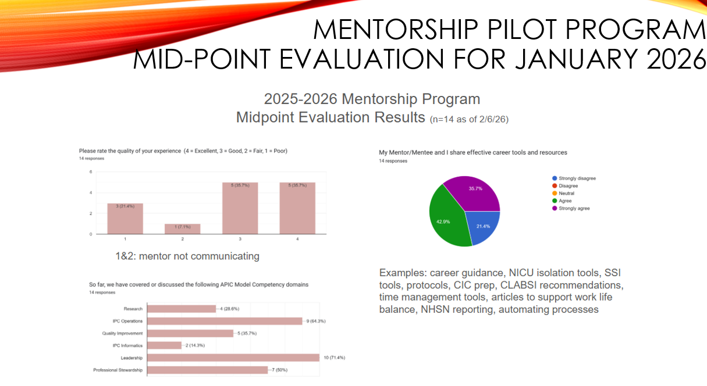  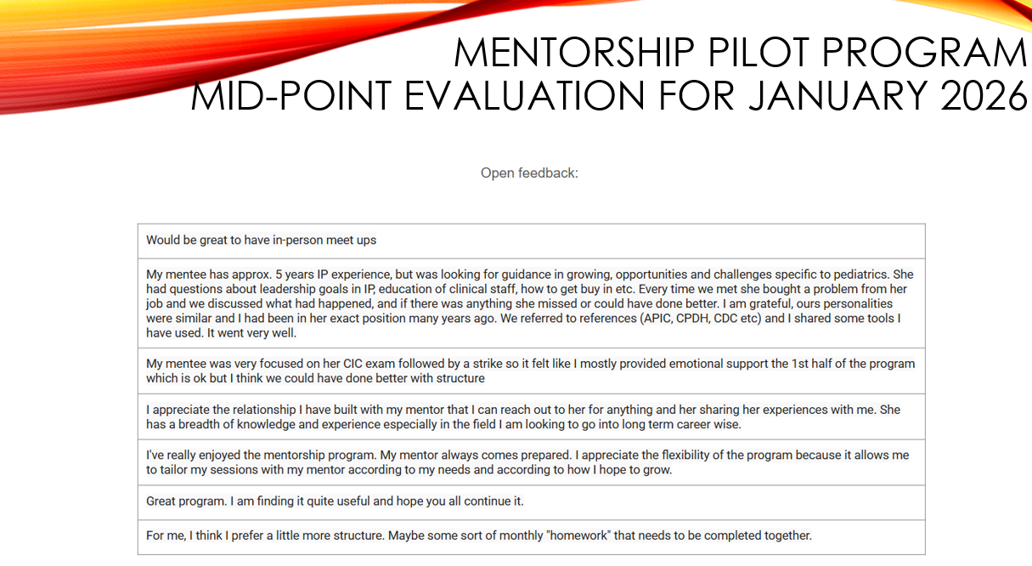
Updates | The team discussed CACC updates and educational opportunities for local chapters. Krystal agreed to reach out to Diksha about presenting CACC updates at the GLA monthly meeting. Each local chapter should have a slide for their chapter meetings to relay CACC and National updates
May CACC Meeting Planning | Jessica also shared that the Inland Empire board was excited to host an upcoming May event, having already booked the auditorium and selected catering. Jessica, Alex, and Kristyn confirmed speakers for an upcoming May event, including Aryeh and Kristyn presenting on catheter-associated bloodstream infection prevention “Mission Control”. Kristyn agreed to cover accommodation costs for Aryeh perhaps carpool, who will be speaking at the event. Alex is waiting to confirm a second speaker, a physician who gave an impactful presentation on Foley catheters at a nursing conference and strong advocate to patient safety and IP advocacy.
Chapter Leader Day | 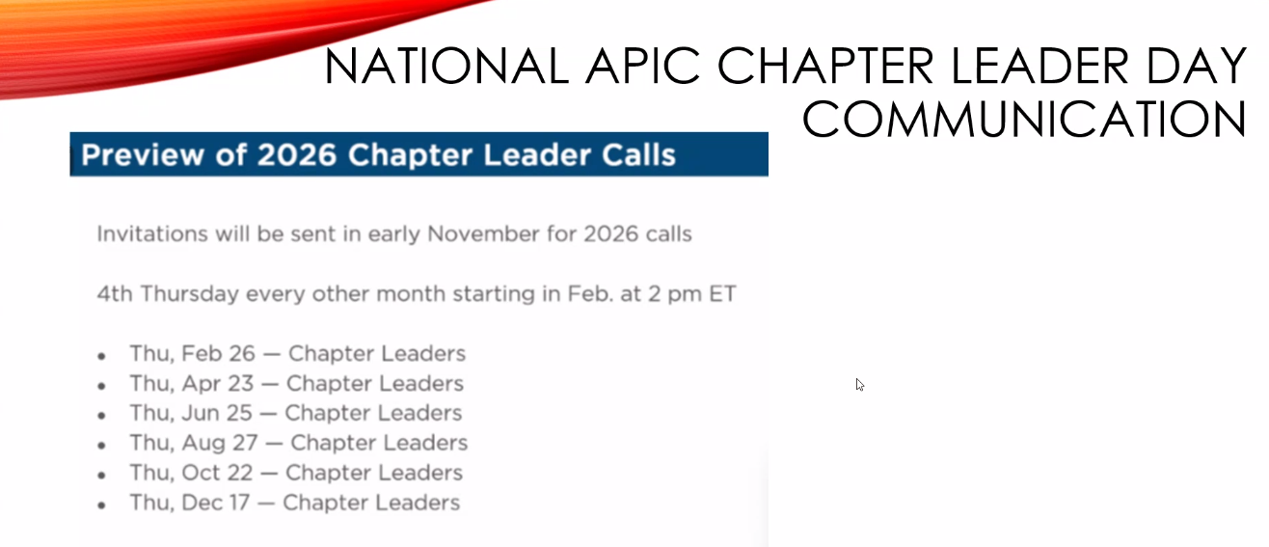  The next National APIC meeting was scheduled for April 23rd, and the group's next meeting was set for March 17th.
2026 CACC BOD Meeting Dates | 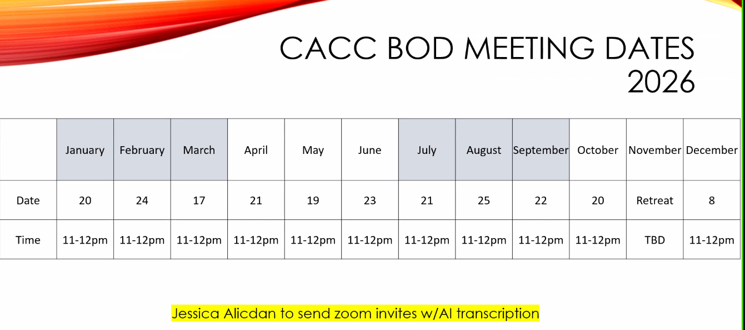  Jessica to forward invites to Alex as they were sent before her election term
2026 CACC Event Dates | 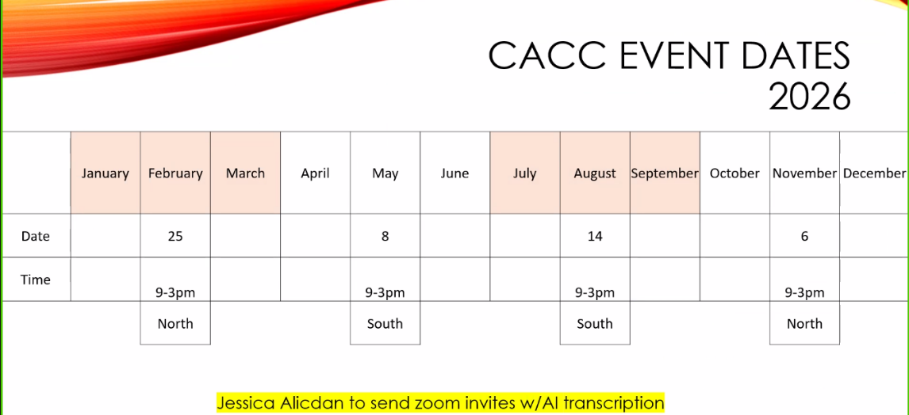
Meeting Adjourned | 12:00 pm
Next Board Meeting | March 17, 2026 11-12PM

Submitted by: Maricar Telmo Secretary
Edited by: Jessica Alicdan President

