CA-APIC Quarterly Meeting- Virtual
August 8,2025
Jessica Alicdan, President
Meeting details
Attendance | As per attendance record.
Old business | None
Welcome Introduction | Jessica A. started meeting at 0930.  Summary of the agenda , housekeeping , bathrooms and QR code for attendance.  Speaker presentation arrangements for Dr. Hudson 11:20 am moved up to 11:05am.  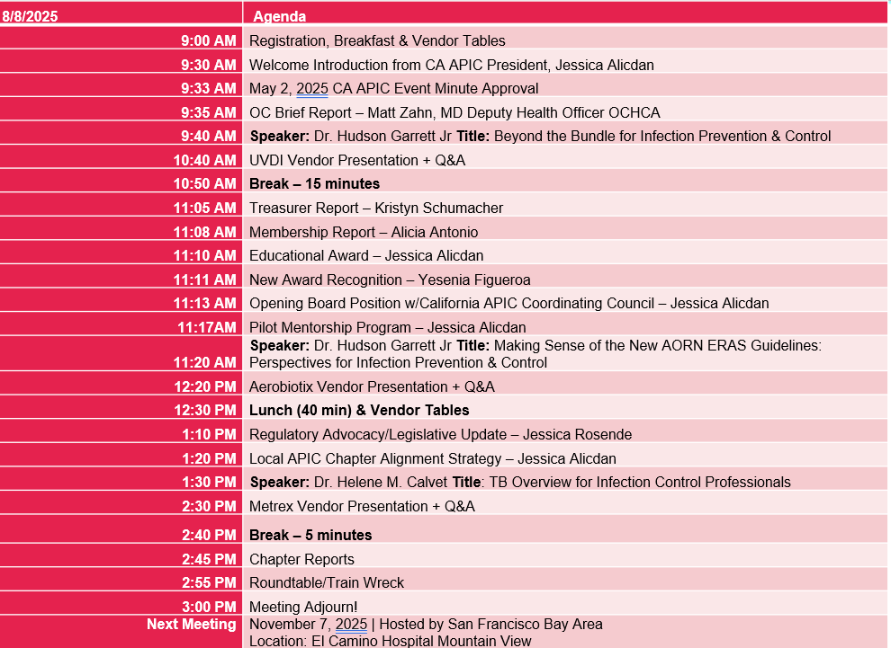
May  Meeting Minutes | Reviewed and approved.  Krystal Smith made a motion to approve, Emily Barnard seconded.  No objections.
OC Brief Report | Emily Barnard gave tribute to Dr Matt Zahn highlighting his contributions to public health and community collaboration. Dr Zahn is leaving his position as Deputy Health Officer OCHCA and transitioning to Children’s Hospital of Orange County
Speaker | Speaker Topic: Beyond the Bundle for Infection Prevention & Control  Presented by : J. Hudson Garrett Jr., Ph.D., MSN, MPH, MBA, IP-BC, PLNC, CFER, AS-BC, VA-BC, CAIP, CMRP, HACP, HACP-IC, LTC-CIP, CIC, DICO-C, CPPS, CCHR-S, CPHQ, CVAHP, CPXP, CDIPC, CPHRM, CHIPP-B, FACDONA, FAAPM, eFACHDM, FAPIC, FAOM, FRSPH, FNAP, FAHVAP, FACHE, FSHEA, FIDSA
Vendor Presentation | UVDI presented by Kristen Ruinard
Speaker | Speaker Topic: Making Sense of the New AORN ERAS Guidelines: Perspectives for Infection Prevention & Control  Presented by : J. Hudson Garrett Jr., Ph.D., MSN, MPH, MBA, IP-BC, PLNC, CFER, AS-BC, VA-BC, CAIP, CMRP, HACP, HACP-IC, LTC-CIP, CIC, DICO-C, CPPS, CCHR-S, CPHQ, CVAHP, CPXP, CDIPC, CPHRM, CHIPP-B, FACDONA, FAAPM, eFACHDM, FAPIC, FAOM, FRSPH, FNAP, FAHVAP, FACHE, FSHEA, FIDSA
Vendor Presentation | Aerobiotix presented by Chris Remala
Treasurer Report: Kristyn Schumacher | Checking Balance:  April balance: 33,840.15  May balance: 33,840.15  June balance: 31,967.60  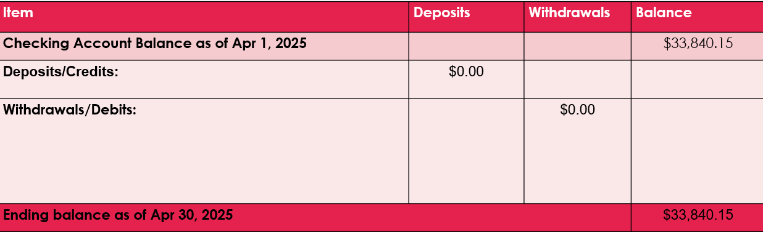  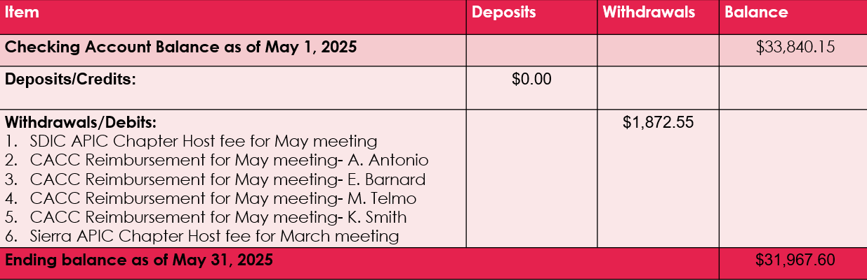  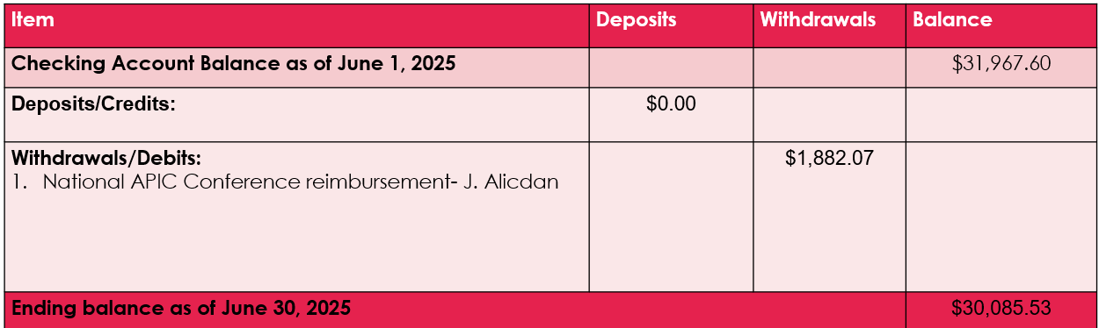
Membership Report: Alicia Antonio | CACC July members: 972  Alicia reported that with big improvement with the numbers compared to the last meeting .  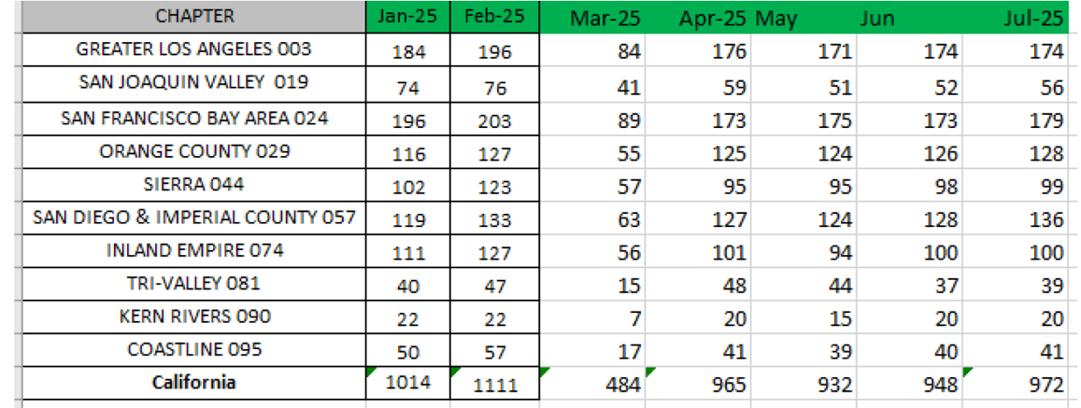  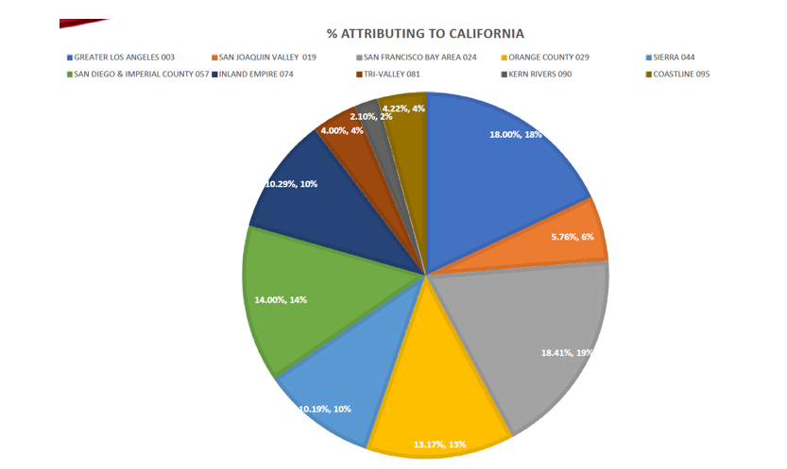
Educational Awards Recipients | 3 recepients  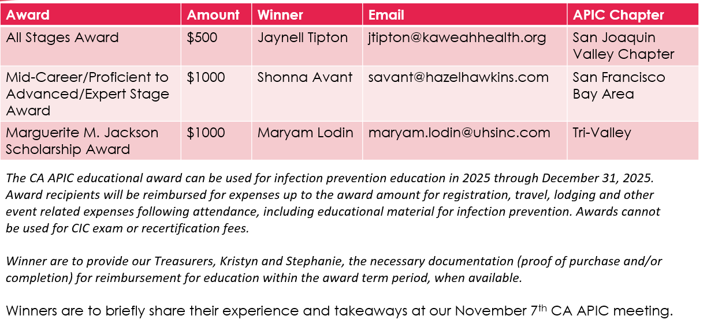
Award Recognition | Presented by Yesenia Figueroa . New award recognition is an award to be given to recognize those that have served in the board and that are willing to sever the board . Board members already approved this award recognition . CACC members will have to vote if we can allot a budget to ensure we have the ability to purchase the plaques or maybe mugs from APIC store for a minimum cost . Voting survey will be sent out to members.  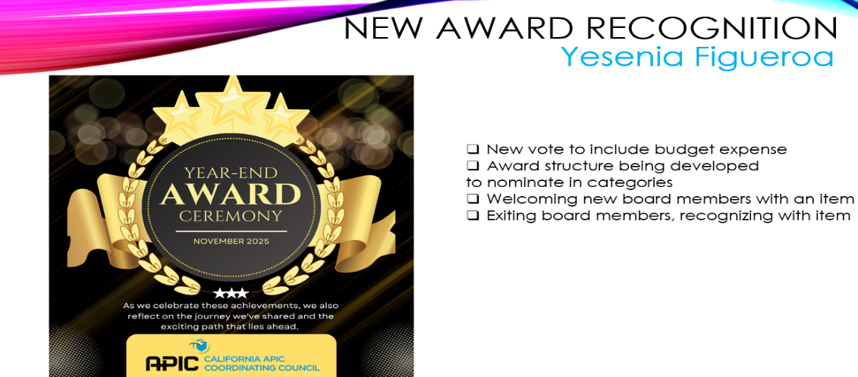
BOD Open Position | Announced by Jessica Alicdan 3 open position  
Pilot Mentorship Program | Jessica Alicdan reported about the mentorship program  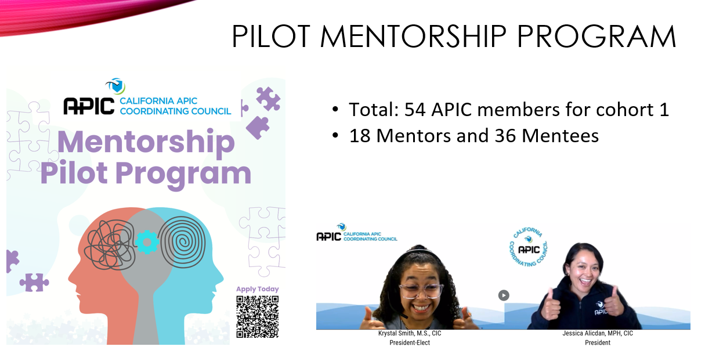
Vendor Presentation | Aerobiotix presented by Chris Remala
Regulatory Advocy/Legislative Update | Reported by Jessica Rosende encouraging members to the survey for Legislative Day in Feb. 2026.  
Alignment Strategy Report | Jessica Alicdan reported about the June 24,2025 alignment meeting and discussion of CACC obtaining BRN # CE provider that all chapters can use and how to create more engagement among APIC members and new members.  Next Alignment Strategy meeting 10/23/25.  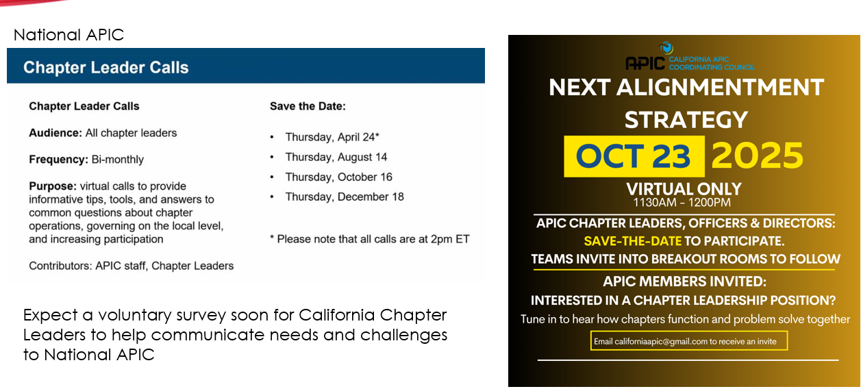
Speaker | Speaker Topic: TB Overview for Infection Control Professionals  Present by: Dr Helen Cavet
Vendor Presentation | Metrex presented by Jake
Chapter Reports | Coastline: Aug 15,2025 Annual Conference  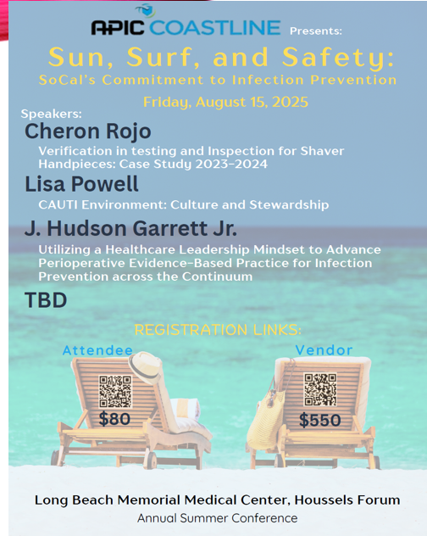  Greater Los Angeles: reported by Wanda  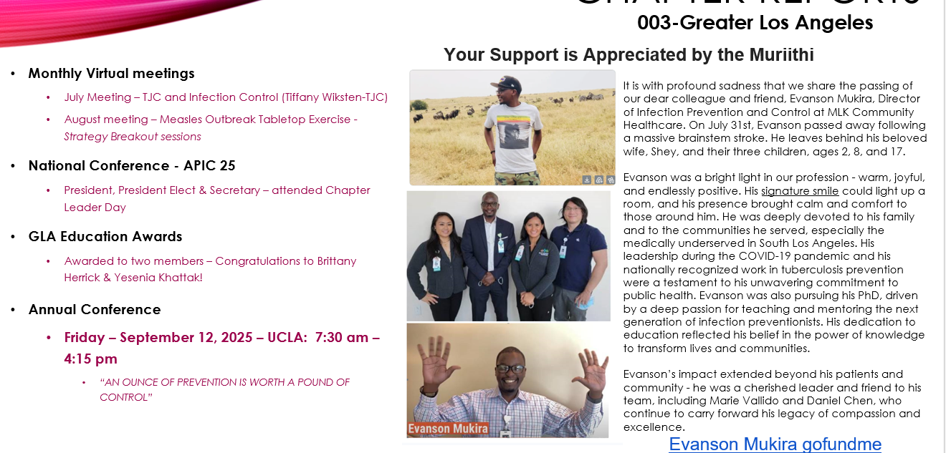  Inland Empire: no report  Orange County: Emily B. reported  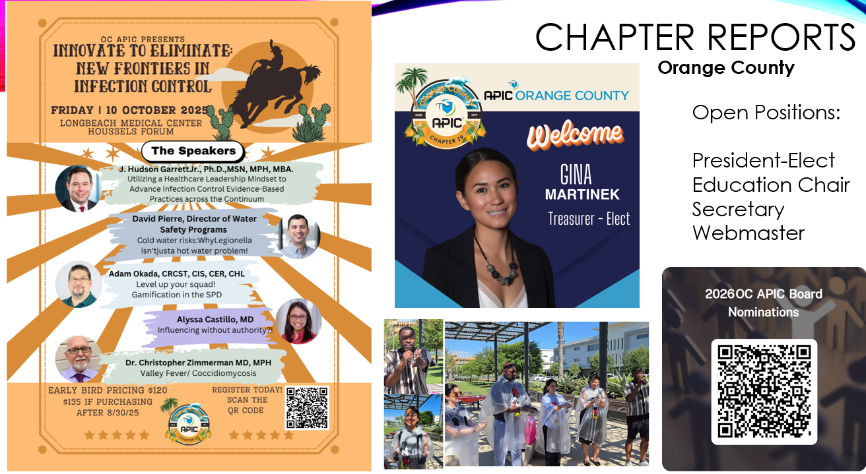  Kern County: no reports  San Diego: Frank Myers reported    San Joaquin County: will be hosting the CACC educational series in Oct. with Maureen Spencer as speaker  Tri-Valley: Nina reported that chapter awarded 1 education recipient, they will have Fall conference and holiday luncheon at Sherman Oaks  San Francisco: reported by Maricar T. LTC-CIP Review class for SNF IP was successful, 8 open positions for 2026 BOD, Dec. 10, 2025, Annual Product Faire free for members and Nov. 7 SFBA will host the CACC meeting.  Sierra: Quarterly meeting is ongoing, and annual conference will be West Sacramento offering 6.5 IPU’s. They are also rebuilding their website. Jessica A. mentioned that National APIC also does website redevelopment.
CACC Advocacy Update | Biohazard Waste CACC letter was sent to National APIC, CA Hospital Association, CA Ambulatory Association and CDPH , only CDPH responded .  Jessica will send another email and include other higher leaders.
CEU/IPU | 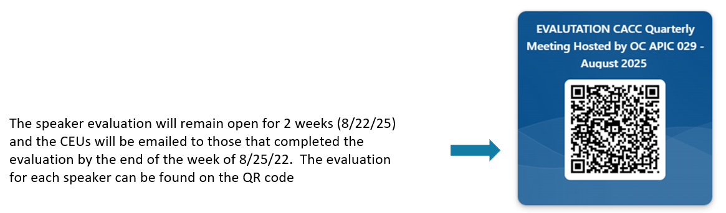
Meeting adjourned | The business meeting ended @ 3pm
Next Meeting | Nov. 7, 2025, hosted by San Francisco Bay Area Chapter – El Camino Hospital MV

Submitted by Maricar Telmo 8.11.25

