2025 Bi-State Infectious Disease Conference

Renaissance St. Louis Airport Hotel
Friday, October 3rd, 2025
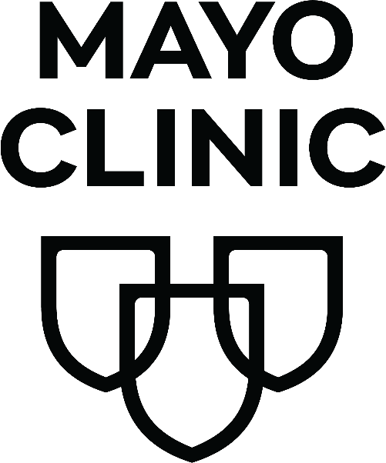

7:15 – 7:30 |  | Registration
7:30 – 8:00 |  | Continental Breakfast/ Vendors
8:00 – 9:00 |  | Session 1: Kansas City TB Outbreak (Matt Shoemaker)
9:10 – 10:00 |  | Session 2  Infection Prevention/ID Focus: Candida auris (Megan Dethloff/Patrick Reich [Intro], Tina Bui-Bullock [Lab], Linda Behnen and Tanner Martine [Home Health], Carlee Hoxworth [Inpatient IP])  Public Health/Epidemiology Focus: NREVSS (Jessica Goswitz)
10:00 – 10:30 |  | Break/Vendors
10:30 – 11:30 |  | Session 3  Infection Prevention/ID Focus: CAUTI prevention - Urine Management and Culture Contamination (Jen Jaffe)  Public Health/Epidemiology Focus: STL County E. coli outbreak (Adrienne Merriweather, Sami Friederich and Bridget Edgerton)
11:30 – 1:00 |  | Lunch and Mark Barnes + Committee “Entertainment”/ Networking and Vendors  - Identify the bug contest  - Coloring contest
1:00 – 1:50 |  | Session 4  Infection Prevention/ID Focus: Tick-Borne Illness Trends (Dr. George Turabelidze)  Public Health/Epidemiology Focus: Partaking in Missouri's Syphilis Elimination Strategic Plan (Allie Bodin)
2:00 – 3:00 |  | Final Session: Dr. Steve Lawrence

Room Set-ups:

