Instructions to View Info Blasts on the Delaware Valley & Philadelphia APIC Website

- Go to: https://community.apic.org/delawarevalleyphiladelphia/home



- Please sign in to see member only content. Click on this blue button to progress to the login screen.



- Below is a snapshot of the login screen.
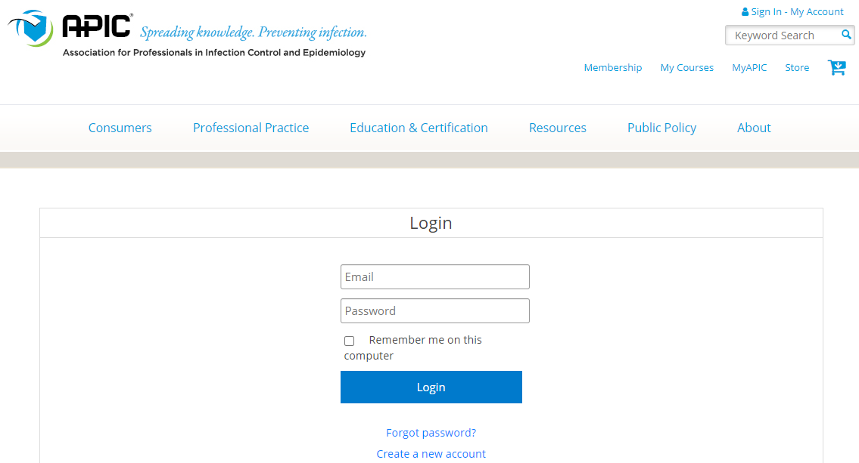

- Enter your email (the email you use for your APIC login) and your APIC password. It will then transport you to the home page. You are signed in when the login button is gone and replaced by your icon.



- Next, you will move your cursor over the Members Only section and click on the drop-down menu.

- Move your cursor down until you locate “Info Blast” and click once. The most recent Info Blast should be viewable at the top and you can scroll through the previous updates.


