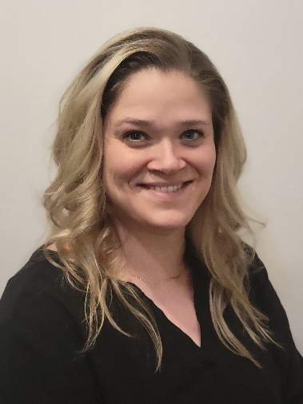
Kayla has worked in long-term care since 2006, beginning her career as a CNA and advancing to a master’s prepared RN. In 2014, she accepted the role of Infection Preventionist/Staff Development Nurse at Valley Senior Living, a 196-bed facility. As regulations and expectations for infection prevention in long-term care evolved, the position was later split, allowing Kayla to dedicate her full attention to Infection Prevention.
In addition to her role at Valley Senior Living, Kayla has been actively involved at the national level. She served on the Long-Term Care Test Development Committee with CBIC in 2021, worked as an Item Writer for the CBIC Long-Term Care Committee in 2022, and participated in the APIC Long-Term Care Staffing Calculator Focus Group in 2024. Kayla also serves as APIC Faculty and Consultant, teaching courses such as Long-Term Care Infection Prevention Essentials and a multi-week North Dakota LTC-CIP coaching course. She has been a member of her local APIC chapter since 2014 and served as Committee Chair in 2022 and again in 2026.
Kayla has additionally worked as an Adjunct Clinical Instructor, sharing her passion for long-term care with the emerging licensed workforce, and has previously served as a CNA test proctor for the state of North Dakota.

