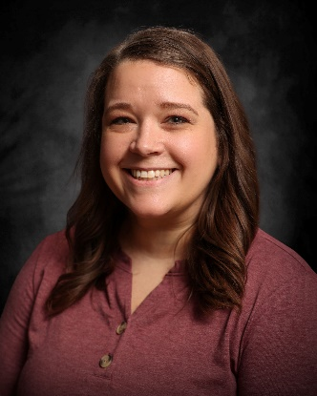
I’m Katie Tofteland, I’m a nurse at SMP Health – St. Andrew’s in Bottineau, ND. We’re a 25 bed critical access hospital with a clinic attached. As the only Infection Preventionist, I’m in charge of all areas. We have 15 patients who live with us permanently in non-skilled swing bed. We also have acute, skilled swing bed, and observation patients on the floor. We have an ER, cardiac rehab, OR for outpatient procedures, and do a lot of outpatient services like IV infusions, wound vacs, etc. I’ve been here for 14 years and still help out in all areas. Before I moved here, I worked at Trinity Hospital in Minot, ND, for 2 years on their Ortho/Oncology/Neurology floor. Outside of work, I have 2 kids, Gus who is 8 and Ellie is who 3. Our lives are spent running to all the sports. My husband is the Game Warden up here, so we spend a lot of time outside as well.

