Quarterly Business Meeting
Friday, February 14, 2025 at 11:00 a.m. via Teams

CALL TO ORDER: 11:02 a.m. by A. Christenson

ROLL CALL
Present:
- Anna Christenson | - Jessica WIngen
- Tracey Sherman | - Kate Westphal
- Jenna Bredahl | - Katla Porter
- Jennifer Hartleib | - Erica Loegering
- Sarah Jacobson | - Tiffany Peterson
- Katie Pierce | - Jordan Taghon

APPROVAL OF MINUTES: Minutes of the November 15, 2024 meeting were emailed to the members for review. T. Peterson made a motion to approve, seconded by A. Christenson. Minutes approved.

STANDING REPORTS

Legislative Updates
Legislative update prepared and presented by T. Sherman. Detailed review of state updates (SD, ND, MN) and national updates. See attached report.

Chapter Membership
A. Christenson provided an update. Chapter membership is currently 59 members.

Treasurer’s Report
Calendar year 2024 financial summary provided by T. Peterson. Report approved.
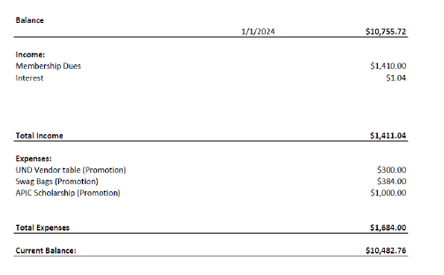

Chapter Education Plan
No report. No education planned for today.

Nominating Committee
One open chapter position:
- President-Elect: serves as President-elect through 2025 and to assume the President role in 2026. J. Bredahl nominated Anna Christenson, seconded by T. Peterson. Motion passed.

OLD BUSINESS
Chapter Dues
Increased to $25.00. Kayla Porter shared she recently renewed and the chapter fee was $15.00. Discussion of changes at national APIC and this may have delayed the implementation.

NEW BUSINESS
APIC Dacotah Plains Chapter Conference
September 2025. Discussion of pros and cons of early/late September and different days of week. Preference to have in early September. No objection to mid-week conference. Labor Day noted to be September 1, 2025.

The meeting was adjourned at 11:24am.

Respectfully submitted,
Jenna Bredahl, RN BSN

