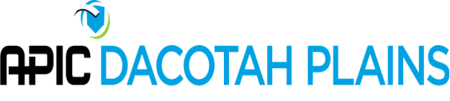
APIC Dacotah Plains Board Meeting Agenda
2:00 p.m.- September 13th, 2021
Launch Meeting - Zoom

- Roll Call
  - Jenna B, Susan Z, Shannon H, Carra H, Amanda S, Lisa O
- Approve Minutes
  - Both minutes from the board meeting as scheduled and special meeting to approve education reimbursements for APIC Virtual were presented. Jenna-Motion to Approve Minutes as written were made, Lisa O second. After opportunity to discuss, motion carried.
- Education
  - Shantel Badlands INC.-Shantel had reached out to Badlands Health and Human Svc. Center for education per the discussion at the last board meeting. She never received a response back. Offered to continue to pursue this education if still wanted.
  - Shannon has education booked through the rest of the year. Shantel, Susan and Stephanie will be on the list to present for next year.
- APIC National Conference
- Next year Conference
  - Discussion held regarding should we at least plan on virtual vs. in person. Lisa to pursue looking at platforms that put on virtual events. Education and vendor booths. Reach back to Minnesota APIC chapter to see what platform they are using and how well their virtual went. Link to the Minnesota APIC virtual conference was provided by Shannon Hansen.
- Upcoming elections
  - Jenna, President Elect will become president. Secretary, Education, Legislative, Membership will all be up for election. Willingness to Serve document will be revised by Susan Ziemann and sent out the beginning of October.
- Webinars
  - CIC prep course 9/24/21 will be attached to the agenda per Lisa.
- Mini education
  - Education will be attached the agenda per Lisa.
- CIC study groups
  - New prep course coming up via APIC
- Membership
  - Lengthy discussion held about how to communicate with members. Difficulty making lists out of the excel file with certain email formats. Jenna to add that to the list of things to follow-up with national in order to see if there is a simpler way to send lists to the whole group since using the mailer through the site does not allow links to be sent.
- Mentoring
  - Talk about using the IP Talk as a mentor platform.
  - Discussion held about facilitating a formal mentoring program, APIC has a structured program.
  - ND specific APIC “information for the novice IP” resource development packet
- APIC Talk
  - Lengthy discussion about use of the chapter APIC talk. Emails are coming through, but the last use was in the last month. Suggested that board uses the talk board for communications. MEMCHAP Dacotah Plains Digest. Educate on this email subject line so emails stand out better. Jenna to email national and ask if there is a way to change that subject line.
- Link for Friday Meeting-Lisa will send a zoom link later today or tomorrow morning for Friday.

