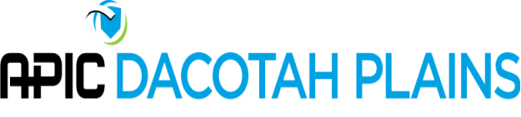
APIC Dacotah Plains Board Meeting Agenda
2:00 p.m.- Monday, February 8, 2021

- Introduction and Roll Call
  - Jenna Bredahl, Shantel Klym, Coleen Bomber, Shanon Hansen, Lisa Orlando, Susan Kringlie, Melanie Krabseth, Amanda Serfoss
- Approval of minutes – December 2021
- Old business
- New business
  - Membership chair- Needs replacement. Put on the agenda for the chapter meeting to see if someone was interested.
  - Leadership Calls-option to email the entire chapter from the website. Shannon going to call to see if these tools could be a presentation. Sending out invites to get onto peoples calendars.
  - Education- Purewick and Wifi bladder scanner
  - Change to website r/t fall conference
  - Consider doing some support group things. There are some things through national APIC
  - Discussion about COVID policy
- Via Teleconference (855) 640-8271 Participation code: 54529959# (Chairperson Passcode: 40050190#)

