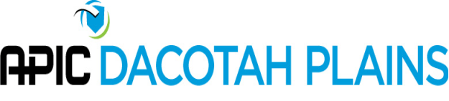
APIC Dacotah Plains Board Meeting
9:00am (CST) – December 4, 2020
Via Teleconference

Call to Order: 9:10 a.m. by Lisa Orlando

Introduction and Attendance
Present via phone:
- Lisa Orlando | Western Horizons
- Coleen Bomber | Northwood Deaconess
- Sue Niebuhr | Trinity Health
- Pam Remington | Trinity Health
- Jenna Bredahl | Jamestown Regional Medical Center
- Shantel Klym | CHI St. Alexius Dickinson
- Sue Ziemann | CHI St. Alexius Bismarck
- Shannon Hansen | Altru Health System

- Approval of Minutes:
Tabled.

- 2021 Meeting Calendar:
The board members present discussed the meeting schedule and decided to keep the existing chapter meeting schedule of the 3rd Friday of February, May, September and November. Meetings are held at 11:00am. The 2021 chapter meeting dates are as follows:
  - February 19, 2021
  - May 21, 2021
  - September 17, 2021 (subject to change depending on Fall Conference)
  - November 19, 2021
Chapter Board meetings discussed and decision made to hold board meetings on the 2nd Monday of February, May, September and November. Meetings are held at 2:00pm. The 2021 board meeting dates are as follows:
  - February 8, 2021
  - May 10, 2021
  - September 13, 2021
  - November 8, 2021

Suggestion to post meeting dates on website and link to calendar. J. Bredahl to determine if the website has the capability to send invites/reminders to chapter members.

- APIC Leader Calls
L. Orlando discussed board participation in APIC Leader Calls. Suggested sharing the responsibility of joining calls. Agreement that increased communication in the new year to determine who will be participating in the calls.

- COVID-19 Impact Survey and Chapter Needs Assessment Survey
This survey is designed to illuminate the magnitude of the pandemic's impact on individual chapters, as well as the chapter network at large. It will also help us gather feedback regarding your chapter's needs and current satisfaction with APIC programs and resources. The 2021 survey will not be scored.
L. Orlando reported this has been completed.

- Education Programs
The education option planned for today is a pre-recorded webinar on vaccines. The 1:00pm education session may be canceled as members can view this on-demand. To be discussed at the chapter meeting.

- APIC Dacotah Plains Recruitment
L. Orlando discussed a survey to assess hurdles to membership. Will plan to work on this in the new year.

- Future Conferences
Discussion regarding Fall Conference being moved to 2021. At this point, it is too early to tell if the conference will be possible. Continue to monitor and discuss.

The meeting was adjourned at 9:50 a.m.

Respectfully submitted,
Shantel Klym

