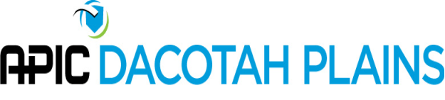
APIC Dacotah Plains Board Meeting
2:00 p.m. – Monday, October 21, 2019
Via Teleconference

Call to Order: 2:00 p.m. by Coleen Bomber

Attendance
Present via phone:
- Coleen Bomber | Northwood Deaconess
- Sue Niebuhr | Trinity Health
- Susan Kringlie | CHI Mercy Health
- Pam Remington | Trinity Health
- Lisa Orlando | Unity Medical Center
- Jenna Bredahl | Jamestown Regional Medical Center

- Chapter Health Survey
  - C. Bomber facilitated the completion of the annual chapter health survey with input provided by members present. Results will be available toward the end of the year. Upon receipt, the results will be shared with the entire chapter and priorities will be established at the following chapter meeting.
- 2020 Conference Update
  - Venue- Ramkota (Bismarck, ND)
  - Speakers/Presentations – L. Orlando to connect with S. Ziemann regarding vendor educational offerings. L. Orlando will also evaluate Minnesota APIC conference for possible speakers/topics.
  - Menu – J. Bredahl will include the Ramkota menu in the attachments sent to the chapter prior to the November 2019 meeting. Menu options will be discussed.
- Next Meeting:
  - The next meeting will be held on January 20, 2020 at 2pm via teleconference

The meeting was adjourned at 3:20 p.m.

Respectfully submitted,
Jenna Bredahl, RN BSN

