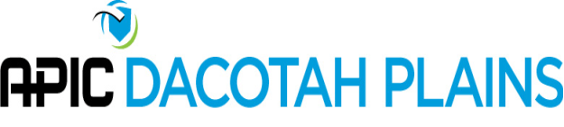
APIC Dacotah Plains Board Meeting
2:00 p.m. – Monday, August 19, 2019
Via Teleconference

Call to Order: 2:00 p.m. by Coleen Bomber

Attendance
Present via phone:
- Coleen Bomber | Northwood Deaconess
- Sue Niebuhr | Trinity Health
- Susan Kringlie | CHI Mercy Health
- Sue Ziemann | CHI St. Alexius
- Lisa Orlando | Unity Medical Center
- Jenna Bredahl | Jamestown Regional Medical Center

- APIC Chapter Leader Call
  - Each chapter is asked to submit what our 2020 dues will be. Discussion. Unanimous vote to stay at $15.
- Gwen Borlaug and next program
  - Will provide education at next meeting (nasal decolonization) and will sponsor lunch. Conference room reserved at St. Alexius, will need catering. Catering options discussed.
- APIC Member Services Committee (MSC) Liaison
  - Each chapter has a MSC Liaison assigned. Coleen received notification about this after the chapter leader call. Our liaison is Aimee Baerlocher. A list of MSC liaisons is attached.
- Website Update
  - All information for upcoming meeting will be added to the website. A link to the website will be sent to the chapter members prior to the next meeting.
- Education/Travel Update
  - No additional requests have been received.
- 2020 Conference Update
  - Plan to have a PayPal account for conference registration. This will be linked through the website. Question if we can have vendor fees paid through website also.
  - Lisa Orlando reported on venue and conference dates. Decision made to hold 2020 Fall Conference on September 18, 2020. Venue possibilities include Bismarck Convention Center or hotel options. Lisa will obtain pricing for venue with catering considerations.
- CBIC
  - In 2020, no re-certification exam required. Option to re-certify through competency assessment process.
  - Coleen completed the Nursing Home Infection Preventionist training through CDC. She reported this was a very good course for IP basics.
- Chapter Leadership Positions
  - The following positions due for re-election in 2020 are:
    - President-Elect
    - Program chair
    - Nominating Committee
    - Secretary
    - Membership chair
- Next Meeting:
  - The next October 21, 2019 at 2pm via teleconference

The meeting was adjourned at 2:30 p.m.

Respectfully submitted,
Jenna Bredahl, RN BSN

