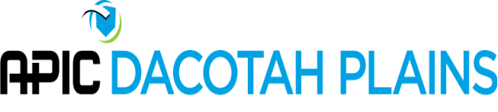
APIC Dacotah Plains Board Meeting Agenda
2:00 p.m.- November 8, 2021
https://apic.zoom.us/j/94804765140?pwd=Uy93alFhZWgzZk1mcEhJcHE3Q05tZz09

- Roll Call- Shantel Klym, Jenna Bredahl, Susan Ziemann, Susan Kringle, Shannon Hansen, Lisa Orlando, Deb Kleven
- Approve Minutes
  - First – Susan Ziemann, Second- Jenna Bredahl
- Next year Conference
  - Jenna – originally, the day that we were wanting was not available. Lisa did check with a few other organizations. Vimeo was not an option related to the price. C-vent Events do LTCA events and there are breakouts available, so Lisa waiting on getting more information back on this. September 16th is the ideal date for online conference. We can move the date to find a time that would be available, Jenna to check on dates near September/October that are available.
  - Susan Kringle suggested that rather than reinvent the wheel, and no one has experience hosting something so large, is there another agency we can partner with to make this go more smoothly. Lisa had a couple contacts (Faye, QIN, Sanford) to ask to see if they have insights on how we can make some of this work. Shannon H to ask UND because they are likely doing some things virtually.
  - Lisa to reach out to more people and have more information to bring to the membership meeting next week to try and make a decision since we are coming to the first of the year. Thoughts also discussed on virtual vendors on how we can do that. Shantel and Lisa shared experiences of how to manage.
  - IT is a large concern among the group and how that looks if someone is having issues, who will be available or able to troubleshoot.
- Upcoming elections
  - Issues with little interest in some of the areas. Secretary, membership, and nominating committee do have some interest. Education, president elect and legislative representation need to have someone run for those offices. Lisa to email the new persons to the nominating committee so they can personally reach out to them and ask if they would be interested in a position.
- Webinars
  - None to report at this time.
- Mini education
  - None to report at this time from Lisa
  - Steripath about blood culture apparatus to reduce BC contamination would like to be involved in an education piece
  - APIC members for 20 minute sessions to take place in February.
  - November has Microbiologist
- CIC study groups
  - Nothing formal within our group to study, but there are other study groups coming out. December is the start date. Spoke about CIC exam helps. Shantel to speak about the scholarship received through APIC.
- Membership
  - Some new members, nominating committee to reach out to see how involved they would like to be in our group
- Mentoring
  - Lisa signed up with ANA to be a mentor, discussed anyone else have interest in doing this for APIC. There are some new IP’s in our chapter who are new to the position. Discussion about how we use the email group, but in the past, this has failed and we have gone to a more informal approach. This has been discussed at past meetings and attendance has been an obstacle. Jenna suggested to continue to offer what we have for membership. If we see that there is great demand, become more formal at that point. Other obstacle is everyone being stretched so thin.
- APIC Talk.

