
Board Meeting Agenda
- November 14, 2025
- Opening & Roll Call
  - Opening at: 1:02PM
  - Attendees: Tiffany Peterson, Megan Compson, Anna Christenson, and Tracey Sherman
- Approval of Minutes: First motion by Tiffany Peterson and seconded by Megan Compson
Approved at 1:08PM
- Old Business
  - Annual Election- Willingness to Serve
- New Business
  - Updated list of board positions- Approved
  - Need an updated list of emails for cross referencing against chapter member email listing
  - Chapter Members
    - 50 members
  - Treasurers Report-Approved
  - 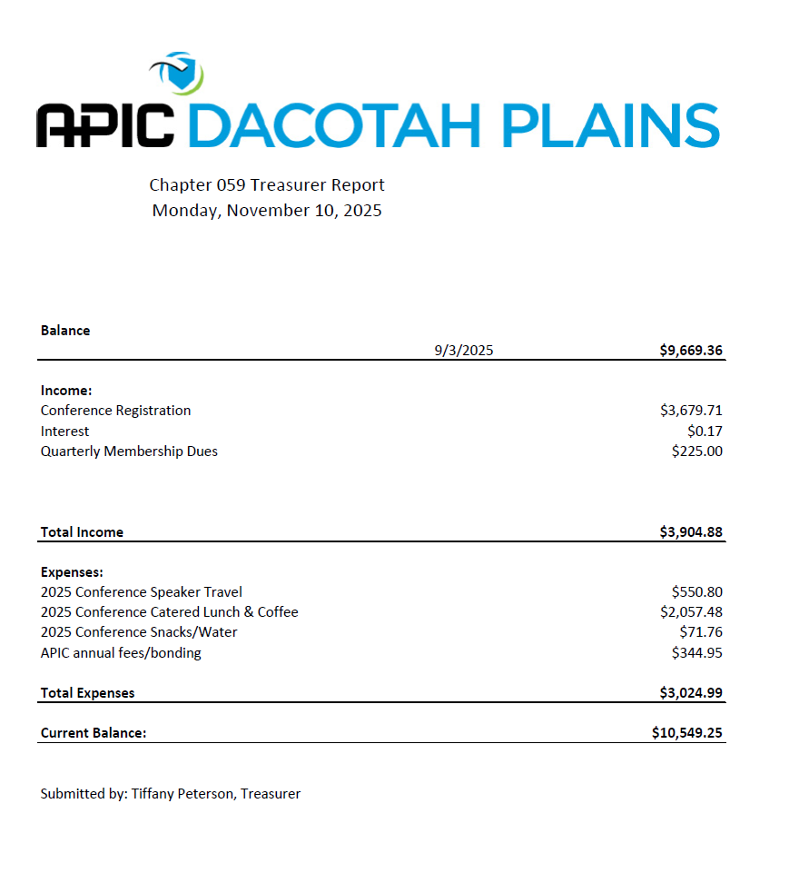
  - Legislative Update
- Adjournment

