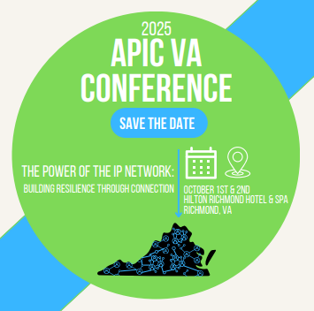
50th Annual APIC-VA Conference
Silent Auction
There will be a Silent Auction Fundraiser during our conference. Please, consider donating an item or basket this year. Bring your items on the morning of October 1st. Bidding will be open all-day October 1st and October 2nd until the 10am break. Winners will be announced at lunch. Payment may be made via cash/check/credit card.
Contact Connie Atkinson with any questions: connie.w.atkinson@vcuhealth.org
Silent Auction donation ideas:
- Food & Drink – restaurant gift card, cooking classes, wine tasting, brewery tour
- Entertainment – concert tickets, sport events, comedy show, movie tickets
- Personal Services – spa retreat, personal training, art/music experience
- Artwork by local artists
- Custom made jewelry
- Photography services
- Lottery tickets
- Fitness – yoga class, gym membership, home workout equipment
- Online classes – The Great Courses Plus and Masterclass
- Oil change or car wash
- Theme Park tickets
- Stationary
- APIC merchandise
- Themed baskets:
- Local hometown goods sampler  - Wine lovers  - Chocolate lovers  - Spa/pampering goods  - Coffee enthusiast  - Outdoor adventure  - Book lovers | - Family fun night  - Gardening  - Movie night  - Date night  - Beach/pool party  - Rainy day basket  - Dog pampering

 |  | 