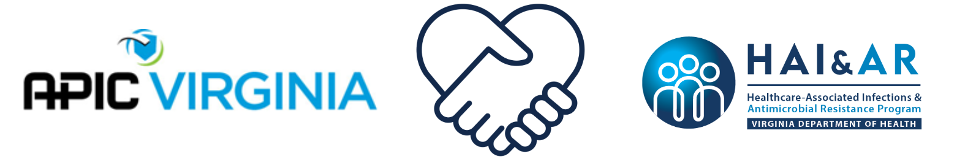

APIC Virginia & Virginia Department of Health
Infection Preventionist Mentorship Program FAQs

Why should I become a mentor or mentee?
- Be a part of an innovative program that is reciprocal in nature. Both mentors and mentees share and learn from each other equally! An added bonus is that the independent learning modules and prompts for discussion have already been prepared. This reduces preplanning and workload on the mentor.

What will I gain from participating?
- A new professional colleague who may end up being a career coach and your biggest fan!
- An opportunity to learn infection prevention practices from a different perspective
- 6 CEUs

What’s the time commitment?
- Commit just two hours per month for six months to enhance your professional growth.
  - One hour will be spent in an engaging virtual education session to prepare you for an in-depth discussion on the monthly theme
  - The second hour will be a 45-minute virtual or in-person meeting between the mentor and mentee and miscellaneous communication time. Each mentor/mentee pair will schedule this meeting at a time that works for you!

Is there a fee associated with participating?
- Nope, Nada, No! It is absolutely, positively free!

Who can be a mentor?
- Mentors will be current APIC members who hold an infection prevention certification and have three or more years of experience working as an infection preventionist.

Who can be a mentee?
- Mentees will be individuals working in infection prevention in a healthcare, congregate care, or public health setting for one or more years. Mentees do not have to be APIC members and are not required to have any infection prevention certification.

I am a brand new IP. Is this program for me?
- Unfortunately, if you have worked as an IP for less than a year, this program is not right for you. However, hang tight! You can apply to be a part of the next group of mentor/mentee pairs after you have been in your position for at least one year!

How are mentors and mentees paired?
- The selection team will consider the applicant’s primary practice setting and geographic location. They will also aim to match pairs that prefer to meet at the same time period (e.g., during the workday or in the evening).

What if I don’t “click” with my mentor/mentee?
- In the mentor/mentee matching process, the selection team will do their best to put together a team that will be successful. If, however, the dynamics don’t fully meet the needs of either participant, we have an escalation process to promote a great outcome for all involved. Contact mentorship@apicva.onmicrosoft.com if you have any issues with your mentor or mentee.

What if I don’t fully complete all six modules, will I get credit for what I complete (CEUs)?
- Yes, but to get the full benefits of the mentorship program, we highly encourage everyone to complete all six modules.

When can I join? How can I join?
- The application for the program is available on the APIC VA mentorship website
- Apply by August 11, 2025 to become part of the next group of mentors and mentees!

How do I access the mentorship resources?
- All our mentorship program resources are available on the Virginia TRAIN platform. Go to https://www.train.org/virginia and create an account if you do not already have one. Once you have created an account, each month you will have access to the appropriate module. After completing the monthly evaluation, a certificate will be available to you in TRAIN. The certificate remains in the TRAIN system if you need to access it in the future (e.g., if you need it to submit for re-certification). If you are having access issues at any time, contact mentorship@apicva.onmicrosoft.com.

If I am a mentor, can I apply this for recertification?
- Mentors and mentees can use the CEUs from the program toward recertification.

