
APIC Montana Chapter #117 Fall Retreat
October 7, 2022 1pm-4pm and October 8, 2022 8am-4pm

Board members
Alida Merritt, President | Jordan Zepeda, President-Elect, | Peggy Shumsky, Secretary | Carrie Corwin, Treasurer | Jill Furan, Membership Chair | Teri Hulett, Chapter Legislative Representative | Kirsten McNurlin, Communication/Chapter Website
Vacant – President-Elect | Vacant – Education Chair | Vacant – Chapter Legislative Representative
Date/Time | TOPIC | Owner
October 7  1-4pm  5pm-7pm  October 8  0800 | Tour of Rocky Mountain Laboratory  Drinks and Hors d’oeuvres at The Edge, Hamilton  Welcome, Introductions | Marshall Bloom  APIC MT Board (i.e., on us)  Alida Merritt
0815 | Employee Engagement and Retention | April Weinberger, BH CMO
0830 | General Business Meeting, Review of chapter bylaws, Nomination and election of 2023 Board, Spring Conference Planning | Alida Merritt/Jordan Zepeda
1000 | Break
1015 | Traditional Native American Prayer Practices | Gina Millegan
1045 | True Colors in Leadership | Jordan Zepeda
1115 | Unleash Your Potential | Alida Merritt
1145 | Lunch – On Your Own
1315 | Making a “No” Your “Yes” | Peggy Shumsky
1345 | The Legacy of Mary Mallon | Kirsten McNurlin
1415 | Break
1430 | Escape Room | Erika Baldry/Samantha Carle/Andrea Woody
1530-1600 | Adjournment | Alida Merritt/Jordan Zepeda
Whenever | Dinner on your own/group dinner

Quality Inn of Hamilton: 1113 North 1st Street (on the right just after Super 1 Foods)
Bitterroot Health – Daly Hospital: 1200 Westwood Drive (Turn right on Pine Street. Go to North 10th Street and come in the ED entrance)
Rocky Mountain Lab (RML): 903 South 4th Street (Park in Visitor Parking lot, which is roughly 1 block prior to RML Visitor Center)
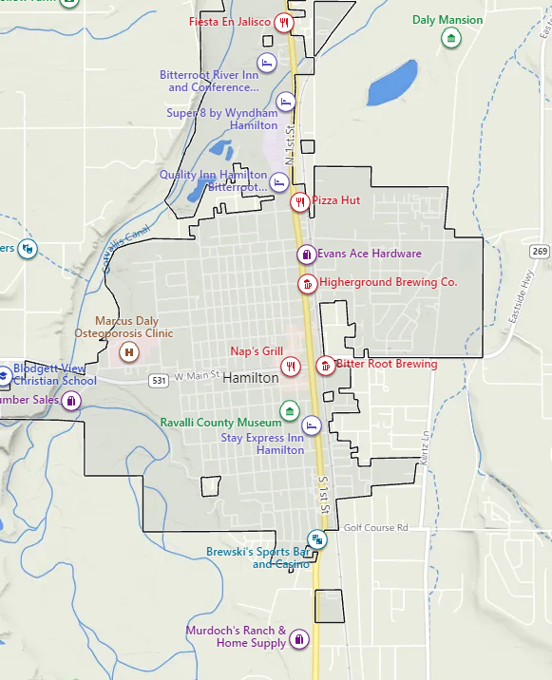
Bitterroot Health- Daly Hospital
RML

