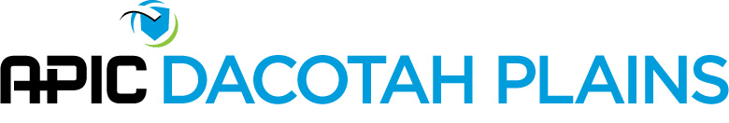
APIC Dacotah Plains Business Meeting Agenda
11:00 a.m. - Friday, February 15, 2019
Quarterly Meeting- Minot, ND
- Introduction and Roll Call
- Approval of Minutes – November 16, 2018 – Jenna Bredahl
- Reports
  - Treasurer – Pam Remington
  - Membership – Sue Niebuhr
  - Bylaws – Lisa Orlando
  - Legislative Representative – Julie Jacobson
  - Program – Susan Kringlie
  - Nominating Committee – Shantel Klym, Deb Kleven, Mirabelle Adamu
  - HAI Steering Committee – Faye Salzer
  - CRE/CRO Task Force – Faye Salzer
- Unfinished Business
  - 2018 Chapter Health Survey

- New Business:
  - Exhibitor at Infection Prevention Conference March 20 & 21
  - LTC 2019 Associate Membership Renewal and May conference
  - Chapter Website
  - New online reporting in 2019 for Chapters
  - LTC 2019 Trade Show
  - Education Opportunities
    - North Dakota Department of Health Webinars http://www.ndhealth.gov/disease/hai/Training/Default.aspx
    - APIC Dacotah Plains Meeting: May 17, 2019 (Jamestown), Sept. 20, 2019 (Bismarck), Nov. 15, 2019 (Bismarck)
    - CDC/CMS Infection Prevention and Control Training in LTC on line – March 20 & 21, 2019 (Bismarck)
    - NDLTCA Annual Convention May 8 thru May 10, 2019 (Bismarck)
    - Live NHSN training March 25-29 @ CDC in Atlanta
    - EPI Courses – Providence RI (March), Orlando FL (April), Portland OR (May)
    - Free Environmental Services Training Modules and Tools

- Other Business:
- Meeting adjourned

Teleconference Information:
  - A teleconference option is offered for this meeting. Members unable to attend the meeting in Bismarck can call in at: (855) 640-8271. Participant code: 54529959#. (Chairperson passcode: 40050190#)
- Meeting Location: International Motel, Minot, ND
- 11am Education Program – Jeff Ficken, Hygiena, “Maximizing Your Environmental Monitoring Program”
- 11:15 am – Business Meeting
- 1pm Education Program – Reports on National APIC June 2018 (Susan & Coleen)

