APIC Utah Chapter 132
May 15, 2024
Microsoft Teams Meeting 11:30-1pm
- Vision: Healthcare without infection in our community.
- Mission: To create a safer community through the prevention of infection by educating, supporting and promoting chapter stakeholders.
No. | Topic | Discussion | Attachments or Action Item(s) | Owner
1 | Welcome and roll call  2 minutes |  |  | Ailene Bascom
2 | Announcements  5 minutes | Alexandria Crandall passed the CIC, Congratulations!  Are you going to National APIC Conference? |  OR  Ailene Bascom: Are you going to the National APIC 2024 Conference Questionnaire | Ailene Bascom
3 | Metrex CaviWipes APIC Conference Award | Congratulations to Kimberly Pratt! Thank you to Metrex CaviWipes for providing the $2,500 award. |  | Ailene Bascom
4 | Board member reports  2 minutes | Membership 158  Checking $ 6,002.90  Savings $ 20,288.85 |  | Chrissy Radloff  Sharon Sumner/Misty Valencia
5 | HD update  5 minutes  5 minutes | DHHS Update:  - DHHS Grand Rounds, June 27, 8am  - Monthly Epi lecture series sign up.  SLCo HD Update:  Respiratory Virus Hospitalization Surveillance Network link (RESP-NET).  - CDC HAN for H5N1 acquired in a dairy worker. SLC participates with CDC in influence surveillance. Due to ongoing concerns with H5N1, surveillance will continue through the summer.  - County is seeing an increase in invasive Group B streptococcal (GBS) in drug users and those suffering from homelessness.  - Sharon asked about to increase in Syphilis in prenatal moms, Michelle will get more information and provide in the minutes. | - DHHS Grand Rounds with Leisha Nolen: Meeting Registration - Zoom  - https://mailchi.mp/fe389d3b3c7c/epi-lecture-series-sign-up  - MDRO identification tool  - Utah DHHS Measles one pager  - Project Firstline Resources  - Measles one-pager  - CMS requirement for Enhanced Barrier Precautions in Nursing Homes  - CMS QSO-24-28  - Implementation and Use of Enhanced Barrier Precautions in Nursing Homes  - HAI Report sent out recently  - Post-acute care / Antimicrobial Stewardship Collaborative ECHO- May 22, 2024 from noon-1pm MT "Steward Strategies for Interpretation of Novel Urinary Diagnostics by Lauren Biehle, PharmD. CME credit is available for these sessions and this link will allow you to register for the meeting as well as provide a link to view previously recorded sessions and see upcoming sessions. This will be the last session until September.  - IPC resource list (IPC program education and guidance)  - Virginia Infection Prevention Training Alliance: MDRO Resources  https://www.cdc.gov/surveillance/resp-net/dashboard.html  - Early-Stage Syphilis (Primary, Secondary, and early non-primary non-secondary) cases continue to increase.  - Increases in syphilis cases among people with a history of incarceration, unstably housed, substance use disorder and communities of color.  - Women with syphilis comprise our fastest growing increase.  - The number of pregnant women with syphilis has increased in past 2 years  - Hispanic and women of color are disproportionately affected  - 6 probable cases of congenital syphilis in 2023  - 1 probable case of congenital syphilis in 2024 YTD | Bea Jensen  Michelle Vowles
6 | APIC Utah Chapter Conference | Utah APIC Chapter Conference, Thursday, October 10th, Thanksgiving Point.  - Poll sent through chat for virtual vs. in-person preference. |  | Karen Singson
7 | Education  60 minutes | MedPro & Metrex  “The Wipe on the Wall” presented by  Sharon Ward-Fore, BS, MS, MT (ASCP), CIC, FAPIC  1 CE offered  Objectives:  - Explain the importance of disinfectants.  - Explain why no disinfectant wipe can have every organism on its label.  - Describe how antibiotic resistance differs from resistance to disinfectants.  - Determine the best disinfectant for your facility using a Questionnaire and Risk Assessment. | 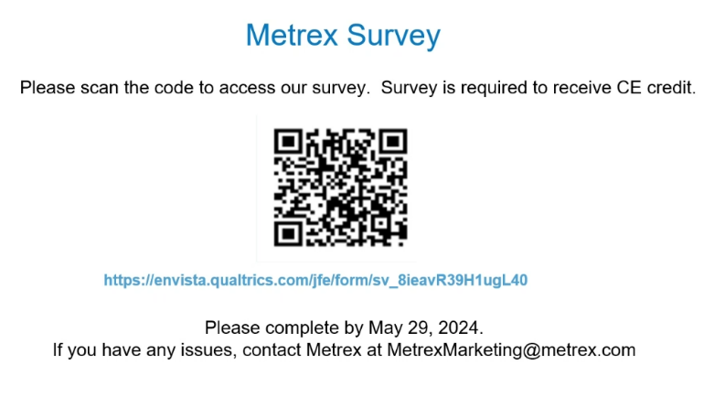 | Becky Ess
8 | Roundtable  5 minutes | No items |  | Group
 | Next meeting | Wednesday, July 17th, 11:30am to 1pm |  | Ailene Bascom
Attendees: Ailene Bascom, Brenda Gregg, Marti Vanderhoeven, Sharon Ward-Fore, Leslie Stulce, Jessica Osguthorpe, Ann Evans, Tanner, Crissy Elliot, Lisa Pearson, Ellen Kellner, Nichole Harward, Amy Squier, Joni Johnson, Michelle Vowles, Devin Christensen, Misty Valencia, Chrissy Radloff, Kerry Elwood, Heather Lindsey, Taylor Kintz, Sharon Sumner, Jarred Gurss, Bonnie St John, Kim Rasmussen, Bea Jensen, Annette Wendel, Amber Pulley, Lisa Macdonald, Jill Goold, Alexandria Crandell, Danniell Frey, Ashley Miller, Lori Evans, Zoey Bridges, Gary Hodges, Karen Singson, Kristina Skinner, Jason Russel Argyle, Marisa Hassemer, Josh Siefke, Carla Tang, Andrea Price, Cherie Frame, Jamie Fendler, Jane Gabalski, Rita Wiloughby, Vicki Swenson, Heather Bowers, Pam, Heidi Melling, Lisa Higley, Christy Christensen, Isaac Workman, Lisa Higley, Heather Bowers, Carrie Taylor, Cami Hansen,.

