APIC Utah Chapter 132
January 17th, 2023
Intermountain Employee Service Center
5245 College Dr, Murray, Room 1 & 2
Microsoft Teams Meeting 11:30-1pm
- Vision: Healthcare without infection in our community.
- Mission: To create a safer community through the prevention of infection by educating, supporting and promoting chapter stakeholders.
No. | Topic | Discussion | Attachments or Action Item(s) | Owner
1 | Welcome and roll call  2 minutes | Meeting conducted by Bonnie St John, Pres. Elect |  | Ailene Bascom
2 | Announcements  5 minutes | Congratulations to Marti Vanderhoeven on her CIC recertification! |  | Ailene Bascom
3 | Board member reports  2 minutes | Membership 149 Active, 15 Grace Period  Checking $ 6,199.11  Savings $20,27544 | Reminder if you are in the grace period please reactivate. Chrissy Radloff will send a reminder email. | Chrissy Radloff  Sharon Sumner
4 | HD update  5 minutes | UDOH Update: Interfacility Transfer from has been approved. It is posted on the state HAI Website.  UDOH Grand Rounds Announcement. Next meeting is February, 14th at 12 to 1pm.  The first in-state transmission of Candida auris has been identified.  Post Acute Care ECHO Series, next Feb 21  SLCo HD Update:  Influenza has been weird in that there has been a mix of strains.  The state had a case with Oxacarbapenemase in an E. coli. More outpatient facilities (clinics) with carbapenem resistance cases. Also, a recent case of NDM E. coli. | https://epi.health.utah.gov/wp-content/uploads/Interfacility_Transfer_Form.pdf  https://utah-health.zoom.us/meeting/register/tJYrd-CtqTgqGtIjkI4xif-nm6Xg8dZzBYnM#/registration  https://physicians.utah.edu/echo/clinical-support-areas/post-acute-care | Bea Jensen  Michelle Vowles
5 | Education/In-person luncheon  60 minutes | Chapter Education Conference Survey to be sent out soon.  Scholarship application for National APIC Conference will be sent out soon.  “Optimizing Skin Prep Selection: Choosing the Appropriate Antiseptic for Surgery.”  Presented by Michael Rempel, DNP, RN, CNOR | Learning Objectives:  - Recognize the importance of selecting an appropriate antiseptic for surgical skin prep.  - Identify patient considerations, surgical site location, and surgical factors that impact antiseptic selection.  - Analyze the safety factors that must be taken into account when selecting an antiseptic for skin prep.  - Compare and contrast the different types of antiseptics available and determine which is appropriate for specific surgical procedures.  - Select an appropriate antiseptic for skin prep to improve patient outcomes and lower risk of surgical site infections.  - 1 CME, CNE, AAPA, AANP credit  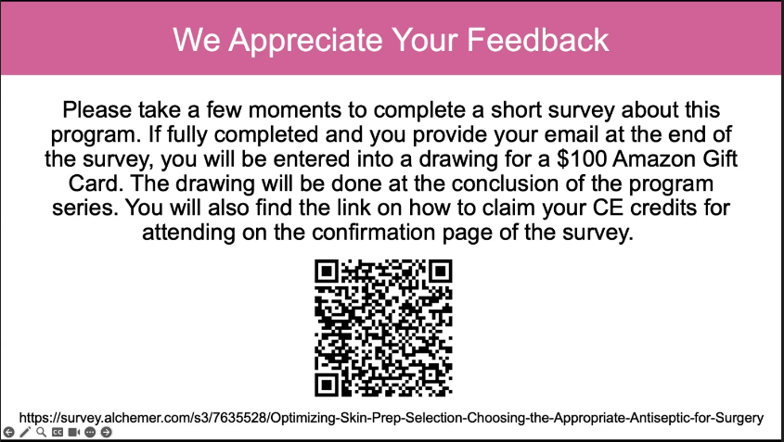  Please use the QR Code below to create a HMP login to complete the survey and access your CME Certificate. | Karen Singson/  Greg Randall
6 | Roundtable  5 minutes | Chapter project underway on Resilience and Burnout. Please fill out the survey and receive a $10 gift card. This project has been submitted to APIC National. | Qualtrics Survey | Qualtrics Experience Management  Suggestion for purchase. Available on Amazon.  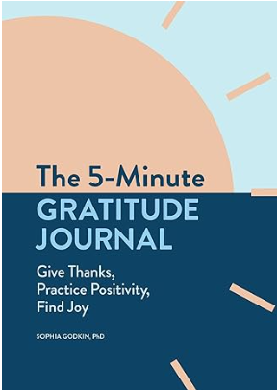 | Group
 | Next meeting | Wednesday, March 20th, 11:30am to 1pm |  | Ailene Bascom
Attendees: Vicki Swenson, Dawna Nielson, Bonnie St. John, Jessica Osguthorpe, Hailey Lorscheider, Michelle Vowles, Jamie Fendler, Kerry Elwood, Heidi Melling, Breann Christopherson, Heather Bowers, Danniell Frey, Ellen Kellner, Chrissy Radloff, Leslie Stulce, Misty Valencia, Devin Christensen, Ailene Bascom, Cami Hansen, Brian Hill, Wendy Chatland, Annette Wendel, April Clements, Nichole Harward, Rebekah Ess, Sharon Sumner, Linda, Misty, Bea Jensen, Lisa Evans, Sandra Hanson, Cherie Frame, Alexandria Crandell, Karen Singson, Melinda Williams, Katreena Merrill, Marisa Hassemer, Dacota Shell, Denver Allen, Heather Lindsay, Greg Randall, Andrea Price, Carla Tang, Alisha Allen, Brenda Gregg, Merkley Julianne, Marti Vanderhoeven, Jason Argyle, Tyler Brady, Crissy Elliott, Christy Christensen, Rhonda Wigglesworth, Gary Hodges, Michel Rojas, Trisha Skirvin, Tyler Barney, Ashley Miller, Kathryn Smith, Kayla Burnett, Isaac Workman, Nancy Ostermiller, Maja Kollmann, Kristina Skinner, Kelly Endo

