
APIC Ch. 20 Conference and Expo plans to welcome professional attendees to Macon, GA for the largest gathering of infection preventionists (IPs) in the State of Georgia. Exhibitors will have the unique opportunity to engage with the most in-demand audiences in the field – from infection Preventionists and epidemiologists to public health and healthcare professionals.
Top reasons exhibitors should participate in APIC Ch. 20 1st Conference and Expo:
- Maintain or build brand awareness with IPs
- Generating new sales leads
- Generate sales of current products and services
- Brand awareness
- Networking
- Quality attendee base of IP super-users and influencers

Exhibitor Benefits
- 4 complimentary exhibitor booth staff registrations per 10’ x 10’ booth
- 24-hour perimeter security services
- Full Conference Badges for booths of 200 square feet or more*
- Company name, logo, and description listing in program
- Complimentary post-show attendee list
*Exhibitors in 10’ x 20’ spaces receive (1) complimentary Full Conference Badge. Speak with one of the Exhibit Hall team members to discuss special packages available.

Exhibitor Booth Rates:
Standard Inline | $1600
Standard Corner | $2000
Islands | $34 per Square Foot
Non-Profit Exhibitors | The above standard booth fees also apply to non-profit exhibitors. A limited number of inclusive booth furniture packages (10’ x 10’ carpet, on (1) 6’ x 30’ table, two (2) side chairs, waste basket, ID sign and nightly vacuuming) will be offered to the first five (5) non-profit exhibitors that submit their application, deposit, and 501(c)(3) form, based on the date that these are received.

Exhibit Hall Hours
Exhibitor Installation
Tuesday, January 27 | 12:00 – 5:00
Wednesday, January 28 | 07:00 – 08:00

Exhibit Hall Open
Tuesday, January 27 | 4:00 – 6:00
Wednesday, January 28 | 1:00 – 5:00
Thursday, January 29 | 12:00 – 4:00

Exhibitor Dismantle
Thursday, January 29 | 4:30 – 6:00
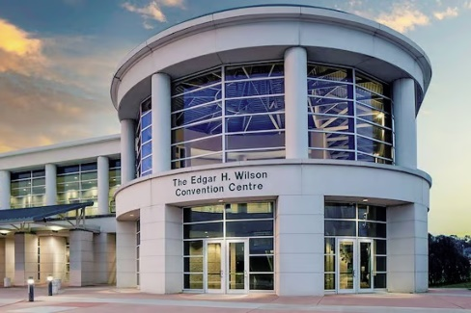

Important Dates:
October 1, 2025 | Exhibitor Housing and Registration open
November 30, 2025 | Full Payment is due  (Applications received on or after this date must include 100% payment of booth)
December 15, 2025 | Island Schematics are due (Last day to submit application for Island)
January 27, 2026 | Exhibitor Installation begins
January 27, 2026 | Exhibit Hall opens at 4:00 PM
January 28, 2026 | Exhibit Hall opens at 1:00 PM
January 29, 2026 | Exhibit Hall opens at 1:00 PM
January 29, 2026 | Exhibit Hall dismantle begins at 4:00 PM

100% unopposed Exhibit Hours!

Click the link below to apply and pay:
https://www.paypal.com/ncp/payment/NQLAYZV8HUKYY

(Applications received on or after November 30, 2025, must include 100% payment of booth)

