Did you know you can set up your account to stay better connected to what’s going on with Ohio’s ANIA chapter? To start, log in to the chapter website:
Then in the upper right corner where you are logged in, click the drop down button to see a snapshot of your profile. From there, click on Communities:
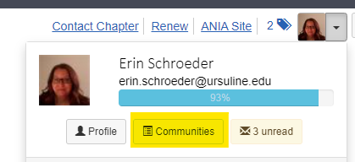
This will bring you to the communities section of your profile, if you’ve already connected to communities, they’ll show below, but if its your first time, you can choose to explore all communities:
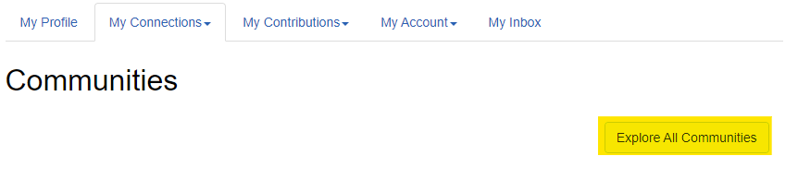
From here you can see all the great communities you can connect with across ANIA. If there is a community you are interested in that you are not connected with, you will have the option to select the blue Join button (note there is no button if you’re already connected)
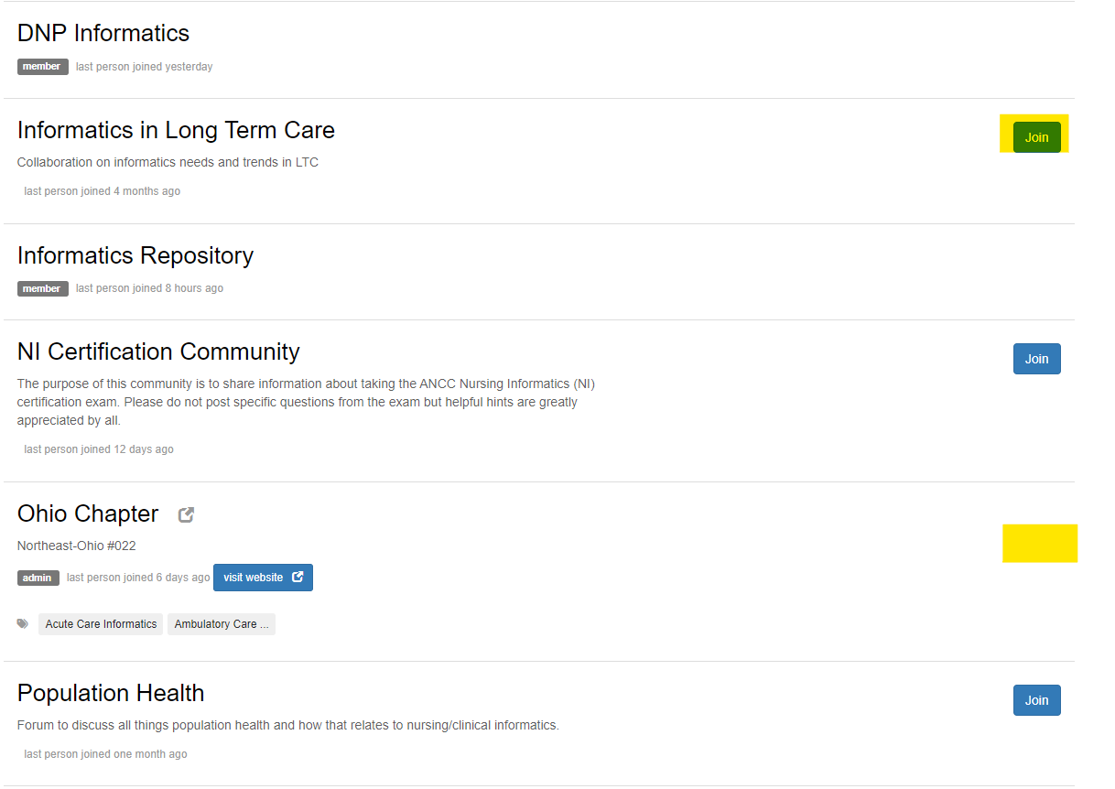
Once you select Join, you have some choices to make to decide how often you would like updates on these communities:
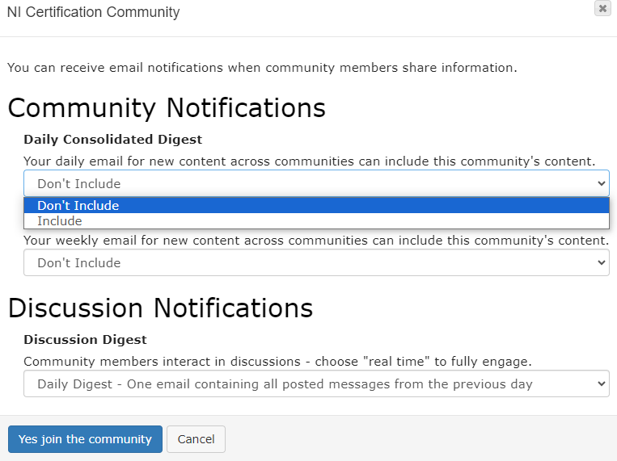
The discussion digest setting would allow you to get a message every time someone posts, a message a day after messages have been posted so you can see the discussion that has been happening, or no updates at all.
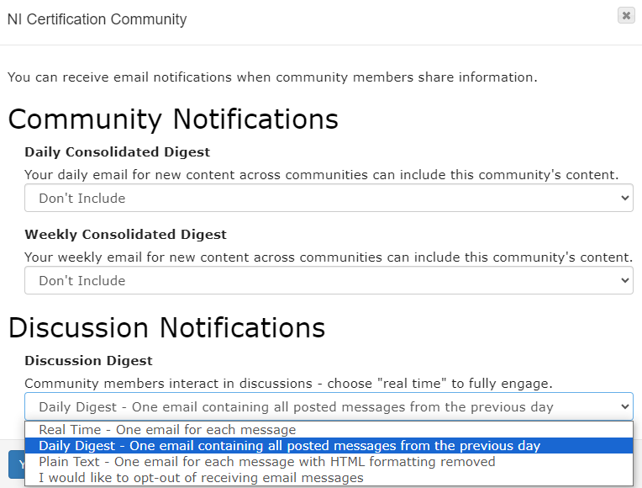
If you are following a community and would like to change your settings for you email notifications, you can do so under my account: community nofications
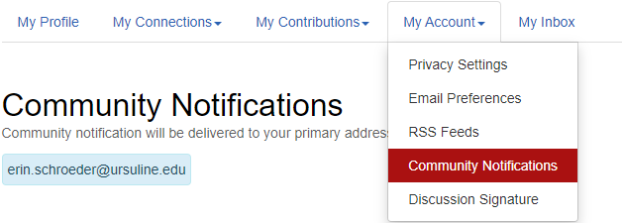
By adjusting the discussion email drop box you can adjust your settings, or you can simply select the consolidated daily digest box to quickly update your settings to the email a day after comments are posted.

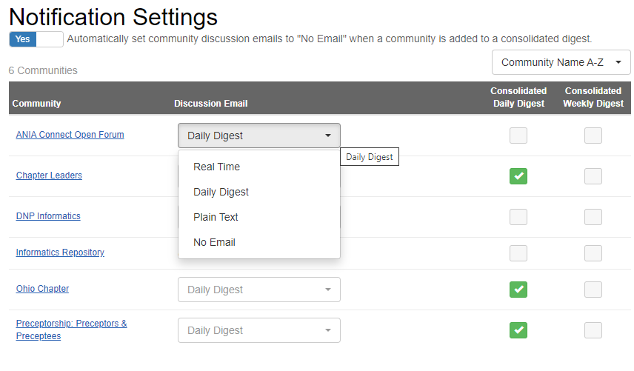
If you have any questions, please contact any member of the board for assistance!

