Purpose
- To customize a message for each recipient
- To send e-mails individually to many members
To prepare:
- Word document – type what you want to be in the body of the e-mail
  - Note: Cannot add attachment (will only include content in body of Word document)
- Excel spreadsheet – clearly labeled tabs
  - When opening a new spreadsheet, there will be three tabs (worksheets) at the bottom labeled Sheet1, etc. To change the names of each worksheet, right click the tab and choose ‘rename’. Label each worksheet to remind yourself what information is on each. This will be helpful for the mail merge later.
- Must use Outlook as your e-mail server
To begin the mail merge for sending e-mails:
- Keep the desired Word document open
- Close the Excel file that lists members’ names, e-mail addresses, and other information
- In Word, click on the ‘Mailings’ tab at the top
- Click the icon that says ‘Start Mail Merge’
- A drop-down list will appear; choose ‘Step by Step Mail Merge Wizard’ at the very bottom
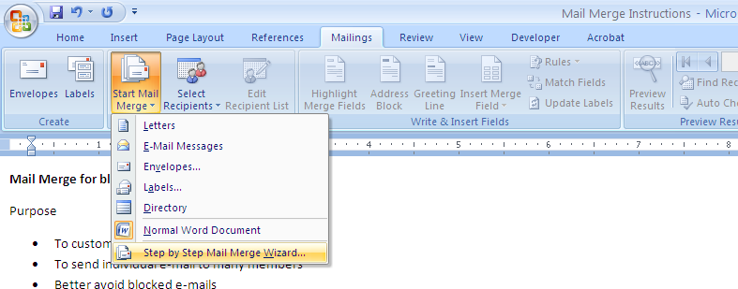
- A box will appear on the right side of the screen, taking you through the six steps of the process
- Step 1
  - Select document type
  - Choose ‘e-mail messages’
  - Click ‘next’ at the bottom of the wizard box
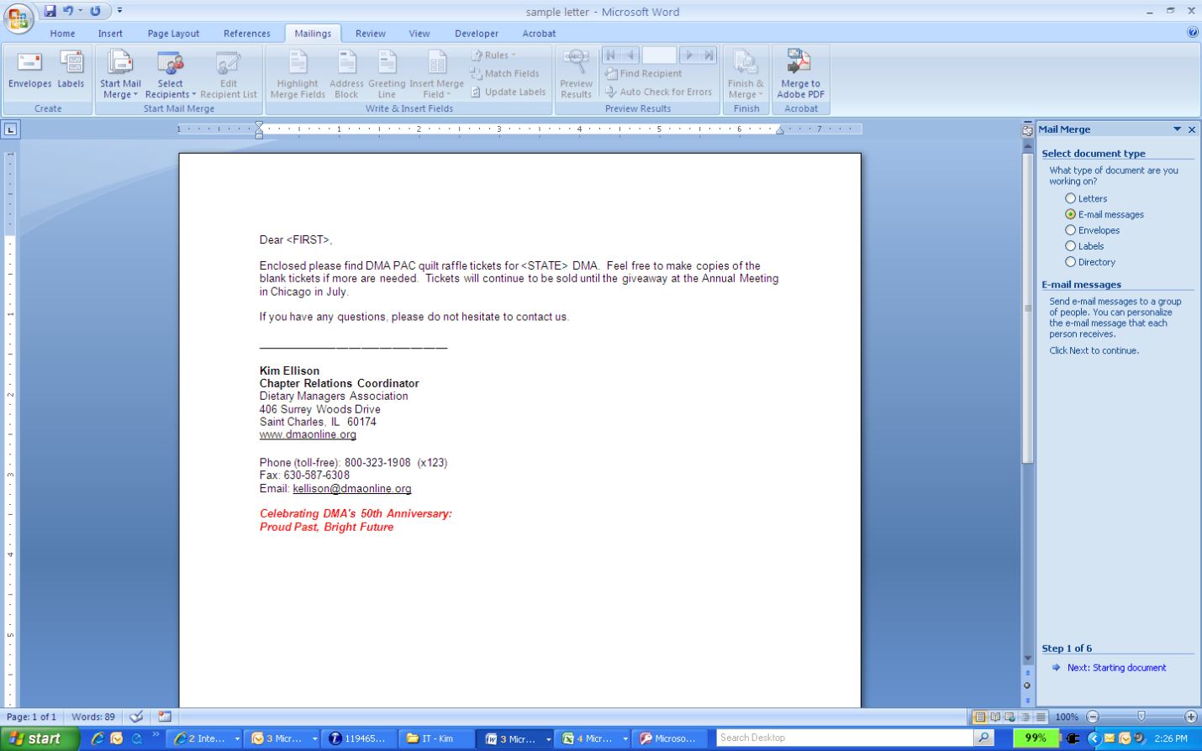
- Step 2: Selecting a starting document
  - If you already have the content typed in the open file, choose ‘use current document’
  - If you would like to use another document that is saved on your computer, choose ‘start from existing document’. Then, open that document.
  - You will be able to edit the content throughout the rest of the wizard, if desired.
  - Click ‘next’ at the bottom of the wizard box
- Step 3: Select recipients
  - If you already have your Excel spreadsheet set up with the names, e-mail addresses, and whatever other information you want to customize, choose ‘use an existing list’.
  - Under the radio buttons, click ‘browse…’
  - Find the Excel file on your computer and open
  - Another box will pop up in the middle of your screen, giving you the option of which tab you want to use. Double-click the worksheet name that contains the e-mail addresses and information you wish to link to the Word document.
  - Another box will appear showing the list you have chosen. Here, you can uncheck any names you do not wish to include. At the bottom part of the box under ‘Refine Recipient List’, click the ‘Find Duplicates’ hyperlink. If there are any within the worksheet you are using, they will be shown here. Uncheck any duplicates. (For example, if ‘Kim Ellison’ is listed two times or more, uncheck all except one.)
  - Click ok
  - Click ‘next’ at the bottom of the wizard box
- Step 4: Write your e-mail message
  - If you wish to customize any information, place the cursor where you wish to enter individual information. Click ‘More items…’ from the wizard box on the right side of the screen. All columns within your chosen spreadsheet will show up in a pop-up box; here, they are called ‘fields’. Choose the information you wish to add, then click ‘insert’. It will appear as the column name for now (example: <<CITY>>).
  - Repeat this step as often as necessary
  - Click ‘next’ at the bottom of the wizard box
- Step 5: Preview your e-mail messages
  - To see that all customized information is included, click the << and >> boxes near the top of the wizard box
- Step 6: Complete the merge
  - Make certain the message is exactly how you want all of your recipients to see it
  - Click ‘Electronic Mail…’
  - A ‘Merge to E-mail’ pop-up box will appear in the middle of your screen.
    - To: A drop-down list will again show the columns from your Excel worksheet. Choose the column that has e-mail addresses listed.
    - Subject: Type the title of your e-mail. All recipients will see this in their inbox.
    - Mail format: Choose which format you want to send your e-mail as. The following are the options:
      - Attachment (sends the message from your Word document as an attachment within the e-mail message; recipients will only see the attachment, not the actual message, immediately upon opening the e-mail. The attachment will have to be opened separately)
      - Plain text (will remove all font formatting)
      - HTML (keeps all font formatting, like bold and italicization)
  - Click ‘OK’ to send
- Check your Outlook ‘sent’ folder to make sure e-mails were sent. There is no limit to how many e-mails you may send. However, the sent e-mails may take up a lot of room within your e-mail system, and you may want to delete them for this reason.

Great job with a successful completion of a mail merge!

