Mail merge instructions for printing mailing labels
Purpose
- To print mailing labels for chapter newsletters, ballots, meetings, etc.
- ANFP member lists should only be used by ANFP volunteers for chapter or district business and not distributed to third parties.
To prepare
- Export chapter roster into Excel spreadsheet Under member login at www.ANFPonline.org. (chapter management portal)
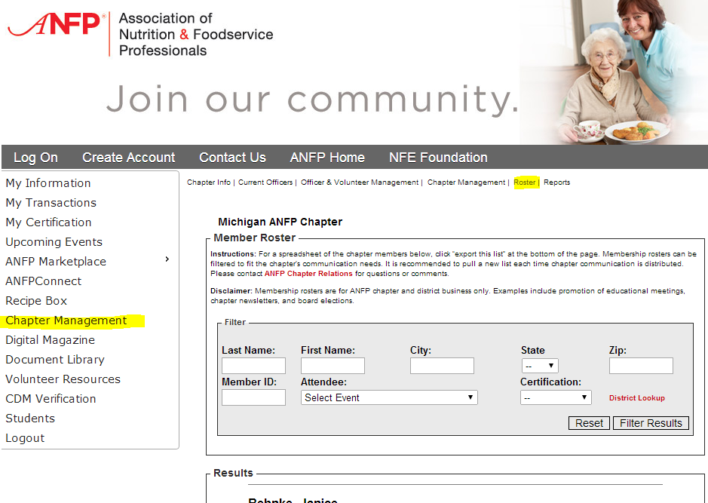
- Save spreadsheet to your computer. Close the spreadsheet.
- Insert mailing labels to your printer.
Print mailing labels (via mail merge)
- Open a new Word document
- Click on the ‘Mailings’ tab at the top. Choose ‘step by step mail merge wizard’.
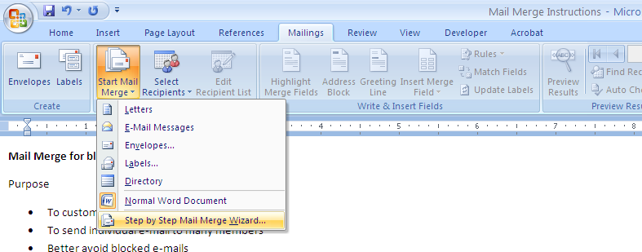
- A box will appear on the right side of the screen, taking you through the six steps of the process.
Step 1
- Select document type  - Choose ‘labels’  - Click ‘next’ at the bottom of the wizard box | 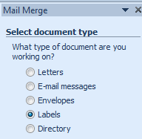
Step 2: Label Options
- Click on label options in the wizard (right of doc)  - If not set up previously, you may have to choose ‘new label’. Find the label size you are using, or enter the label dimensions.  - Push ok on pop-up. Document will be separated into labels.  - Go to next step of wizard. | 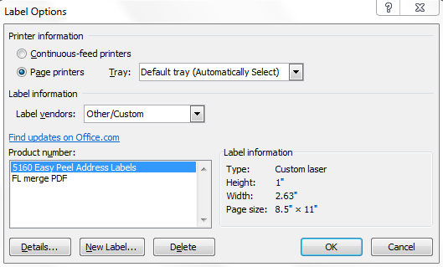
Step 3: Select recipients
- Click on browse to connect an Excel spreadsheet.  - In pop-up, find the member roster wherever it was saved on the computer. Double-click this (or push ‘open’.)  - Another box will appear showing the list you have chosen.  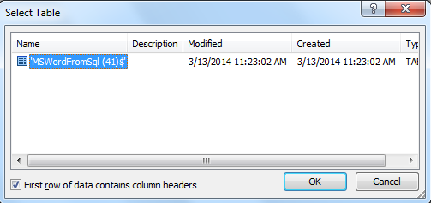  - If there are any within the worksheet you are using, they will be shown here.  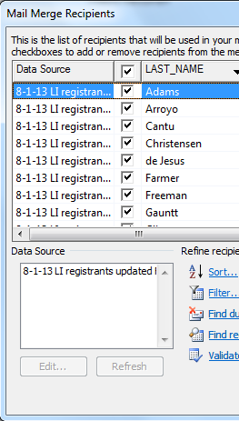  - Click ok. ‘Next record’ will appear in each label box.  - Click ‘next’ at the bottom of the wizard box | 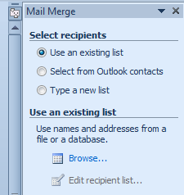
Step 4: Arrange your labels
- If you wish to customize any information, place the cursor in the upper left label box.  - Click ‘More items…’ from the wizard box on the right side of the screen. All columns within your chosen spreadsheet will show up in a pop-up box; here, they are called ‘fields’. Choose the information you wish to add, then click ‘insert’. It will appear as the column name for now (example: <<CITY>>).  - Repeat this step as often as necessary. Arrange address as needed in first label box.  - Click the ‘update all labels’ box to right.  - Click ‘next’ at the bottom of the wizard box. | 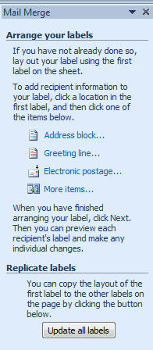
Step 5: Preview your labels
- As long as all labels are correct and all are being printed, click ‘next’ in wizard.  - To see additional pages of all customized, click the << and >> boxes near the top of the wizard box. | 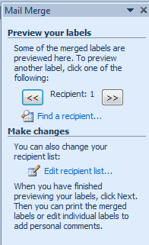
Step 6: Complete the merge
- Click ‘Print’ to right in wizard.  (*If you choose print option outside of wizard, it will only print current page.)  - Click ‘ok’ for all records in pop-up.  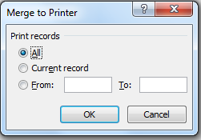  - Choose preferred printer, and push ok! | 