
Official Conference Program Book

CONFERENCE THEME HERE
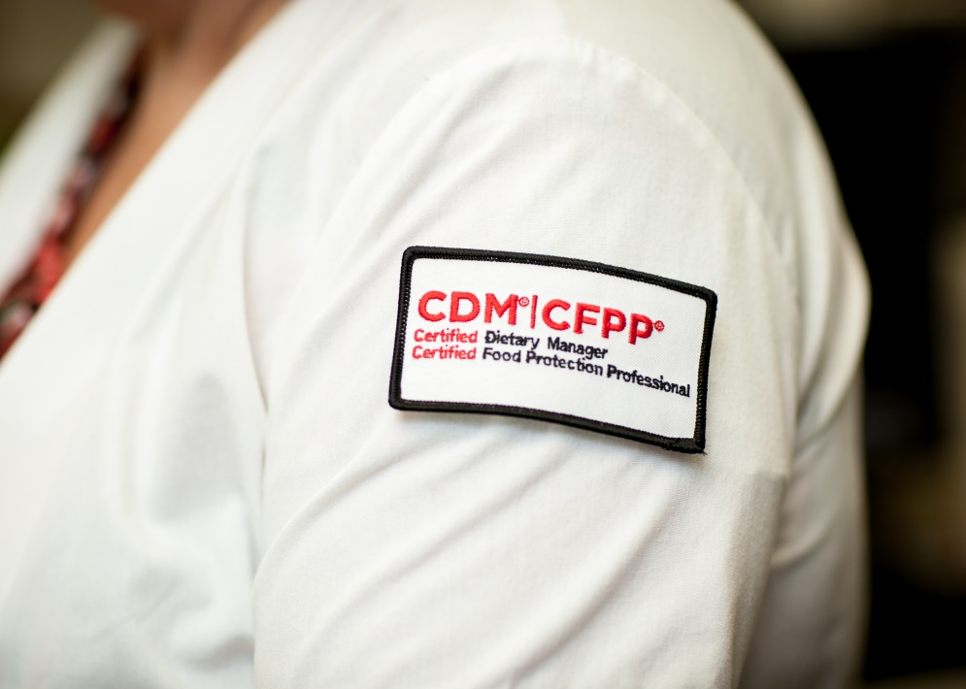
Annual Chapter Meeting
Date:
Location:
TABLE OF CONTENTS
Description | Page

NETWORKING EVENT
Date |  | 
Time
Event
Location
Additional Information

SPECIAL GUESTS

ANNUAL CHAPTER CONFERENCE 2015

 |  | Welcome to the Annual Chapter Conference for nutrition and foodservice professionals! The next few days will be filled with education, exhibits, and networking opportunities. This conference program book will guide you through the days ahead. Please stop by the ANFP chapter registration if you have any questions or concerns during your time here.
 | Registration Hours |  |  | Continuing Education Hours
 | Saturday, August 1  (1:00 pm – 4:00 pm)  Sunday, August 2  (7:00 am – 5:00 pm) |  |  | A maximum of 10 CE hours are available for attending the 2015 Annual Chapter Conference.  As of June 1, 2014, CDMs are now responsible for tracking their own continuing education (CE) hours and submitting them before the end of their three-year reporting cycle. Use the CE Record on in this program book to track sessions you attend and follow instructions to report the CE hours you earned at this event in your online record. Save the record and the certificate of attendance for verification purposes.
 | Thanks for Your Consideration
 | Thanks for not smoking in the meeting rooms and for silencing cell phones during education sessions.
 | Speaker Handouts |  |  | Expo
 | Speaker handouts are available online at: www.ANFPonline.org/MN under the Events Calendar on the chapter meeting page. Please note that handouts will not be available on-site. |  |  | Visit the Exhibit Hall on Tuesday, August 4 from 9:00 am - 12:00 pm where exhibitors will showcase  how their products and services can contribute to your operational effectiveness and bottom line,  while maintaining the highest levels of quality in dining and foodservice.
 | Leadership Recognition |  |  | First Aid Emergencies
 | Join us for breakfast at 7:30 am on Monday, August 3 in Grand Cypress DEF to celebrate the success of both the organization and the dedicated leaders that steer the direction of ANFP. |  |  | Please pick up a house phone and dial “0” for the hotel operator if medical assistance is required.



As of June 1, 2014, CDMs are now responsible for tracking their own continuing education (CE) hours, and submitting them before the end of their three-year reporting cycle. Use the list below to track the sessions you attended and to report the CE hours you earned at this conference in your online record. CDMs are advised to save all CE-related documentation for two three-year certification cycles.

- To report conference CE online, log in to the online member portal at www.ANFPonline.org.
- After logging in, click on My Transactions.
- Click on Report CE (right side of screen) under the Events section.
- Save this page along with the Certificate of Attendance provided on page 40 for verification purposes.

Date/Time | Education Session | CE Hours | Attended (X)
8/2/15 (8 AM – 10 AM) | Advanced Leadership | 2.0 GEN
8/2/15 (10 AM – 1 PM) | Expo | 3.0 FS
8/2/15 (1 PM – 2 PM) | Foodborne Illnesses | 1.0 SAN
 | General (GEN) Hours Earned:
 | Sanitation (SAN) Hours Earned:
 | Food Show (FS) Hours Earned:
 | TOTAL HOURS EARNED:

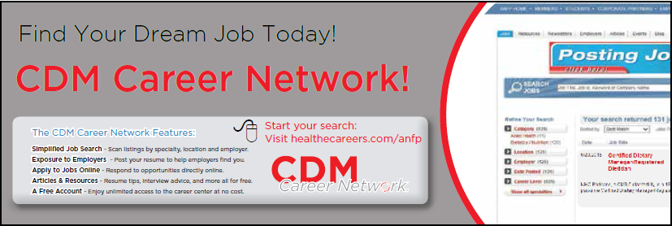

MEET THE SPEAKERS
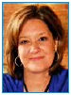  Debra Zabloudil, CDM, CFPP | Debra Zabloudil is the President and CEO of The Learning Studio, based in Chicago. The Learning Studio, celebrating its 10th anniversary this year, is a recognized industry expert in leadership and management training, as well as consulting around all things concerning adult education. On any given day, Debra and her team can be found traveling the nation, and sometimes the globe, producing anything from small group think tanks to large scale events working with speakers and content experts from every profession and industry imaginable. Debra is a highly sought-after speaker and trainer, and writes and speaks regularly on a variety of leadership topics.


AccuTemp | Burlodge
Booth #1 | Booth #2
www.website.org | www.website.org
Company description | Company description
Company | Company
Booth # | Booth #
www.website.org | www.website.org
Company description | Company description
Company | Company
Booth # | Booth #
www.website.org | www.website.org
Company description | Company description
Company | Company
Booth # | Booth #
www.website.org | www.website.org
Company description | Company description
Company | Company
Booth # | Booth #
www.website.org | www.website.org
Company description | Company description

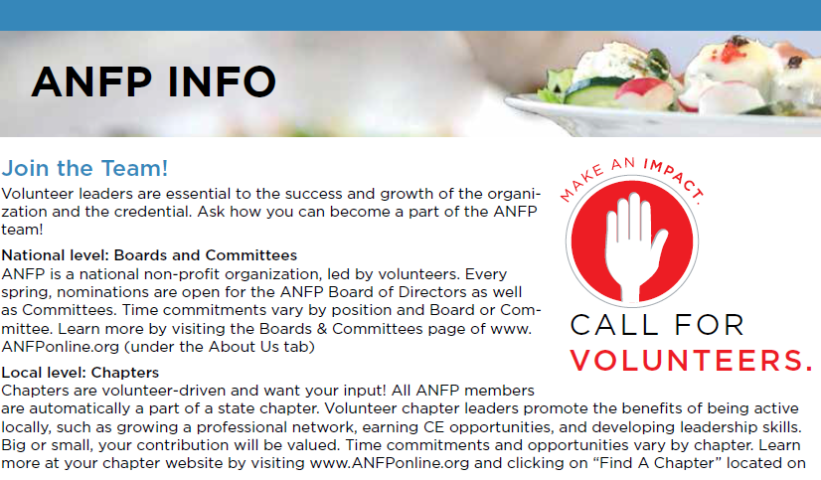

CHAPTER BOARD
President
President-elect
Secretary
Treasurer
Legislative Spokesperson
Program Chair
Newsletter Editor

Have a question about your membership or this conference? Be sure to stop by the registration table to ask a chapter leader.
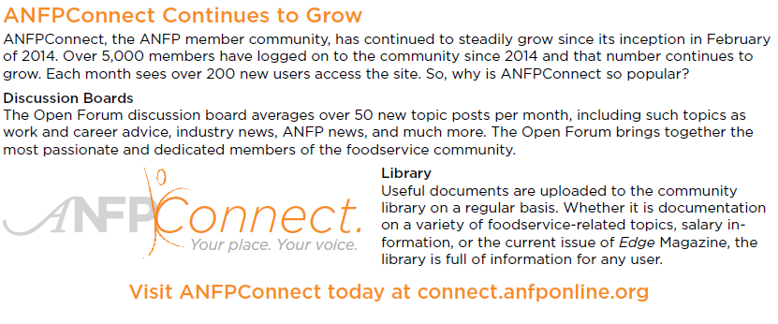
NOTES

 | Thank you for attending the Annual Chapter Conference! We hope to see you next year.

