Sample ANFP Invitation to Speakers

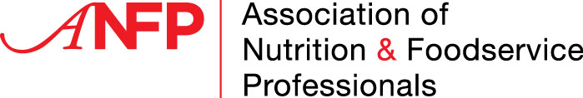

(Date)

(Name)
(Title)
(Address)
(City, State Zip)

To (Name):

My name is (NAME) and I am the (TITLE) at (FACILITY) located in (CITY NAME). It would be our honor if you could attend our (spring/fall) state meeting in (LOCATION), on (DATE).

Few people fully understand the existing regulations governing the dietary services in long term care facilities, and, most important, the nutritional services provided to patients and residents. The public has been led to believe that the only qualified individual in health care dietary services is the registered dietitian (RD). While the RD's role is essential, there are approximately 14,000 dietary managers across the United States who assume the daily responsibilities of providing nutritional meals to hospital patients and nursing home residents. The Association of Nutrition & Foodservice Professionals (ANFP) provides educational training and certification to dietary managers.

Our (# OF CHAPTER MEMBERS) state members are active throughout the state and working hard to make sure (STATE) regulations reflect the important role of the dietary manager.

Your input at our state meeting would be most helpful in explaining current regulations regarding health care dietary services and upcoming legislation regarding the health care system. I am available to answer any questions you may have. I look forward to hearing from you about your ability to speak at our state meeting.

Sincerely,

(Name)
(State) ANFP (Volunteer Position)

