To Be Like Me Survey

Please read the statements that follow, and tell us if you agree or disagree with the statements. It is important for you to know that there are NO right or wrong answers - you should answer them to show how you feel! The emojis at the top can help you decide how you feel.


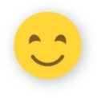
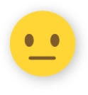
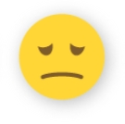
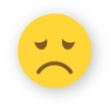

 | Strongly agree (1) | Somewhat agree (2) | Neither agree nor disagree (3) | Somewhat disagree (4) | Strongly disagree (5)
I can be good friends with a person who has disabilities. (1)
A person with disabilities can have a lot of friends. (2)
A person with a disability who has a job can be very good at his/her job. (3)
A person with disabilities can have lots of hobbies. (4)
I am comfortable starting a conversation with someone who has a disability. (5)
I know what people with disabilities do differently. (6)
I know what I can say to people with disabilities. (7)
I know the difference between physical and mental disabilities. (8)
I know how I can help people with disabilities. (9)
I understand how a person with a disability feels. (10)
I would be embarrassed if someone with a disability invited me to come over. (11)
I would invite someone with a disability to my home. (12)
I would introduce someone with a disability to my friends. (13)
I would talk to someone with a disability when we first meet. (14)
If I saw someone with a disability being bullied, I would report it to an authority figure (someone I know could help). (15)

What does it mean to have a disability?

How do you think people with a disability should be treated?

