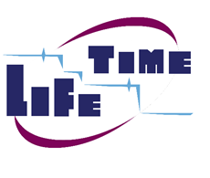
Joint Statistical Meetings ● McCormick Convention Center ● Chicago IL
North Building ● Room CC-N138 ● Tuesday, August 2 2016 ● 3:30 pm to 5:00 pm CDT
Annual Business Meeting Agenda
Lifetime Data Analysis Interest Group (LIDA-IG)

Item | Description | Leader | Time
1 | Welcome | Mei-Ling Ting Lee | 5 minutes
2 | Introduction to LIDA | Jonathan Siegel | 10 minutes
3 | Introduction of current officers | Mei-Ling Ting Lee | 10 minutes
4 | Charter | Jonathan Siegel | 5 minutes
5 | Elections and section status | Jonathan Siegel | 5 minutes
6 | Membership report | Jonathan Siegel | 5 minutes
7 | 2017 Conference on Lifetime Data Science | Ming-Hui Chen | 10 minutes
8 | LIDA-IG Invited and Topic Contributed Sessions at JSM | Bin Nan | 5 minutes
9 | Springer Award Presentation | Springer | 5 minutes
10 | Newsletter and Website | Zhezhen Jin | 5 minutes
11 | Treasurer’s Report | Mei-Ling Ting Lee | 5 minutes
12 | Discussion and Other Business | Mei-Ling Ting Lee | 10 minutes
13 | Socializing | All | 10 Minutes

