ASA Section on Teaching of Statistics in the Health Sciences (TSHS)
Executive Committee Meeting Minutes

21 June 2024 / 1:00-2:00 PM Eastern / [ZOOM - updated link, https://zoom.us/j/91426027055?pwd=REg4VnNRRC9zSEgrM050cFVkZkhhUT09

2024 Executive Committee |  | emails |  | Present?
Elected Officers (Voting)
Melinda Higgins | Chair | Melinda.higgins@emory.edu | x
Maria Ciarleglio | Past-Chair | maria.ciarleglio.yale@gmail.com | x
Jaya Satagopan | Chair-Elect | satagopj@sph.rutgers.edu | x
Amy Nowacki | Council of Sections Representative (2022-2024) | nowacka@ccf.org | x
Appointed Voting Officers
Angelo Elmi | Secretary (2024-2025) | afelmi@gwu.edu | x
John Doucette | Treasurer (2024-2025) | john.doucette@mssm.edu
Usha Govindarajulu | Program Chair (2024) | usha.govindarajulu@mountsinai.org | x
Ed Gracely | Webmaster | eg26@drexel.edu | x
Heather Hoffman | Publicity Officer | hhoffman@email.gwu.edu
Charlotte Bolch | Blog Editor | cbolch@midwestern.edu | x
Appointed Non-Voting Officers
Jim Dignam | Resource Review Co-Editor (2023) | jdignam@bsd.uchicago.edu | x
Mingzhao Hu | Resource Review Co-Editor (2023)  Program Chair Elect (2024) | Hu.Mingzhao@mayo.edu | X
Carol Bigelow | Portal Co-Director | cbigelow@schoolph.umass.edu | x
Jenna Carlson | Portal Co-Director | jnc35@pitt.edu | x
Amy Nowacki | ASA Fellows Nominations Chair | nowacka@ccf.org | x
Darsy Darssan | Webinar Coordinator | d.darssan@uq.edu.au

Call to Order (Melinda)
- Melinda called the meeting to order at 1:05 pm EST
- May 2024 Minutes were approved.

Treasury Report (John)
- All TSHS awards recipients have been contacted and all forms have been submitted.
- We ended 2023 with $21,619 in our account. Through April of this year, we received $541 in member dues, for an ending balance of $22,160 through April 2024.
- Confirm STATA donation of $5000 - Brooke Johnson from Stata reported having submitted this payment on April 22. Presumably it will appear on our next financial statement, which has been requested from Derek Curtis at ASA.

JSM (Usha, Mingzhao)
- Updates on reserving a community table for JSM 2024 – from Ming (via email while he is attending a conference today):
  - We have a shared table with Stat History and Data Science Education.
  - “... the other two sections we are sharing the table with, stat history and data science education, both indicated that they will not be keeping a roster of people to man the tables. Instead they will just have some section meet ups at the tables. Both cited the difficulty in finding volunteers to be at the tables full time when there are a lot of events to attend at the meetings.”
- Updates on getting a new poster printed for JSM 2024 – Ming
  - Waiting for final confirmation - will send to Melinda
- Ming Hu - final details on 4 roundtables - will send to Melinda

- Melinda - JSM Times and Meeting Locations (confirmation from Christina Link at ASA, christina@amstat.org )

- Event 1: Monday Aug 5 from 7:00 – 8:30 am - confirmation below
  - Morning Business Meeting
  - 20 people
  - LOCATION: Hyatt Regency, room H-Columbia 4.
  - No Food and No AV - I could try to bring some kind of morning treats or snacks - BUT if we can afford it I’d rather order something simple so I won’t have to run around at 6am trying to find food for everyone that morning. For a simple assortment of pasties and coffee for 15-20 people it’ll be about $650.
  - Food options at Hyatt, https://pdxrp.hyattmenusandexperiences.com/pdf.php?language=en
  - The catering menu is also now uploaded to our Google Drive at https://drive.google.com/file/d/1h3ZiQuFzsicB3fii5Qq1EazjMKjy3kUy/view?usp=drive_link
  - Jaya - offered to help sponsor breakfast: “I would love to sponsor breakfast for our Executive Committee meeting of Monday, August 5 (7-8:30am). I hear from some friends that J Café, which is about 5 minutes walk from Hyatt Regency (our meeting location), has nice breakfast. People can choose their preferred breakfast (https://jcafeportland.com/#Breakfast) and I’m happy to get it and bring it to our meeting. Or, I’m happy to get bagels for all. Please let me know your thoughts on this. “

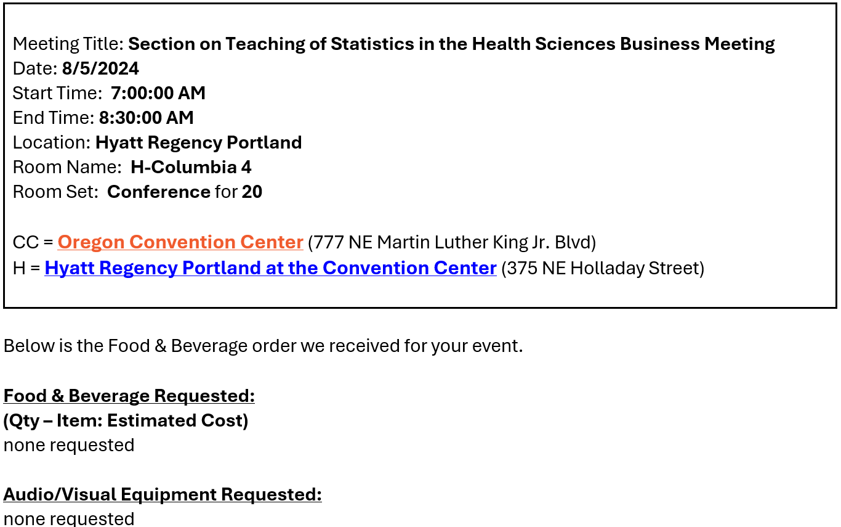

- Event 2: Monday Aug 5 from 6:00 – 8:00 pm - confirmation below
  - Evening Mixer for TSHS Section Members
  - 50-60 people
  - Food - see below
  - AV - nothing officially requested, but the room has AV built in and there is no extra charge for us to use it.
  - Location: Oregon Convention Center, room CC-252 - Christina sent me this “And in case you want to take a look, the Convention Center has a really cool virtual tour of the facility so you can see the space. Just scroll to the bottom of the page for the floorplan, you will see Level 2 – Portland Ballroom in green on the left side. Room 252 is the first room on that ballroom level:
  - https://www.oregoncc.org/en/plan/floor-plans-and-facility-features
  - The linked menu has NO prices - i’ve asked Christina how to get these to finalize our cost estimate…

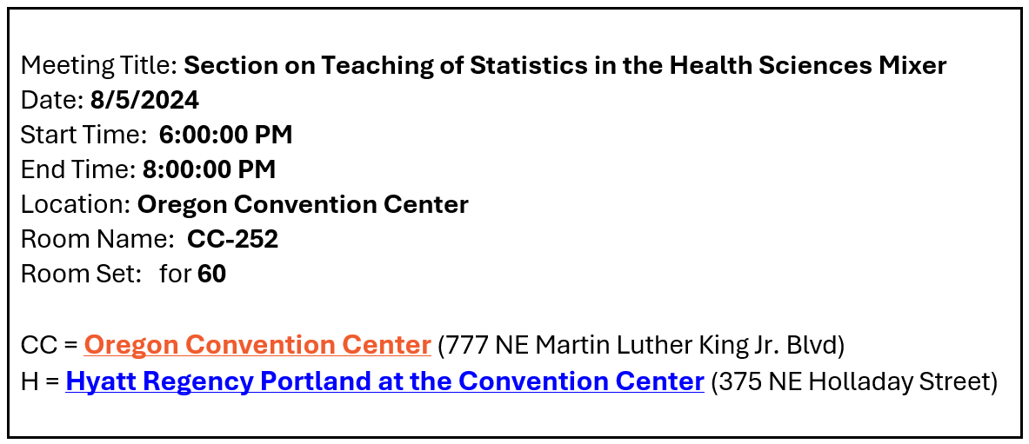

NOTE: They currently have the food selections below which I do not remember placing. I’m waiting to hear back from Christina on these final food details (see below). The food order below is about $3000 with tax and tip (25%) it is ~$3750.

For the conference center, here is the MENU options: https://www.oregoncc.org/sites/default/files/2023/10/25/Website%20Version%20OCC%20-%20Catering%20Menu.pdf

The final catering menu with prices is on our Google Drive at https://drive.google.com/file/d/1KEpT57LmTxJ43aGgII5OaDMqlPGOs0jZ/view?usp=drive_link

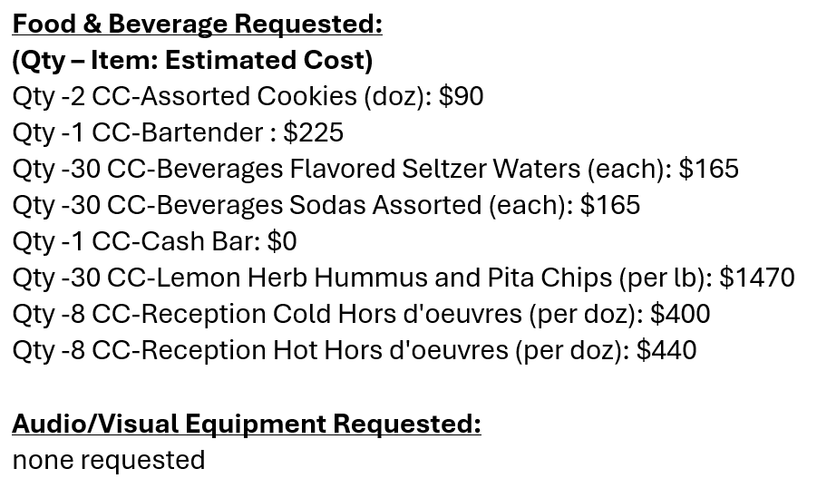

Nominations Update (Melinda)
- Melinda contacted Haley Grant - waiting to hear back.
- These awards are confirmed and will be presented at the JSM 2024 Mixer:
  - Distinguished Achievement Award $250: Jeff Szychowski jszychow@uab.edu
  - Outstanding Teaching Award $250: Hilary Watt h.watt@imperial.ac.uk
  - Young Investigator Award $500: Alice Paul alice_paul@brown.edu
  - Council of Sections Outstanding Service Award: Ann Brearley brea0022@umn.edu

Webinars Update (Darsy - on vacation)
- Next(Fall) webinar: Juan Klopper from The George Washington University Biostatistics and Bioinformatics Department is interested in AI and teaching Biostatistics.
- Looking for someone who can give a webinar on AI being used in teaching Biostatistics. Jaya Satagopan shared link of using AI in public health at Univ. of Mich. as a possible webinar speaker.
- Melinda sent DRAFT Letter of Appreciation to Darsy for review. We will get this sent out to the Spring Webinar panelists and presenters by July.

Portal Update (Carol, Jenna)
- Updates from Carol - two datasets have been reviewed. Carol to put together the actual posting to the portal after checking them. To be announced at mixer.
- Status of recognizing Dennis Pearl at JSM for his contributions to the portal? Waiting to find out if he will be at JSM.

Career Development Update (Ada)
- Melinda waiting to hear if Haley Grant is interested in this position

Blog Update (Charlotte)
- Charlotte updates:
  - two posts added to the blog about the webinar and the resource review.
  - Melinda will send to Charlotte - the specific announcements for JSM including mixer info and highlighting sessions to attend, etc. It would be great if I could get that by the end of June so I can post it in July.
  - What JSM sessions should we highlight?

- Status of next resource review (Jim and Ming): Looking at machine learning in teaching statistics in health care.

Publicity Update (Heather)
- Posted the publications and grants surveys requests on the discussion forum.
- Webinar summary almost finished and will be posted soon.
- Call for award nominees posted in Amstat News.

Website/YouTube Update (Ed)
- We are not putting award winners into the website until the Mixer, but once we do it will be helpful to have the relevant information. Each award needs different information. For young investigator, the listing should include the paper they submitted. Most of the others should have a blog post the site can link to.

Council of Sections Update (Amy and Melinda)
- Council of Sections governing board meeting on Sunday of JSM (August 4).
- Melinda attended the June 4, 2024 ASA Education Council meeting.
  - We have until July 12th to provide feedback on the DRAFT Education Strategic Plan, uploaded to Our Google Drive at https://docs.google.com/document/d/1OxU201Epw8OeQzYIA__PYvdbP8TAV5OA/edit?usp=sharing&ouid=111562570507272542777&rtpof=true&sd=true - feel free to review and send Melinda (melinda.higgins@emory.edu) any comments or feedback you’d like for me to send back to committee.

Fellows Committee Update (Amy)
- No nominations this cycle. Send out emails for names next month.

New Member Welcome (Melinda)
- DONE - Melinda sent the updated email template to Angelo on 05/24/2024. Angelo has sent the new members email to all new members from Q2-2024 using list from Rick Peterson. Next new member email to be sent in early July.

Section Handbook/Operations Manual (Jacqui)
- Melinda got confirmation from Jacqui – revisions to the Operations Manual are complete - see https://docs.google.com/document/d/1lREbE5mrjbikOjiHqfCC5xwKU7VIywFF/edit?usp=drive_link&ouid=111562570507272542777&rtpof=true&sd=true

Other Business

NOTE: Echo360 Links to Date:
- June 2024 meeting recording, https://echo360.org/media/db23ad16-3f28-451d-931c-8da00fb3f716/public
- May 2024 meeting recording, https://echo360.org/media/bdc98b95-917a-49fc-a895-68fc0ebe8b0b/public
- April 2024 meeting recording, https://echo360.org/media/a4d6becd-09f1-4c6f-afb9-646ddb00a70a/public
- March 2024 meeting recording, https://echo360.org/media/c6144ca9-b1e3-4c39-bcc0-3736852bb713/public
- February 2024 meeting recording, https://echo360.org/media/2602d4d7-e8ad-4fd4-8b84-4a34d0a73e1a/public
- January 2024 meeting recording, https://echo360.org/media/8365c2b1-efc9-44fe-bf14-1d933972fc7a/public

