ASA Section on Teaching of Statistics in the Health Sciences (TSHS)
Executive Committee Meeting Minutes

15 April 2024 / 1:00-2:00 PM Eastern / [ZOOM - updated link, https://zoom.us/j/91426027055?pwd=REg4VnNRRC9zSEgrM050cFVkZkhhUT09

2024 Executive Committee |  | emails |  | Present?
Elected Officers (Voting)
Melinda Higgins | Chair | Melinda.higgins@emory.edu | x
Maria Ciarleglio | Past-Chair | maria.ciarleglio.yale@gmail.com | x
Jaya Satagopan | Chair-Elect | satagopj@sph.rutgers.edu | x
Amy Nowacki | Council of Sections Representative (2022-2024) | nowacka@ccf.org
Appointed Voting Officers
Angelo Elmi | Secretary (2024-2025) | afelmi@gwu.edu | x
John Doucette | Treasurer (2024-2025) | john.doucette@mssm.edu | x
Usha Govindarajulu | Program Chair (2024) | usha.govindarajulu@mountsinai.org | x
Ed Gracely | Webmaster | eg26@drexel.edu | X
Heather Hoffman | Publicity Officer | hhoffman@email.gwu.edu
Charlotte Bolch | Blog Editor | cbolch@midwestern.edu | x
Appointed Non-Voting Officers
Jim Dignam | Resource Review Co-Editor (2023) | jdignam@bsd.uchicago.edu
Mingzhao Hu | Resource Review Co-Editor (2023)  Program Chair Elect (2024) | Hu.Mingzhao@mayo.edu | x
Carol Bigelow | Portal Co-Director | cbigelow@schoolph.umass.edu | x
Jenna Carlson | Portal Co-Director | jnc35@pitt.edu
Amy Nowacki | ASA Fellows Nominations Chair | nowacka@ccf.org
Darsy Darssan | Webinar Coordinator | d.darssan@uq.edu.au | x
Ada Youk – suggested nominee | Career Development Chair | ayouk@pitt.edu

Call to Order (Melinda)
- Melinda called the meeting to order at 1:05 pm EST

Review/Approval of March 2024 Minutes (Angelo)
- March Minutes approved by committee.

Treasury Report (John)
- JSM is asking if we will fund the luncheon ticket. Need to pay for the speaker ($25 for breakfast and $50 for lunches).
- John is waiting to hear back about financials. He was notified by Rick of forthcoming change where treasurers can view balance directly in the future. No update as of April.
- STATA is being invoiced for $5000 contribution.

JSM (Usha, Mingzhao)
- Updates on reserving a community table for JSM 2024 – Ming
  - Will follow up.
- Updates on getting a new poster printed for JSM 2024 – Ming
  - poster (about $120), business cards, flyers need to be designed, finalized in May/June, encouraged people to reach out with contributions for design.
- Melinda will put in a meeting/event request for JSM for 2 events – finalizing time/location
  - Event 1: Monday Aug 5 from 7:00 – 8:30 am
    - Morning Business Meeting
    - 20 people
  - Event 2: Monday Aug 5 from 6:00 – 8:00 pm
    - Evening Mixer for TSHS Section Members
    - 50-60 people
- Ming Hu - discuss requests and funding for 4 roundtables

Nominations Update (Melinda)
- Ada suggested Haley Grant for the career development position, Assistant Professor at Univ of Pitt, https://www.sph.pitt.edu/directory/haley-grant (to be updated).
- Discussion about hiring someone more senior. Melinda will reach out to Haley and discussion will continue next month.
- Nominee selected for Outstanding Section Service Award.

Webinars Update (Darsy)
- 17 participants for K-12 Biostatistics outreach webinar. Recording available on youtube (https://www.youtube.com/watch?v=yTkO5QDFf8o ) and on our website.
- Next(Fall) webinar: Juan Klopper from The George Washington University Biostatistics and Bioinformatics Department is interested in AI and teaching Biostatistics.
- Looking for someone who can give a webinar on AI being used in teaching Biostatistics. Jaya Satagopan shared link of using AI in public health at Univ. of Mich. as a possible webinar speaker.

- Portal Update (Carol, Jenna)
- Update from Carol (Feb 2024):
  - “I now have Julia Soulakova's data set and she has asked me to do a first draft of her dataset submission to the portal. I am happy to do this because I have the time, I think it will markedly expedite the process, and she is very busy at her end.
  - Regarding the Stand Your Ground Dataset and dealing with the Tampa Bay Times, after some exchanges with an attorney (who specializes in copyright and data use matters), the clear sense I got is that I might be being overly cautious. The attorney's conclusion is that if the publication is already out and Nicole Ackerman had permission, then it may even not be necessary to go beyond the permission I have from Nicole. And that if I do pursue any sort of interaction with the Tampa Bay Times, I should frame it as "I'm just letting you know" rather then as a "May I please". So I will be moving forward on this dataset as well.”
  - Recognize Dennis Pearl at JSM for his contributions to the portal?

Career Development Update (Ada)
- Melinda received a request for support from Hadiza Galadima (Assistant Professor of Biostatistics at Old Dominion University) who was the recipient of the 2023 TSHS Outstanding Teaching Award. Ideas from the committee on recommended/suggested reviewers?
- Membership database posted with space to fill in faculty institutions and ranks: https://docs.google.com/spreadsheets/d/1eWVtFjHslvM7pfqUMLmNFROiWa2f5TO5/edit?usp=drive_link
- We should check and update. The list could be used for letter writers (e.g. for promotions/tenure).

Blog Update (Charlotte)
- Status of next resource review (Jim and Ming): Last review posted by Charlotte on 1/2/2024. The next review is due in March. Likely to continue into April.
- Blog post on effect sizes being finished up.
- Please send photos to post on the blog officer page to Charlotte.

Publicity Update (Heather)
- Posted the publications and grants surveys requests on the discussion forum.
- Webinar summary almost finished and will be posted soon.
- To do: We would like to look into what can be posted on Amstat News.

Website/YouTube Update (Ed)
- Our YouTube channel has 25 subscribers.
When linking to or advertising our webinars, use the Initiatives → Educational Activities buttons to get the YouTube link.
Going through the Library may take people to an intermediate link that requires a TSHS login to access.
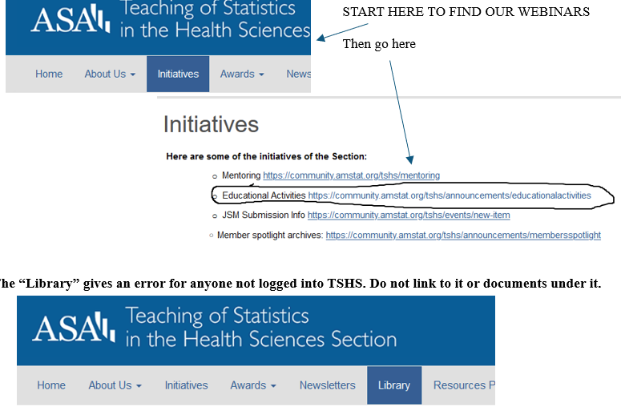

Council of Sections Update (Amy and Melinda)
- Statistics and Data Science in Aging interest group proposal has been submitted to the Council of Sections Governing Board (COSGB). The proposed interest group was discussed during our recent COSGB meeting and the members of the governing board found it to be favorable. Before the COSGB takes a vote on the interest group, we wanted to share this with you to make sure your section wouldn’t have any concerns if this interest group is formed. Similarly, we would like to hear if your section supports the proposed interest group. More information on the proposed interest group and their intentions can be found in the attached letter. If you have any feedback on this, please submit it to your COS representative (Amy Nowacki – nowacka@ccf.org) so that they may respond to the COSGB no later than Tuesday, April 30.
- Also, NEW! ASA recently created the ASA Leader HUB, where ASA volunteers can find tools and materials all in one convenient location.
- Melinda attended the ASA Education Council meeting on April 4th. Material shared via email and will be uploaded to the google drive, in the /ExecutiveCommittee/Agendas_2024/EducationCouncilMeeting_04042024/ folder.

Fellows Committee Update (Amy)
- No nominations this cycle.

New Member Welcome (Melinda)
- To do (Melinda): Send to Angelo for Quarter 1 of 2024 by end of March. In April the new member welcome letter will be sent to new members after obtaining emails from Rick Peterson. Melinda will send to Angelo.

Section Handbook/Operations Manual (Jacqui)
- Melinda emailed Jacqui – waiting for an update
- Status of Operations Manual (Jacqui):
  - The Budget Committee and Nominations Committee exist in the manual, but the duties of these committees are actually performed by the Treasurer and Awards Committee. These committees will be removed.
  - Need to add a new section for Darsy’s role organizing Webinars.
  - Need to add details about the Career Development committee.
- Latest version of Operations Manual uploaded to tshs.asa shared Google drive

Other Business
- Google Drive – does everyone have access?
- Recordings of Meetings? Melinda can share via Echo360 – other preferred options? Could take up a lot of memory/space on Google Drive…

NOTE: Echo360 Links to Date:
- April 2024 meeting recording, https://echo360.org/media/a4d6becd-09f1-4c6f-afb9-646ddb00a70a/public
- March 2024 meeting recording, https://echo360.org/media/c6144ca9-b1e3-4c39-bcc0-3736852bb713/public
- February 2024 meeting recording, https://echo360.org/media/2602d4d7-e8ad-4fd4-8b84-4a34d0a73e1a/public
- January 2024 meeting recording, https://echo360.org/media/8365c2b1-efc9-44fe-bf14-1d933972fc7a/public

