ASA Section on Teaching of Statistics in the Health Sciences (TSHS)
Executive Committee Meeting Minutes

16 February 2024 / 1:00-2:00 PM Eastern / [ZOOM - updated link, https://zoom.us/j/91426027055?pwd=REg4VnNRRC9zSEgrM050cFVkZkhhUT09

2024 Executive Committee |  | emails |  | Present?
Elected Officers (Voting)
Melinda Higgins | Chair | Melinda.higgins@emory.edu | X
Maria Ciarleglio | Past-Chair | maria.ciarleglio.yale@gmail.com
Jaya Satagopan | Chair-Elect | satagopj@sph.rutgers.edu | X
Amy Nowacki | Council of Sections Representative (2022-2024) | nowacka@ccf.org
Appointed Voting Officers
Angelo Elmi | Secretary (2024-2025) | afelmi@gwu.edu
John Doucette | Treasurer (2024-2025) | john.doucette@mssm.edu | X
Usha Govindarajulu | Program Chair (2024) | usha.govindarajulu@mountsinai.org | X
Ed Gracely | Webmaster | eg26@drexel.edu | X
Heather Hoffman | Publicity Officer | hhoffman@email.gwu.edu | X
Charlotte Bolch | Blog Editor | cbolch@midwestern.edu | X
Appointed Non-Voting Officers
Jim Dignam | Resource Review Co-Editor (2023) | jdignam@bsd.uchicago.edu
Mingzhao Hu | Resource Review Co-Editor (2023)  Program Chair Elect (2024) | Hu.Mingzhao@mayo.edu | X
Carol Bigelow | Portal Co-Director | cbigelow@schoolph.umass.edu
Jenna Carlson | Portal Co-Director | jnc35@pitt.edu
Amy Nowacki | ASA Fellows Nominations Chair | nowacka@ccf.org | X
Darsy Darssan | Webinar Coordinator | d.darssan@uq.edu.au | X
Ada Youk  Need to update? | Career Development Chair | ayouk@pitt.edu | X

Call to Order (Melinda)
- Melinda called the meeting to order at 1:05 pm EST

Review/Approval of January 2024 Minutes (Angelo)
- Minutes were taken from December 2023 meeting by Jesse Troy. Final edits from Jesse were sent on January 28, 2024 and were approved during the February meeting.

Treasury Report (John)
- Submitted section award form for the best contributed presentation at JSM 2023. Darsy Darssan will receive the award soon.
- Received four roundtable abstract submissions. JSM is asking if we will fund luncheon ticket ($25 for breakfast and $50 for lunches). We are waiting to hear back for clarification regarding email below.

“However, please do check with the section to be sure they are willing to fund the luncheon tickets for the 4 proposals you received. The cost is $25 for AM roundtables and $50 for PM roundtables. Please let us know if you have any further questions at all.

Thank you,
Kathleen”

If we are told that the money is for the speakers, we will reply and say yes.

JSM (Usha, Mingzhao)
- Melinda received notification for 2 JSM Requests – meeting/events and a community table (details below) – role of Usha as Program Chair?
  - JSM 2024 – Meeting/Event Request:
  - 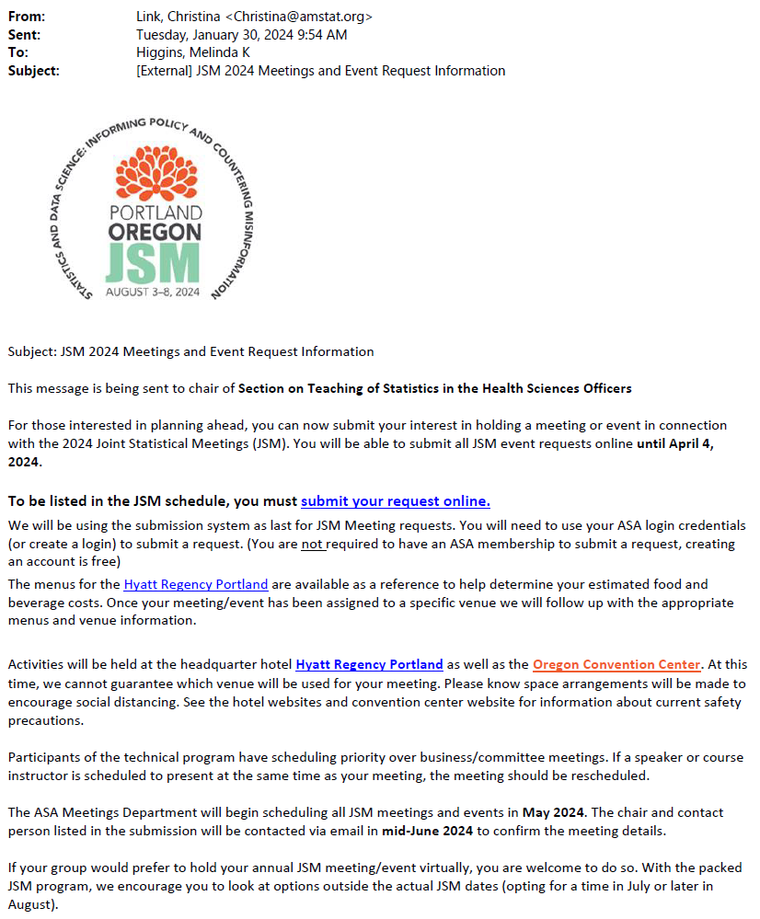
  - Per Maria for the 2024 JSM: “We have two events that we need to reserve rooms for: the Mixer and the Business Meeting. For the business meeting, we usually reserve a conference style room for about 20 people. The business meeting is always on the Monday morning of JSM from 7‐8:30 am. The Chair purchases food for the business meeting (i.e., no food is ordered through JSM). No AV or audio is usually requested. For the mixer, we usually requests a reception style room for about 50 people. The mixer is always on the Monday evening of JSM from 6‐8 pm. We order food through JSM for the mixer. You can choose the menu of appetizers and beverages that you like. I recall that last year, when I submitted the room request, I just selected some general food and beverage items and then later (closer to JSM) ASA contacted me for the detailed menu selections. I did not choose alcoholic beverages or to have a bartender this year, but you could choose to do that. We have done that in the past but they usually require a bartender. We also do not usually request AV or audio for the mixer. Also I did not choose to have a bartender or alcoholic beverages at the mixer LAST year. But you can choose to have that this year, if you’d like. We just had sodas and bottled water at the mixer last year.
  - Request for a community table:
  - 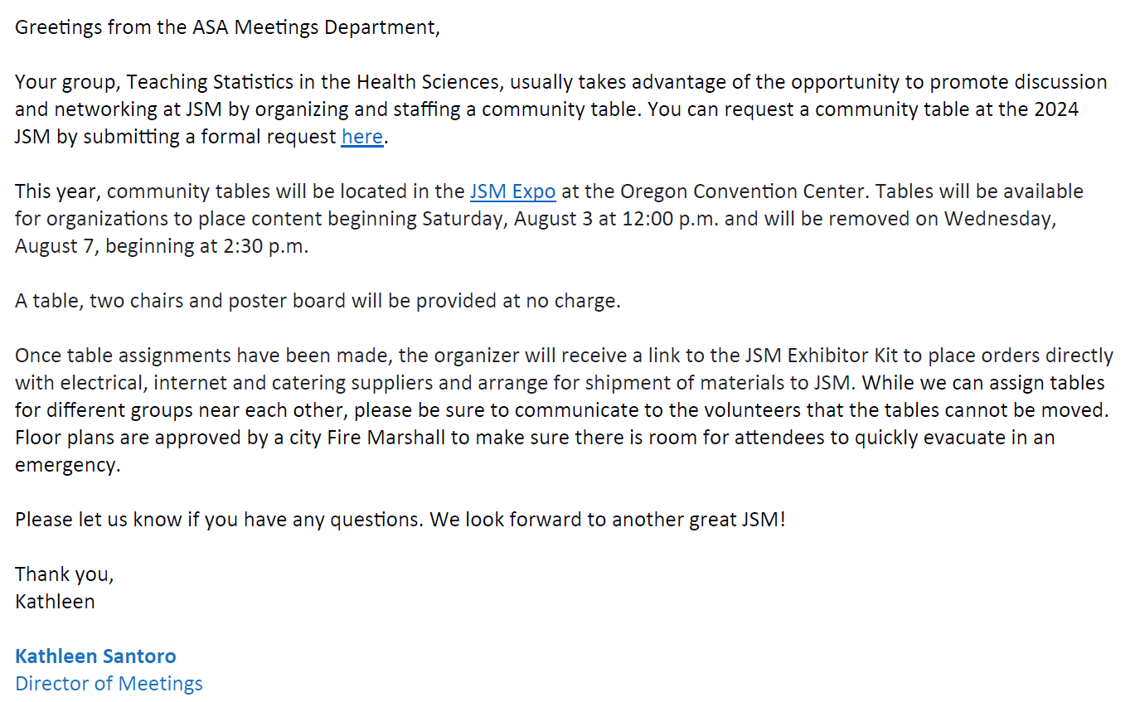
- Ming Hu - discuss requests and funding for 4 roundtables
- No contributed abstracts yet. Waiting for submissions. Submissions closed on Feb. 1.

Nominations Update (Melinda)
- Nominations will be discussed with Ada to figure out Career Development chair.

Webinars Update (Darsy)
- Next Webinar: Meeting students where they are: K-12 Biostatistics outreach
- Format: Panel discussion, led by Marta Shore, Lecturer, Division of Biostatistics & Health Data Science at the University of Minnesota. Panelists include: Dr. Anne Eaton, Assistant Professor, Division of Biostatistics & Health Data Science at the University of Minnesota; Dr. Sarah Samorodnitsky, Postdoctoral Research Fellow, Fred Hutch Cancer Research Center; Michelle Sonnenberger, PhD Graduate Student, Division of Biostatistics & Health Data Science at the University of Minnesota. and Jacqueline Hicks..
- Late for Winter Webinar
- Possible date: April 9th 3 pm CT US? (Note the DT change)
- Will send the details to Heather.
- Following (Fall webinar): Brief discussion about a webinar in teaching statistics in health sciences with AI. Heather mentioned someone at GW to whom she will reach out. Darsy will reach out to Heather and Jaya.

Portal Update (Carol, Jenna)
- Update from Carol (Feb 2024):
  - “I now have Julia Soulakova's data set and she has asked me to do a first draft of her dataset submission to the portal. I am happy to do this because I have the time, I think it will markedly expedite the process, and she is very busy at her end. Regarding the Stand Your Ground Dataset and dealing with the Tampa Bay Times, after some exchanges with an attorney (who specializes in copyright and data use matters), the clear sense I got is that I might be being overly cautious. The attorney's conclusion is that if the publication is already out and Nicole Ackerman had permission, then it may even not be necessary to go beyond the permission I have from Nicole. And that if I do pursue any sort of interaction with the Tampa Bay Times, I should frame it as "I'm just letting you know" rather then as a "May I please". So I will be moving forward on this dataset as well.”

Career Development Update (Ada)
- Membership database posted with space to fill in faculty institutions and ranks: https://docs.google.com/spreadsheets/d/1eWVtFjHslvM7pfqUMLmNFROiWa2f5TO5/edit?usp=drive_link
- We should check and update. The list could be used for letter writers (e.g. for promotions/tenure).

Blog Update (Charlotte)
- Status of next resource review (Jim and Ming): Last review posted by Charlotte on 1/2/2024. The next review is due in March.
- Please send photos to posting on the blog officer page to Charlotte.
- Incoming TSHS 2024 chair message to Charlotte to post. Melinda sent DRAFT and has gotten feedback. Is a new career development chair needed?.

Publicity Update (Heather)
- To do (Heather): Discussion forum post publicizing new resource review and outgoing Chair message after each is posted to blog has been completed.
- Announcement needed that the download feature is offline for TSHS Dataset portal. Another announcement is needed when it is back up.
- Questionnaires regarding grants and publications will be sent out to TSHS members.

Website/YouTube Update (Ed)
Nothing new. Some broken links on the home page were fixed.

Council of Sections Update (Amy)
- No updates yet.

Fellows Committee Update (Amy)
- No nominations this cycle.

New Member Welcome (Maria)
- To do (Melinda): Send to Angelo for Quarter 1 of 2024 by end of March. In April the new member welcome letter will be sent to new members after obtaining emails from Rick Peterson.

Section Handbook/Operations Manual (Jacqui)
- Need to follow-up with Jacqui to confirm status - Melinda will contact Jacqui - and will send back out to committee for any final reviews
- Status of Operations Manual (Jacqui):
  - The Budget Committee and Nominations Committee exist in the manual, but the duties of these committees are actually performed by the Treasurer and Awards Committee. These committees will be removed.
  - Need to add a new section for Darsy’s role organizing Webinars.
  - Need to add details about the Career Development committee.
- Latest version of Operations Manual uploaded to tshs.asa shared Google drive

Other Business
- Google Drive - does everyone have access?
- Recordings of Meetings? Melinda can share via Echo360 - other preferred options? Could take up a lot of memory/space on Google Drive…

NOTE: Link to meeting recording, https://echo360.org/media/2602d4d7-e8ad-4fd4-8b84-4a34d0a73e1a/public

