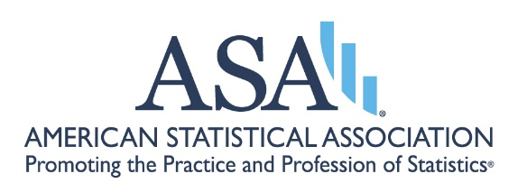

It is important to the ASA and its members that sections and interest groups (IG) are performing well by:
- engaging with their membership
- delivering the services and resources that benefit current members per charter objectives and
- promoting their activities to attract new members
The purpose of this questionnaire is to collect data to inform the Council of Sections (COS), Council of Sections Governing Board (COSGB), and the ASA Board of the activities of all sections and interest groups, and to provide the COSGB with information it can use to assist sections in strengthening and promoting their work.

The Questionnaire is due on January 16, 2026.

2024 Section/Interest Group (IG) Annual Questionnaire
*For the period covering the calendar year 2025.*

---

Section Information
- Section Name:
- Name of Person Submitting Report:
- Email:

Communications
- Number of Newsletters Published:
- Articles Submitted to Amstat News:
- "Welcome New Members" Initiative Implemented: Yes | No
- Last Website Update (Month):
- Social Media Platforms Used:
- Other Communication Methods:

Meeting & Networking Activities
- Number of Sponsored ASA or Non-ASA Conferences:
- Number of Roundtables at JSM:
- Number of Invited or Topic-Contributed Sessions at JSM
(Including Co-sponsored Sessions):
- Member Mixer/Business Meeting at JSM: Yes | No
- Other Networking Activities:

Professional Development & Mentoring
- Number of Webinars Offered:
Topics:
- Number of Professional Development Courses:
Topics:
- Other Professional Development Activities:
- Mentoring Program Offered: Yes | No

Support for Students & Early Career Statisticians
- Travel Grants or Scholarships Sponsored: Yes | No
- Student Outreach Programs Conducted (K-12, Undergrad,
Grad): Yes | No
- Other Support Initiatives:

Outreach Activities
- Coordination with Other Sections: Yes | No
- New Member Recruitment Conducted: Yes | No
- Public Relations Activities:
- Other Outreach Activities:
- Diversity and Inclusion Activities:

Recognition and Awards (For Sections Only)
- Student Awards Offered: Yes | No
- Name(s) of Award(s)
- Number of Awards
- Volunteer Recognition or Member Awards Offered: Yes | No
- Name(s) of Award(s)
- Number of Awards
- ASA Fellow Nomination Committee Established: Yes | No
- Other Recognition Methods:

Executive Committee Activities (For Sections Only)
- Number of Meetings Held:
- Meeting Agendas and Minutes Maintained: Yes | No
- Full Slate of Officer Candidates Submitted for Next Year's
Election: Yes | No
- Position Responsibilities Provided to Candidates: Yes | No
- Officer Training/Orientation Conducted: Yes | No

Challenges and Future Plans
- Barriers or Challenges Faced:
- Assistance Needed from ASA:
- New Initiatives Planned for Next Year:
- Suggestions for Improving this Questionnaire:
- Suggestions for Improving COSGB Support:

Overall Section Performance
- Performance Rating by the Executive Committee:
Excellent | Good | Neutral | Fair | Poor
- Comments on the Performance Rating:

