
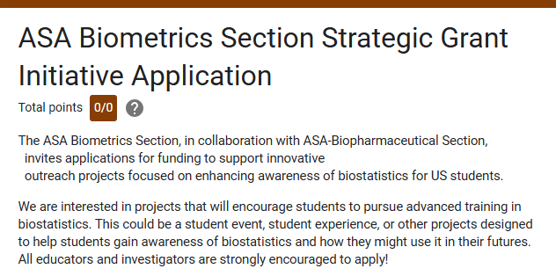
Your Name

-------------------------------------------------------------------

Your Title / Position

-------------------------------------------------------------------

Your Email

-------------------------------------------------------------------

Your Institution

-------------------------------------------------------------------

Are you a member of the ASA? This is required for the grant to be awarded
- Yes
- No

Requested Funding Amount (typical range $250-$1000)

-------------------------------------------------------------------

In 250 - 500 words, please describe the project you are requesting funding for. Make sure to emphasize how your project will help students gain awareness of biostatistics/statistics and will hopefully motivate them to consider further study in the field.

Please clearly state how you plan to use the funding, with specific amounts if possible. For example: $250 for student t-shirts, $150 for student snacks, for a total of $400 requested in funding.
Note: We cannot fund things like secretarial/administrative personnel, tuition, foreign travel, and honoraria and travel expenses for visiting lecturers to the investigator's home institution.

When would you plan on using the funding? This can be vague (like Spring 2026) or specific (like December 12, 2025). Please note that funding should be used by July 1, 2026 at the latest.

We request that all grant recipients share some type of deliverable to show how the funding has been used. This can be something like pictures from a student event with a summary of how many students attended, for example. Please explain briefly what deliverable you plan to share to show how the funding was used.

Thank you!!
Thank you so much for taking the time to apply. If you have any questions, please feel free to email Milan Bimali (MBimali@uams.edu) or Nicole Dalzell (dalzelnm@wfu.edu). We'd be happy to connect with you!

