WOMEN IN IP LAW GLOBAL NETWORKING EVENT 2022

After two amazing virtual events in 2020 and 2021, our 2022 event will be mostly “in person” again!

Now in its 15th year, the event takes place on a single day and comprises a series of events taking place in different cities around the world. The events are hosted by firms or companies in their city, either at their premises or an external venue which they arrange, and there is an international networking meet up in which events taking place at that time connect by videoconference to learn about each other and share details of the event.

This year’s event will take place on Thursday 7 April 2022, which is World Health Day. We have therefore chosen for this year’s event theme: Being Happy and Healthy in Our Work.

We also encourage hosts and attendees to post about their events on social media.

You can see details of previous events by searching for the hashtag #WIPNE on LinkedIn, Twitter and Facebook or by looking at our pages.

Our confirmed countries and cities for 2022 are listed below – thank you to each of our wonderful hosts. Contact details are provided for some events. If there are no contact details and you are interested in joining an event please contact me at sarah.kostiuk@mewburn.com and I will connect you with the local host.

A small number of our hosts are holding virtual events. If there is no event local to you, please consider joining one of those. Again, details are provided below.

We look forward to seeing you there.

Sarah Kostiuk-Smith
Global Networking Event Co-Chair
Partner, European Patent Attorney
Mewburn Ellis LLP

Virtual Events

Calgary, Canada (flower arranging, in English, local delivery only) - Link here

Hong Kong - contact me for details

Lima, Peru (panel discussion, in Spanish) - contact me for details

Mexico City, Mexico (panel discussion, in Spanish) – contact me for details

Milan, Italy (yoga, in English) - Link here

Rio di Janeiro, Brazil (panel discussion, in Portuguese) - Link here

South Africa (virtual safari, in English) - Link here

Warsaw, Poland (Panel discussion, in Polish) - Link here

US States

Austin, TX |    |  | New Orleans, LA | 
Boston, MA |  |  | Northern VA |   Link here
Chicago, IL |   Link here |  | Raleigh, NC | 
Denver, CO |  |  | Rochester, NY | 
Des Moines, IA |  |  | San Diego, CA | 
Frisco, TX |  |  | St Louis, MO | 
Greenville, SC | 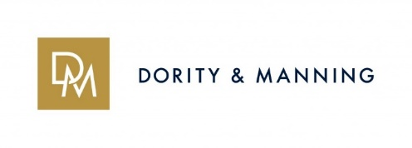 |  | Twin Cities,  Minnesota | 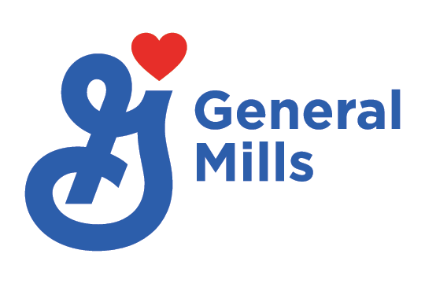
Hartford, CT |   events@cantorcolburn.com |  |  |  Link here
Houston, TX |  |  | Washington DC |   Link here
 |  |  | Wilmington, DE | 
Europe

Amsterdam, Netherlands | 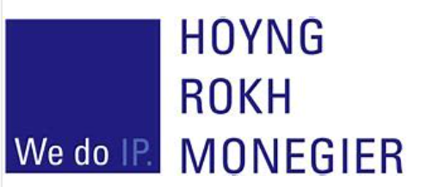  women.ip@hoyngrokh.com | Manchester, UK | 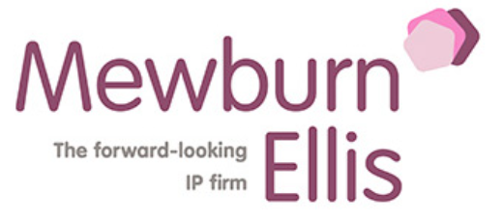  Link here
Dusseldorf, Germany | women.ip@hoyngrokh.com | Milan, Italy |   Link here
Tel Aviv, Israel |   Link here | Munich, Germany | 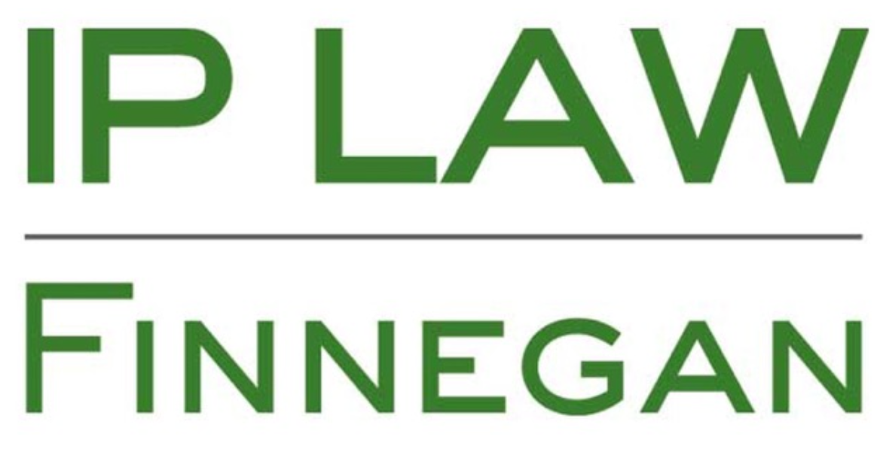  Link here
Kyiv, Ukraine |   There will be no event in Kyiv this year. Our thoughts are with our confirmed hosts. | Paris, France | 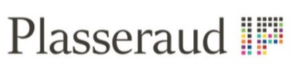  
London, UK |   events@boult.com. | Vienna, Austria | 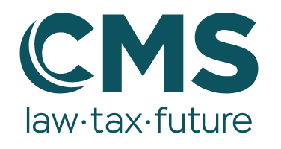
Madrid, Spain | 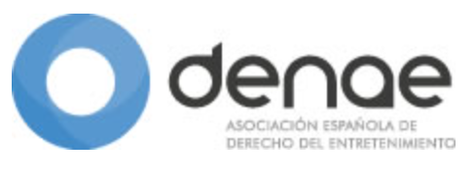 | Warsaw, Poland |   Link here

Around the rest of the world

Buenos Aires, Argentina | 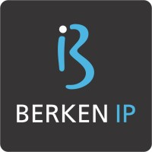 | Guadalajara, Mexico | 
Calgary, Canada |   Link here | Mexico City, Mexico | 
Toronto,  Canada |   Link here | Quito, Ecuador | 
Lima, Peru | 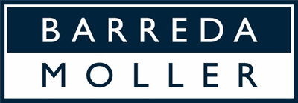  Link here | Rio de Janeiro, Brazil |   Link here

Pretoria, South Africa |   Link here | New Delhi, India | 
Cairo, Egypt |  | Pune, India | 
Hangzhou, China |  | Jakarta,  Indonesia | 
Hong Kong, China |  | Singapore | 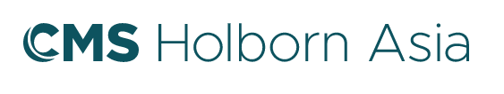
Japan | 

 | Contact | On group email? | Member list sent? | Call time
Austin, TX | sarah.kostiuk@mewburn.com | Y | Requested | 20:00 CST
Boston, MA | sarah.kostiuk@mewburn.com | Y | Requested | 19:00 EDT
Chicago, IL | Link here | Y | Requested | Will advise
Denver, CO | sarah.kostiuk@mewburn.com | Y | Requested | 9:00PDT
Des Moines, IA | sarah.kostiuk@mewburn.com | Y | Y
Frisco, TX | sarah.kostiuk@mewburn.com | Y | Requested | 19:00 EDT
Greenville, SC | sarah.kostiuk@mewburn.com | Y | Requested | 19:00 EDT
Hartford, CT | events@cantorcolburn.com | Y | Requested | 19:00 EDT
Houston, TX | sarah.kostiuk@mewburn.com | Y | Requested
New Orleans, LA | sarah.kostiuk@mewburn.com | Y | Y | 12:00 EDT
Northern VA | Link here | Y | Y | 19:00 EDT
Portland, OR | sarah.kostiuk@mewburn.com | Y | ?? | 9:00 PDT
Raleigh, NC | sarah.kostiuk@mewburn.com | Y | Y | 19:00 EDT
Rochester, NY | sarah.kostiuk@mewburn.com | Y | Y | 19:00 EST
San Diego, CA | sarah.kostiuk@mewburn.com | Y | Y | Will advise
St Louis, MO | sarah.kostiuk@mewburn.com | Y | ?? | 19:00 EDT
Twin Cities,  Minnesota | Link here | Y | Y | 19:00 EDT
Washington DC | Link here | Y |  | 19:00 EDT
Wilmington, DE | sarah.kostiuk@mewburn.com | Y | Y | Not participating in call
19
Amsterdam, Netherlands | women.ip@hoyngrokh.com | Y | Y | 18:00 CEST
Dusseldorf, Germany | women.ip@hoyngrokh.com | Y | Y | 14:00 CEST
Tel Aviv, Israel | Link here |  | Y | Won’t join call
London, UK | events@boult.com | Y | Y | 18:00 CEST
Madrid, Spain | sarah.kostiuk@mewburn.com |  |  | 18:00 CEST
Manchester, UK | Link here |  | Y | 18:00 CEST
Milan, Italy | Link here |  | Y | 2:00 CET In person or online
Munich | Link here | Y | Y | 14:00 CEST
Paris, France | sarah.kostiuk@mewburn.com | Y
Vienna, Austria | sarah.kostiuk@mewburn.com | Y | Y | 18:00 CEST
Warsaw, Poland | Link here | Y |  | 2pm CEST  (virtual)
11
Buenos Aires, Argentina | sarah.kostiuk@mewburn.com | Y | Y | Call does not coincide – may join call 4 or send video
Calgary, Canada | Link here | Y | Y | 9:00 PDT  (Virtual)
Toronto,  Canada | sarah.kostiuk@mewburn.com | Y | Y | 19:00 EDT
Guadalajara, Mexico | sarah.kostiuk@mewburn.com | Y |  | 19:00 EDT
Mexico City, Mexico | sarah.kostiuk@mewburn.com | Y |  | 19:00 EDT (virtual)
Lima, Peru | Link here | Y |  | 19:00 EDT (virtual)
Rio de Janeiro, Brazil | Link here | Y |  | Won’t join call
Quito, Ecuador | sarah.kostiuk@mewburn.com | Y |  | 12:00 EDT
8
Cape Town | Link here | Y | Y | Online
Pretoria, South Africa | Link here | Y | Y | Online
Cairo, Egypt | sarah.kostiuk@mewburn.com | Y | Y | 14:00 CEST
Hangzhou, China | sarah.kostiuk@mewburn.com | Y | Cindy | 8:00 EDT
Hong Kong, China | sarah.kostiuk@mewburn.com | Y | Cindy | Unsure because of Covid Situation
New Delhi, India | sarah.kostiuk@mewburn.com | Y | Cindy | 17:30 IST
Pune, India | sarah.kostiuk@mewburn.com | Y | Cindy | 17:30 IST
Jakarta, Indonesia | sarah.kostiuk@mewburn.com | Y | Cindy | 10:00 (8/4) CST
Singapore | sarah.kostiuk@mewburn.com | Y | Y | 15:00 CST
Japan | sarah.kostiuk@mewburn.com | Y |  | Will not join call
10

