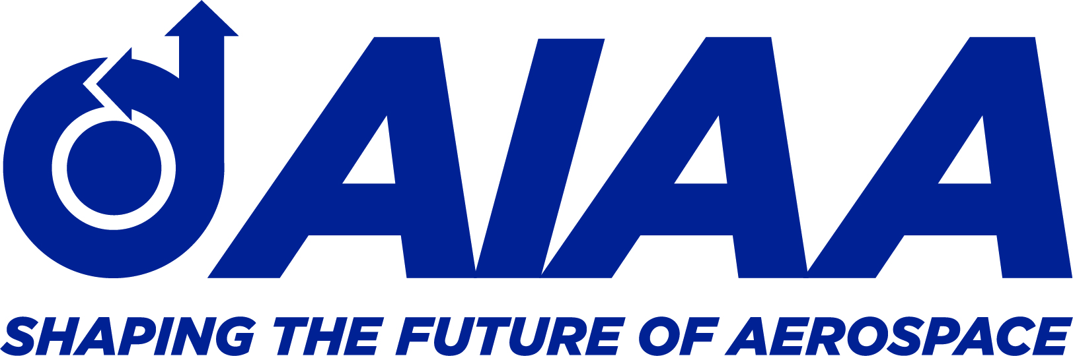

2021 AIAA Greater Huntsville Section Award Nomination Form
Purpose: This form is intended for Section awards, not for AIAA National-level award nominations
Name of Award:
Award Nominee (must be an AIAA member in good standing):
Address:
Phone Number:
E-Mail Address:
Justification (up to 5 one-line bullets/one-row bullets in the available font)
Citation (up to 25 words)

E-Mail completed form to: distribution@hsv-aiaa.org Subject: 2021 Section Awards

Award Nominator must be AIAA members in good standing. They must include their Name, Phone Number and Email address in the email when sending the nomination form. Do not include the Award nominators name on this form.

