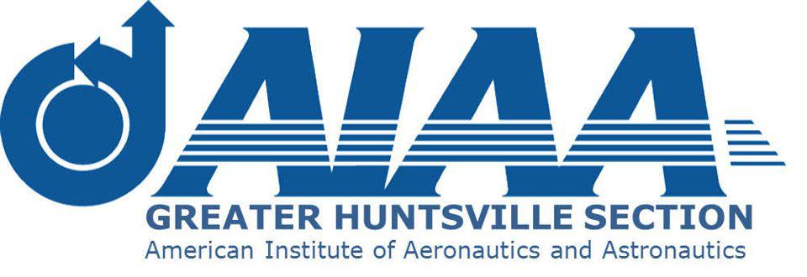

2020 AIAA Greater Huntsville Section Award Nomination Form
Purpose: This form is intended for Section awards, not for AIAA National-level award nominations
Name of Award: The Student of the Year Award
Award Nominee (must be an AIAA student member in good standing):
Graduate Undergraduate (Please check one by double clicking in the box)
Address:
Phone Number:
E-Mail Address:
Award Nominator (must be an AIAA member in good standing):
Address:
Phone Number:
E-Mail Address:
Justification (up to 5 one-line bullets/one-row bullets in the available font, not to spill over to the next line)
Citation (up to 25 words)

Advisor’s signature (Please use electronic signature if emailing):

E-Mail completed form to: joe.majdalani@gmail.com with copy to: distribution@hsv-aiaa.org Subject: 2020 Section Awards

