The 2024 AHEAD Biennial Survey:
Disability Resource Professionals in Higher Education

July 13, 2025

By Tammy Berberi, PhD, MPA

The Association on Higher Education and Disability (AHEAD)
8015 West Kenton Circle, Suite 220
Huntersville, NC 2807
Contents, Figures, and Tables
Background 6
Purpose 6
What’s new in 2024 6
Methodology 7
Survey topics 7
Data Collection 7
Response Rate 7
Dissemination of Results 7
Data 7
Data management 7
Data methodologies 8
Part I: About You 9
Section Highlights 9
Education 9
Professional experience 9
Demographic shifts 9
AHEAD membership 10
Table 1.1: AHEAD membership 10
Education 11
Figure 1.2: Most advanced degree completed 11
Table 1.2: Most advanced degree completed 11
Table 1.3: Currently working towards a degree 11
Table 1.4: Minimum education level for new hires in your current position 12
Professional Experience 13
Figure 1.5: Length of time working 13
Table 1.5: Length of time working 13
Table 1.6: Current professional title 14
Table 1.7: Prior experience in fields related to disability resources 14
Figure 1.8: Fields of influence 15
Table 1.8a: Number of responses assigning each value for fields of influence. 15
Table 1.8b: Percentage of responses assigning each value for field of influence. 16
Demographic profile 17
Figure 1.9: Age of respondents by decade 17
Table 1.9: Age of respondents 17
Figure 1.10: Prevalence of disability and health conditions among respondents 18
Table 1.10: Prevalence of disability and health conditions among disabled respondents 18
Table 1.11: Geographic location 19
Table 1.12: Race & ethnicity 19
Table 1.13: Sexual orientation among respondents 20
Table 1.14: Gender identity among respondents 20
Part 2: About Your Current Position 21
Section Highlights 21
Institutional Characteristics 22
Figure 2.1: Institutional student enrollment 22
Table 2.1: Institutional student enrollment 22
Figure 2.2: Responses by Carnegie classification 23
Table 2.2: Responses by Carnegie classification 23
Table 2.3: Prevalence of Comprehensive Transition & Postsecondary Programs by Carnegie classification 23
Table 2.4: Campus Setting 24
Table 2.5: Other institutional characteristics 24
Figure 2.6: Minority-Serving Institutions (MSI) 25
Table 2.6: Minority-Serving Institutions 25
Figure 2.7: Disability-related opportunities at responding institutions 26
Table 2.7: Disability-related opportunities at responding institutions 26
Institutional Location 27
Figure 2.8: Location of Disability Resource Offices 27
Table 2.8: Location of Disability Resource Offices 27
Figure 2.9: Location of Comprehensive Transition & Postsecondary Programs 28
Table 2.9: Location of Comprehensive Transition & Postsecondary Programs 28
Part 3: Your Appointment, Annual Earnings, and Benefits 29
Section Highlights 29
Table 3.1: Employment situation 30
Table 3.2: Appointment structure for current position 30
Table 3.3: Percentage of FTE devoted to disability resources and / or a CTP 30
Table 3.4: Funding Source for Current Position 31
Average gross annual earnings 32
Figure 3.5: Distribution of annual earnings, all roles 32
Table 3.5: Distribution of annual earnings, all roles 32
Figure 3.6: Earnings by length of time in current role (all roles) 33
Table 3.6 Earnings by length of time in current role (all roles, all institutions) 33
Figure 3.7: Earnings by degree completed and institution type 34
Table 3.7: Earnings by degree completed and institution type 34
Figure 3.8 Earnings by institution type and professional position 35
Table 3.8: Earnings professional position and institution type 35
Benefits 36
Figure 3.9: Percentage of respondents who report a given benefit 36
Table 3.9: Percentage of respondents who report a given benefit 36
Timely topics: Survey parts 4 & 5 38
Timely topics highlights 38
Part 4: Impact of legislative efforts on your work 39
Table 4.1: Awareness of efforts 39
Figure 4.2: Observed changes in staffing or resources 39
Table 4.2: Observed changes in staffing or resources 39
Table 4.3: Changes in accommodations decision-making 40
Table 4.4: Changes in morale or campus climate 40
Figure 4.5: Level of concern about legislative efforts 41
Figure 4.6: Professional resources from AHEAD 42
Table 4.6: Professional resources from AHEAD 42
Part 5: AHEAD Professional Competencies 43
Figure 5.1a: Self-assessed interest and skill level for select key attributes of the AHEAD Professional Competencies 43
Table 5.1a: Number of individual responses - Self-assessed interest and skill level for select key attributes of the AHEAD Professional Competencies 43
Table 5.1b: Percentage of respondents - Self-assessed interest and skill level for select key attributes of the AHEAD Professional Competencies 44

Background

Purpose
The results of the 2024 AHEAD Biennial Survey of Disability Resource Professionals in Higher Education provide benchmark data for the field. Such data can be useful for self-advocacy and for making professional as well as staffing decisions. Findings also chart a course for AHEAD, which seeks to advance disability equity in higher education by providing timely professional development, guidance, and resources to professionals working with disabled people in higher education.
Administered in even-numbered years since 2004, the AHEAD biennial surveys are designed to provide data about disability resource professionals and disability resource programs in an alternating schedule of survey administration: like the 2022 survey, the 2026 survey will once again focus on disability resource programs.

What’s new in 2024
Updates and changes to the survey this year were relatively minor:
- A question was added about the presence of a Comprehensive Transition and Postsecondary program (CTP); a few questions were updated to include likely staff roles for a CTP.
- Questions about disability identity were revised to reflect a broader array of disabilities and health conditions; mental health conditions were disaggregated to reflect the most common diagnoses.
- A question was added about language use other than English in one’s childhood home to better understand multiculturalism among professionals.
Other questions were updated to align with relevant survey instruments:
- Options for postsecondary institution size were aligned with categories used by the Institute for Education Sciences (IES) to better capture the experiences of professionals working at schools with fewer than 1500 students.
- Questions about sexual orientation and gender identity were aligned with two questions that were included in the American Communities Survey for the first time in 2024.

Methodology

Survey topics
As in past surveys about professionals, survey questions are organized in three sections: Part 1: About You, Part 2: About Your Current Position, and Part 3: Your Salary and Benefits.
The 2024 survey also included two timely topics:
- Perceptions of efforts to undermine and eliminate diversity, equity, and inclusion resources in higher education (as of about January 2025)
- Self-assessment of interest and skill level for select attributes of the AHEAD Professional Competencies

Data Collection
The 2024 Biennial Survey accepted responses between November 12, 2024 and January 31, 2025, for a total of 80 days. Invitations and reminders were distributed via the AHEAD member listserv and The HUB newsletter. Limited outreach was also conducted via the AHEAD LinkedIn account. In an effort to spur engagement, AHEAD hosted three drop-in Survey Socials, opportunities to complete the survey on-line in the company of professional peers, via Zoom.

Response Rate
In December 2024, AHEAD’s membership roster included 4,908 members. There were 761 usable responses. The 15.5% response rate is typical for this survey: the 2020 survey of professionals had a 14% response rate and the 2016 survey, a 20% response rate. In 2024, no survey question was required, so the number of responses logged varies somewhat from one question to the next.

Dissemination of Results
A public presentation about the results of the survey was offered as part of AHEAD’s annual Member Appreciation Week, in June 2025 (Unpacking the Results: The 2024 AHEAD Biennial Survey).

Data

Data management
For ease of reading and representation, percentages are rounded to the nearest whole number. As a result, percentages may not total 100%. The number of responses recorded is also provided in case you wish to use elements of the report for your own calculations. Where more than one response is possible (i.e. “Select all that apply”), totals are not provided. Figures (i.e. visualizations) are provided for questions generating a lot of data or complex responses. When a table suffices to convey the composition of responses, a visualization is not provided.

Data methodologies
Two types of calculations mark a departure from past data reporting:
Responses have been “weighted” to reflect relative value.
- Q.16 invited respondents to assign a value between 1 and 5 to indicate how much a given field informs daily work, with 5 indicating high influence and 1 indicating low influence. To determine the relative influence of this series of academic fields, each response was multiplied by the score assigned to it (a number between 1 and 5). The results for each academic field were then tallied to produce a single number. These calculations made it possible to visualize relative influence among related fields.
- Part 5 of the survey seeks to understand professionals’ self-reported interest and skill level for select key attributes of the AHEAD Professional Competencies. Respondents were invited to indicate interest and skill on a scale of 1 (“not very”) to 3 (“very”). Each response was then multiplied by the value assigned to it, and results were tallied to produce a single number that could be plotted on a graph.
To make more focused comparisons, salary data was handled differently than in past surveys. While salary data was again collected using ranges, the midpoint of each reported range was used to calculate a variety of averages. For example, the midpoint for the range $50,000-$60,000 is $55,000. $55,000 was used each time that range was reported; the value $150,000 was used to represent any salary above $140,000. An additional calculation resulted in a weighted average.

Part I: About You
This section included questions about your affiliation with AHEAD, education, professional experiences, and the fields that most influence your daily work. Demographic questions in this section pertain to age, disability identity, geographic location, race and ethnicity, and sexual orientation and gender identity.

Section Highlights

Education
- 53% of respondents have been members of AHEAD for less than 4 years. Welcome! (Table 1.1)
- 71% hold a Master’s degree as their most advanced degree, down 4% compared to 2020. (Figure and Table 1.2)
- 15% are working towards another degree. (Table 1.3)

Professional experience
- 73% have experience supervising others, an increase of 11% over 2020.
- 45% of respondents have been in their current position for less than 5 years, a decrease of 15% compared to 2020. (Figure and Table 1.5)
- The three fields that most influence respondents’ daily work are: student services in higher education; laws & legal compliance; and Disability, Blind, and Deaf Studies. (Figure 1.8 and Tables 1.8a and 1.8b)

Demographic shifts
The proportion of disability resource professionals who are women (4 in 5) remains unchanged. Roughly the same percentage of professionals identify as straight (81%) and gay or lesbian (6.5%) as in 2020. The field continues to diversify in other ways:

Age
The profession is getting younger: A greater percentage (+4%) of respondents are younger than 50 than in 2020 (Figure and Table 1.9)

Disability
The proportion of respondents who indicate disability increased by 5% over 2020, a change that may be due in part to the revision and expansion of response options for this edition of the survey (Figure and Table 1.10). For the 2024 edition of the survey:
- 2% of respondents are culturally Deaf (up slightly from 2020)
- 27% of non-disabled respondents report disability experience through a close family member (+11% over 2020)
- 18% of respondents report no prior experience with disability.

Geographic location
The distribution of responses remains roughly consistent across U.S. regions. Fewer responses (5) were received from outside the U.S., compared to 2020 (9) and 2016 (8). (Table 1.11)

Languages
A question about languages was added to the survey this year. 1 in 10 respondents spoke a language other than English in their childhood home. The most common language spoken is Spanish. Other languages include: Arabic, ASL, Chamorro, Cued Speech, Finnish, French, German, Hindi, Korean, Kurdish, Mandarin, Polish, Pidgin Signed English, Portuguese, SimCom, Taiwanese, Vietnamese, and Yoruba.

Race & ethnicity
The percentage of responses indicating a race / ethnicity other than white increased by about 4% over 2020, an increase led by Hispanic or Latino professionals. (Figure and table 1.12).

Sexual orientation & gender identity
The percentage of respondents who are as bisexual, nonbinary, and transgender each increased by 1-2%. (Tables 1.13 and 1.14)

AHEAD membership

Table 1.1: AHEAD membership
Length of membership | percentage | no. responses
Less than 1 year | 14% | 84
1-4 years | 39 | 224
5-9 years | 22 | 134
10-14 years | 12 | 76
15-19 years | 6 | 38
More than 20 years | 7 | 40
 |  | 596

Education

Figure 1.2: Most advanced degree completed
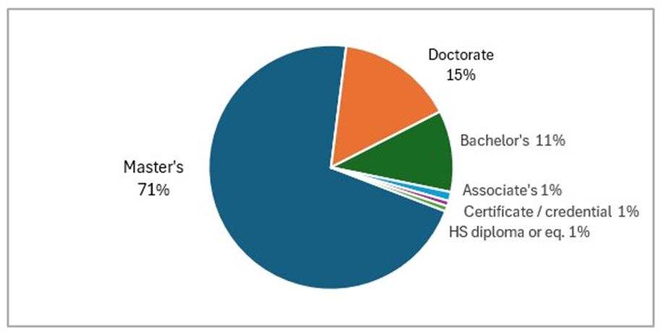
Figure 1.2: A pie chart reflects the percentage of survey respondents with various postsecondary degrees.

Table 1.2: Most advanced degree completed
Most advanced degree completed | percentage | no. responses
Master’s degree | 71% | 490
Doctorate | 15 | 105
Bachelor's degree | 11 | 78
Associate’s degree | 1 | 8
Certificate or credential | 0.6 | 4
High school diploma or equivalent | 1 | 8
 |  | 693

Table 1.3: Currently working towards a degree
Degree in progress! | percentage | no. responses
Doctorate | 7% | 47
Master’s degree | 4 | 29
Bachelor's degree | 1 | 7
Associate’s degree | 0.4 | 3
Certificate or credential | 2 | 14
High school diploma or equivalent | 0.2 | 1
Total | 15% | 101

Table 1.4: Minimum education level for new hires in your current position
Minimum education | percentage | no. responses
Master’s degree | 59% | 389
Bachelor's degree | 35 | 230
Doctorate | 3 | 17
Associate’s degree | 2 | 11
High school diploma or equivalent | 1 | 6
No degree required | 0.1 | 1
 |  | 657

Professional Experience

Figure 1.5: Length of time working
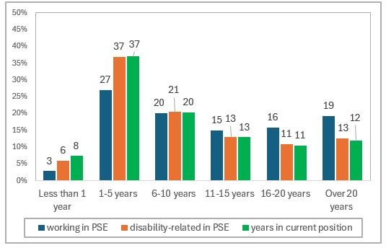
Figure 1.5: Clusters of three bars reflect the percentage of respondents who have worked in various spheres for a given length of time. From left to right, blue represents time working in postsecondary education (PSE), orange, doing disability-related work in PSE, and green, length of time in current role.

Table 1.5: Length of time working
Length of time | Working in PSE  (blue) | Disability-related work in PSE (orange) | Time in current position (green)
Less than 1 year | 3% | 6% | 8%
1-5 years | 27 | 37 | 37
6-10 years | 20 | 21 | 20
11-15 years | 15 | 13 | 13
16-20 years | 16 | 11 | 11
Over 20 years | 19 | 13 | 12

Table 1.6: Current professional title
Professional title | percentage | no. responses
Access Coordinator | 25% | 146
ADA/504 Coordinator | 4 | 24
Assistive/Adaptive Tech specialist | 2 | 10
Associate or Assistant Director | 17 | 98
Director | 41 | 237
Learning Specialist | 2 | 10
Testing Accommodations Coordinator | 2 | 10
Various (write in) | 7 | 38
Total |  | 573

Titles reported via the write-in option were often part of campus administration (e.g. Associate Dean, Assistant Provost, etc.) or a combination director role, such as Director of Academic Support and Disability Resources. Additional titles within the DRO or CTP include physical accessibility specialist, transition specialist, and researcher.

Table 1.7: Prior experience in fields related to disability resources
Many respondents indicate experience in more than one field.
Related field | percentage | Average years of experience
Student or Academic Affairs | 49% | 11.6
K-12 education: related to disability | 31 | 8
K-12 education: not related to disability | 17 | 5.3
Teaching in Higher Education | 32 | 6.7
Counseling, psychology, social work, mental health svcs. | 22 | 9.8
Vocational / Rehabilitation services | 12 | 7.2
Business | 10 | 11.4
Comprehensive Transition & Postsecondary Program | 6 | 6.5
Health Services & Medical professions | 6 | 8.6
Legal Services | 4 | 10.5
None of the above | 6 | n/a

Figure 1.8: Fields of influence
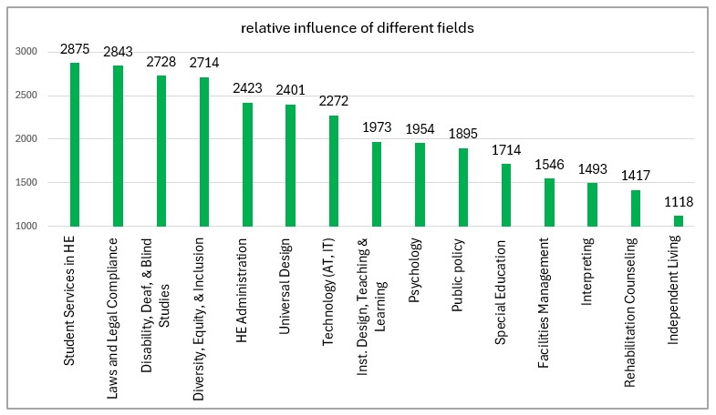
Figure 1.8: A series of vertical bars represent the relative influence of each field. To determine relative influence, each response was multiplied by the value (1-5) assigned by each respondent.

Table 1.8a: Number of responses assigning each value for fields of influence.
Field of influence | 5 | 4 | 3 | 2 | 1
Student Services in Higher Ed (HE) | 372 | 188 | 62 | 30 | 17
Laws & legal compliance | 364 | 167 | 96 | 27 | 13
Disability, Deaf & Blind Studies | 335 | 154 | 104 | 49 | 27
Diversity, Equity & Inclusion | 285 | 223 | 100 | 36 | 25
HE administration | 183 | 222 | 142 | 77 | 40
Universal Design | 171 | 211 | 176 | 69 | 36
Technology (AT, IT) | 132 | 212 | 180 | 90 | 44
Instructional Design, Teaching & Learning | 65 | 180 | 197 | 123 | 91
Psychology | 85 | 151 | 195 | 114 | 112
Public Policy | 63 | 144 | 213 | 133 | 99
Special Education | 79 | 97 | 157 | 138 | 184
Facilities Management | 320 | 97 | 179 | 165 | 191
Interpreting | 48 | 79 | 132 | 147 | 247
Rehabilitation Counseling | 40 | 63 | 122 | 173 | 253
Independent Living/Community Integration | 13 | 33 | 89 | 142 | 370

Table 1.8b: Percentage of responses assigning each value for field of influence.
Field of influence | 5 | 4 | 3 | 2 | 1
Student Services in Higher Ed (HE) | 56% | 28% | 9% | 4% | 3%
Laws & legal compliance | 55 | 25 | 14 | 4 | 2
Disability, Deaf & Blind Studies | 50 | 23 | 16 | 7 | 4
Diversity, Equity & Inclusion | 43 | 33 | 15 | 5 | 4
HE administration | 28 | 33 | 21 | 12 | 6
Universal Design | 26 | 32 | 27 | 10 | 5
Technology (AT, IT) | 20 | 32 | 27 | 14 | 7
Instructional Design, Teaching & Learning | 10 | 27 | 30 | 19 | 14
Psychology | 13 | 23 | 30 | 17 | 17
Public Policy | 10 | 22 | 33 | 20 | 15
Special Education | 12 | 15 | 24 | 21 | 28
Facilities Management | 3 | 15 | 27 | 25 | 29
Interpreting | 7 | 12 | 20 | 23 | 38
Rehabilitation Counseling | 6 | 10 | 19 | 27 | 39
Independent Living/Community Integration | 2 | 5 | 14 | 22 | 57

Demographic profile

Figure 1.9: Age of respondents by decade
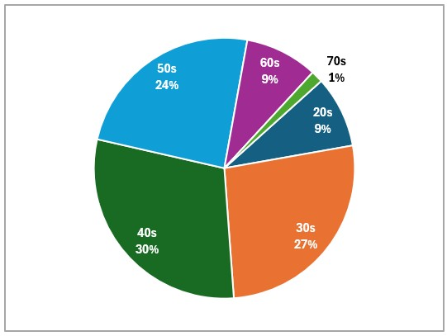
Figure 1.9: Pie chart representing the proportion of respondents whose age falls in each decade, from age 20 through 70s.

Table 1.9: Age of respondents
age | percentage | no. responses
20-something | 9% | 60
30-something | 27 | 180
40-something | 30 | 201
50-something | 24 | 164
60-something | 9 | 61
70-something | 2 | 10
Total |  | 676
Figure 1.10: Prevalence of disability and health conditions among respondents
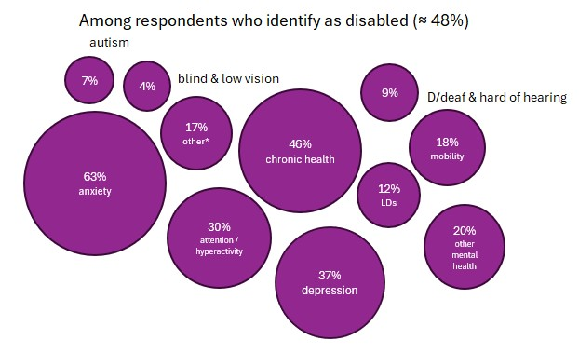
Figure 1.10 represents the incidence of disabilities and health conditions among respondents as a series of unordered proportional bubbles.

Table 1.10: Prevalence of disability and health conditions among disabled respondents
Disability/Health condition | percentage | no. responses
Anxiety | 63% | 200
Autism | 7 | 21
attention/hyperactivity | 30 | 96
Blindness / low vision | 4 | 12
chronic illness/health condition | 46 | 148
Deaf / deaf HOH | 9 | 29
depression | 37 | 119
learning disabilities | 12 | 37
mobility disability | 18 | 58
motor activity disability | 3 | 11
other mental health | 20 | 64
speaking disability | 1 | 3
something else (write in) | 10 | 33
TBI | 3 | 10

Disabilities listed under “something else” include: Asperger’s, autoimmune disorders, Cancer, Diabetes, MS, neurological disorders, PTSD, and recovery from addiction.

Table 1.11: Geographic location
Response rates by U.S. region are as follows:
US Region | percentage | no. responses
Southern Region  AL, AR, FL, GA, KY, LA, MS, NC, OK, SC, TN, TX, VA, WV | 22% | 141
Midwestern Region  IA, IL, IN, KS, MI, MN, MO, NE, ND, OH, SD, WI | 29% | 184
Northeastern Region  CT, DE, DC, MA, ME, MD, NH, NJ, NY, PA, RI, VT | 27% | 171
Western Region  AK, AZ, CA, CO, HI, ID, MT, NM, NV, OR, UT, WA, WY | 22% | 138
Responses from outside the U.S. | 0.8% | 5
Total |  | 639

Table 1.12: Race & ethnicity
More than one response is possible.
Race / ethnicity | percentage | no. responses
American Indian, Alaska Native, or a member of an indigenous people | 2% | 11
Asian (Asian Indian, Chinese, Filipino, Japanese, Korean, Vietnamese, other Asian) | 3 | 21
Biracial or multiracial | 2 | 11
Black (African American, African, Atlantic Islander, Indian Islander) | 4 | 28
Hispanic or Latino (Mexican, Puerto Rican, Cuban, other Hispanic or Latin descent) | 6 | 45
Jewish (write-in response) | 0.3 | 2
Middle Eastern | 0.7 | 5
Native Hawaiian and Other Pacific Islander | 0.8 | 6
White (Anglo, European descent) | 82 | 589

Table 1.13: Sexual orientation among respondents
Sexual orientation | percentage | no. responses
Asexual (write-in) | 0.004% | 3
Bisexual | 7 | 49
Gay or lesbian | 6 | 43
Straight | 81 | 534
Pansexual (write-in) | 1 | 8
Queer (write-in) | 2 | 13
 |  | 650

Table 1.14: Gender identity among respondents
Gender identity | percentage | no. responses
Female | 78% | 528
Male | 16 | 111
Nonbinary | 4 | 26
Trans | 2 | 13
Total |  | 678

Part 2: About Your Current Position
This part of the survey delineates the response pool by various institutional characteristics that may shape respondents’ daily work.

Section Highlights
- Institutional categories by student enrollment were updated to align with categories used by the Institute of Education Sciences (IES). Three size spans were added to the 2024 edition of the survey: less than 200 students, 200-499 students, and 500-999 students; the range of the fourth size category also shifted. These additions result in a more detailed profile of campuses with fewer than 1,500 students, representing in a more detailed way as many as one-fourth of the total number of responses received. (Figure and Table 2.1)
- 1 in 6 responses were completed by colleagues working at a Minority-Serving Institution. Among this subset of 118 schools, 71% are Hispanic-Serving Institutions. (Figure and Table 2.6)
- The 2024 Survey expanded the list of disability-related opportunities available on responding campuses. The most common opportunities available include faculty/staff training and student organizations. (Figure and Table 2.7)

- For the first time, data was collected about Comprehensive Transition & Postsecondary Programs (CTP). About 10% of responding campuses (61) maintain a CTP. CTP exist at all Carnegie classification types. (Table 2.3)

- Among survey responses, the most common administrative location for a disability resource office, across all institution types, is Student Affairs, which houses 33-50% of DROs, depending on institution type. (Figure and Table 2.8).
- The most common location for a CTP is Academic Affairs (25%). (Table 2.9).

Institutional Characteristics

Figure 2.1: Institutional student enrollment
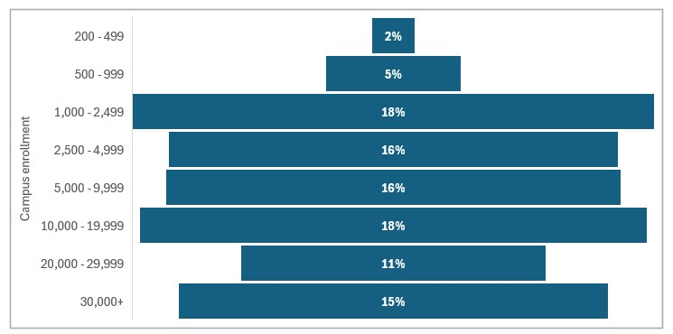Figure 2.1 is a funnel chart with horizontal bars representing the percentage of respondents from institutions of each size, as measured by student enrollment. Responses are distributed across all sizes.

Table 2.1: Institutional student enrollment
Student enrollment | percentage | no. responses
Less than 200 students | 2% | 0
200-499 students | 5 | 9
500-999 students | 18 | 28
1000-2499 students | 18 | 108
2500-4999 students | 16 | 93
5000-9,999 students | 16 | 94
10,0000-19,999 | 18 | 105
20,000-30,000 | 11 | 63
More than 30,000 students | 15 | 89
Total |  | 589

Figure 2.2: Responses by Carnegie classification
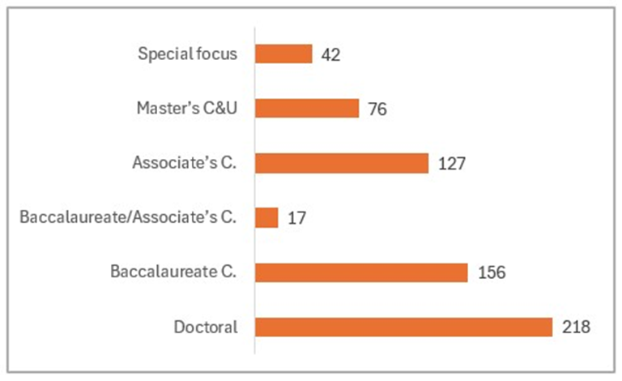
Figure 2.2 is a horizontal bar graph representing the number of survey responses from each Carnegie classification type.

Table 2.2: Responses by Carnegie classification
Carnegie Classification | percentage | no. responses
Special focus | 7 | 42
Master’s College & University | 11 | 76
Associate’s College | 20 | 127
Baccalaureate / Associate’s College | 2 | 17
Baccalaureate College | 24 | 156
Doctoral University | 33 | 218
 |  | 636

Table 2.3: Prevalence of Comprehensive Transition & Postsecondary Programs by Carnegie classification
Institution type | Percentage of total CTP | no. responses
Baccalaureate C. | 52% | 31
Associate’s C. | 22 | 13
Master’s C & U | 15 | 9
Doctoral U. | 13 | 8
Total |  | 61

Table 2.4: Campus Setting
Setting | percentage | no. responses
Suburban or small town | 37% | 222
Urban | 36 | 212
Multiple campuses | 16 | 95
Rural | 5 | 32
Online | 4 | 23
Total |  | 596

Table 2.5: Other institutional characteristics
More than one response is possible.
*All public colleges and universities are non-profit, so they are dramatically undercounted here.
Characteristic | percentage | no. responses
Public | 58% | 388
Private | 37 | 233
Non-profit | 31* | 198
Minority-Serving Institution | 18 | 118
Faith-affiliated | 12 | 71
For-profit | 3 | 18
Military Academy | 1 | 3

Figure 2.6: Minority-Serving Institutions (MSI)
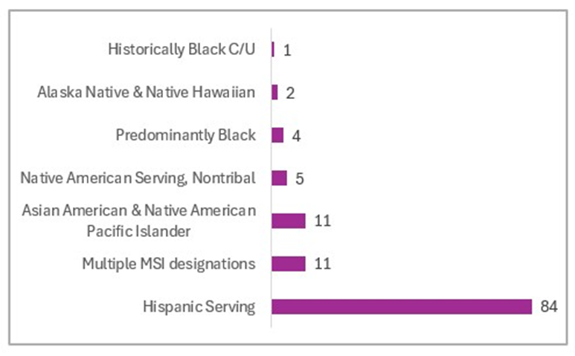
Table 2.6 is a horizontal bar graph representing the number of responding institutions with each MSI designation.

Table 2.6: Minority-Serving Institutions
MSI designation | no. responses
Historically Black College & University | 1
Alaska Native & Native Hawaiian | 2
Predominantly Black Institution | 4
Native American Serving Non-Tribal Institution | 5
Asian American & Native American Pacific Islander | 11
Multiple MSI designations | 11
Hispanic Serving Institution | 84
Total | 118

Note: Nearly one third of respondents selected “I don’t know” whether their institution is designated as a Minority-Serving Institution. The University of California Irvine’s Office of Inclusive Excellence maintains a searchable database of all Minority-Serving Institutions.

Figure 2.7: Disability-related opportunities at responding institutions
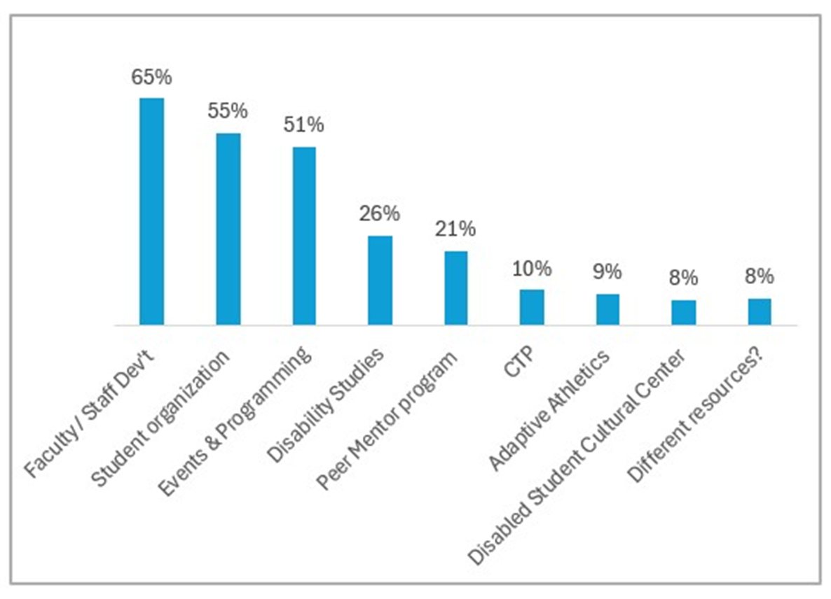
Figure 2.7 is a vertical bar graph representing the presence of various disability-related opportunities and resources on respondent campuses.

Table 2.7: Disability-related opportunities at responding institutions
More than one response is possible.
Opportunity | percentage | responses
Faculty & staff development | 65% | 422
Student organization | 55 | 347
Events & Programming | 51 | 325
Disability Studies courses | 26 | 164
Peer mentor program | 21 | 135
Comprehensive Transition & Postsecondary Program | 10 | 61
Adaptive Athletics | 9 | 65
Disabled Student Cultural Center | 8 | 47
Other resources that were mentioned for this question include an accessible events committee; Autism support group; body-doubling group; disability-specific coaching; ASL courses; Delta Alpha Phi (Honor Society); interest group for employees; disabled BIPOC student group; executive functioning coaching; faculty mentorship program; summer bridge program; workforce recruitment program.

Institutional Location

Figure 2.8: Location of Disability Resource Offices
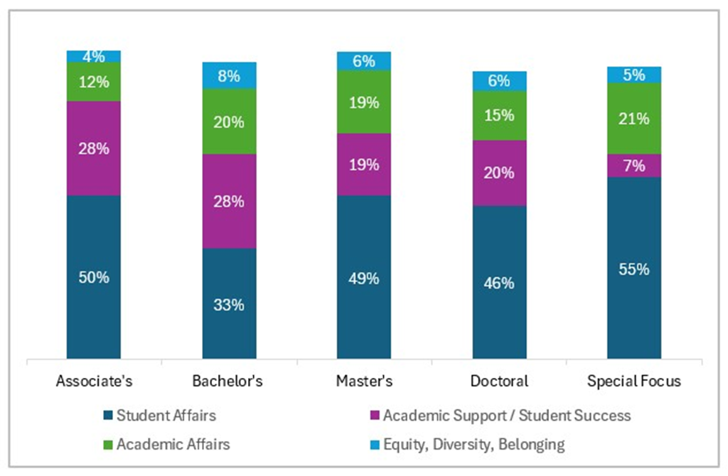
Figure 2.8 is a series of stacked bars representing the location DRO: blue represents Student Affairs; purple Academic Support and Student Success; green, Academic Affairs, and light blue, Equity and Diversity.

Table 2.8: Location of Disability Resource Offices
Type of institution | Student Affairs  (dark blue) | Academic Support/ Success (purple) | Academic Affairs  (green) | DEI  Multicultural Affairs  (light blue)
Associate’s | 50% | 28% | 12% | 4%
Bachelor’s | 33 | 28 | 20 | 8
Master’s | 49 | 19 | 19 | 6
Doctoral | 46 | 20 | 15 | 6
Special-Focus | 55 | 7 | 21 | 5
Other locations include:
an office spanning Student and Academic Affairs; an office spanning Student Affairs & HR; a central office serving many campuses; Enrollment and Retention.

Figure 2.9: Location of Comprehensive Transition & Postsecondary Programs
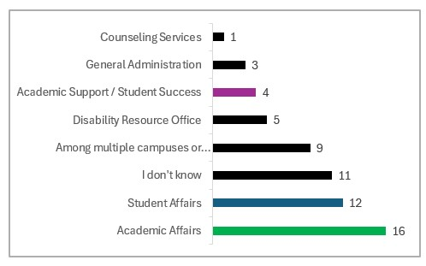
Figure 2.9: A horizontal bar graph representing the institutional location of CTP Programs. Where some alignment exists between the location of the DRO and the CTP, the same colors are used as in Figure 2.8: green for Academic Affairs, blue for Student Affairs, and purple for Academic Support/Student Success.

Table 2.9: Location of Comprehensive Transition & Postsecondary Programs
Location | percentage | no. of responses
Academic Affairs | 25% | 16
Student Affairs | 22 | 12
Among multiple units or someplace else | 14 | 9
Disability Resource Office | 9 | 5
Academic Support/ Student Success | 6 | 4
General Administration | 5 | 3
Counseling Services | 2 | 1
I don’t know | 17 | 11
Total |  | 61

Other locations for CTP include:
College of Education; Continuing Education and Workforce Development; in conjunction with the local high school; library.

Part 3: Your Appointment, Annual Earnings, and Benefits

Section Highlights
- 97% are employed full-time (up 2% over 2020). Thirteen respondents report working part-time. (Table 3.1).
- 94% of respondents in a 12-month, salaried position. Very few respondents report an hourly wage or temporary work contract. (Table 3.2)
- 74% of respondents dedicate 100% FTE to a DRO or a CTP, an increase of 16% over 2020. (Table 3.3)

- In 2024, 88% of reporting positions are funded through permanent institutional funds. 2024 marks a slight decline from 2020, from 90% to 88%. (Table 3.4)
- 62% of all respondents earn between $50,000 and $90,000 per year. (Figure and Table 3.5)

- Average earnings for the three most reported professional positions (Accessibility Coordinator, Assistant/Associate Director, and Director) are disaggregated in three different ways:
- length of time in current role (Figure & Table 3.6)
- degree completed at type of institution (Figure & Table 3.7)
- professional title at type of institution (Figure & Title 3.8)
- For the following professional positions, there were too few responses, or responses didn’t vary enough, for disaggregation by institution type to be meaningful. Across all institution types, earnings are as follows:
- ADA/504 Coordinator (n=24): $65,000
  - AT/IT Specialist (n=10): $57,600
  - Learning Specialist (n=10): $57,500
  - Testing Coordinator (n=10): $56,400
- Average earnings that seem unusually high are often associated with a title in upper-level administration, e.g. Associate Provost & Director of Disability Resources. Consider, for example, the average earnings for a professional who has been in their role for 10-15 years (Figure and Table 3.5).

Table 3.1: Employment situation
More than one response is possible.
Employment situation | percentage | no. responses
Employed full-time | 97% | 666
Employed part-time | 2 | 13
Self-employed/Consultant full time | 0.1 | 1
Self-employed / Consultant part time | 2 | 12
Seeking a different job | 2 | 11
Retired | 1 | 6

Table 3.2: Appointment structure for current position
Appointment structure | percentage | no. responses
12-month position | 94% | 617
Academic year (with option to work in the summer | 2 | 11
Academic year (no summer work) | 1 | 9
Temporary position | 0.6 | 4
Hourly | 0.3 | 2
Total |  | 657

Table 3.3: Percentage of FTE devoted to disability resources and / or a CTP
Portion of FTE | percentage | no. of responses
100% | 74% | 412
75 – 99% | 11 | 60
50 – 74% | 6 | 34
25 – 49% | 4 | 25
Less than 25% | 5 | 26
Total |  | 557

Table 3.4: Funding Source for Current Position
Funding source | percentage | no. responses
Permanent institutional funding | 88% | 498
A mix of both funding types | 6 | 33
Grants and / or other limited resources | 1 | 7
I don’t know | 5 | 31
Total |  | 569

Average gross annual earnings

Figure 3.5: Distribution of annual earnings, all roles
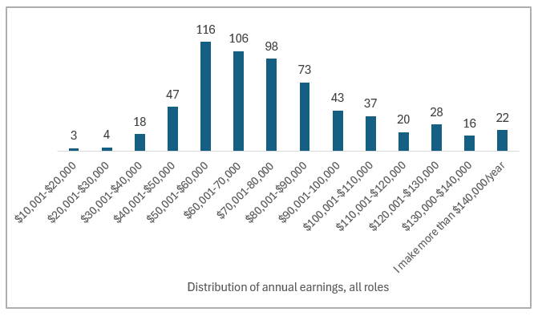
Figure 3.5 is a vertical bar graph representing the distribution of annual earnings among all disability resource and CTP professionals.

Table 3.5: Distribution of annual earnings, all roles
Annual earnings | percentage | no. responses
$10,001-$20,000 | 0.5% | 3
$20,001-$30,000 | 0.6 | 4
$30,001-$40,000 | 3 | 18
$40,001-$50,000 | 7 | 47
$50,001-$60,000 | 18 | 116
$60,001-70,000 | 17 | 106
$70,001-80,000 | 16 | 98
$80,001-$90,000 | 12 | 73
$90,001-100,000 | 7 | 43
$100,001-$110,000 | 6 | 37
$110,001-$120,000 | 3 | 20
$120,001-$130,000 | 4 | 28
$130,000-$140,000 | 3 | 16
I make more than $140,000/year | 3 | 22
Total |  | 631

Figure 3.6: Earnings by length of time in current role (all roles)
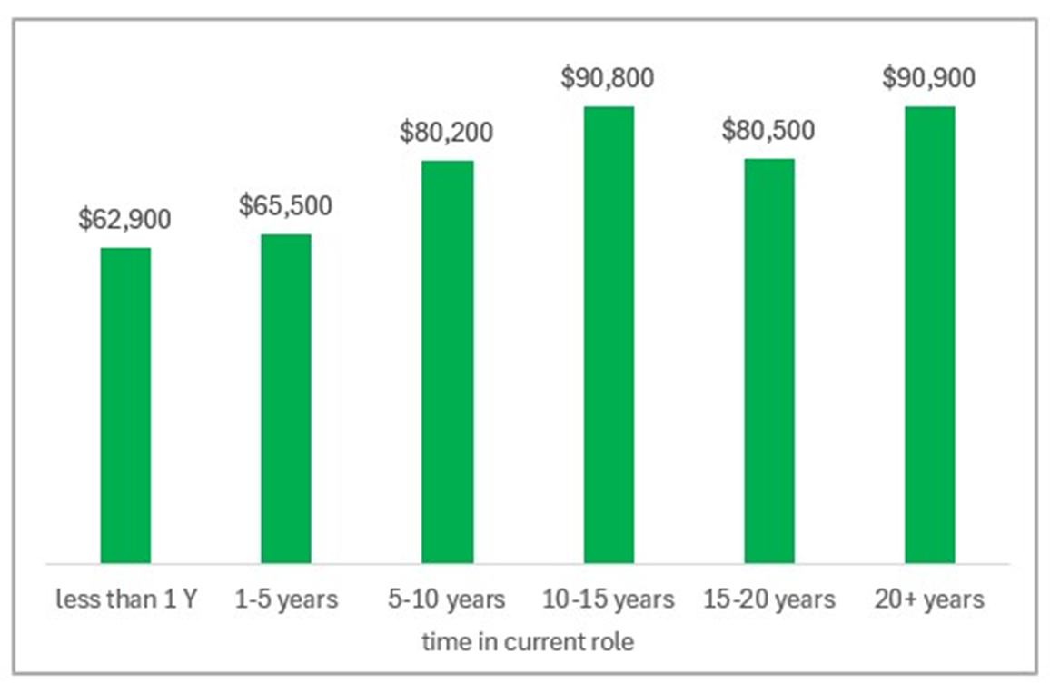
Figure 3.6 uses vertical bars to represent average gross annual earnings by length of time in current position, from less than one year to more than 20 years.

Table 3.6 Earnings by length of time in current role (all roles, all institutions)
Length of time in current role | Average salary
Less than 1 year | $62,900
1-5 years | $65,500
5-10 years | $80,200
10-15 years | $90,800
15-20 years | $80,500
More than 20 years | $90,900

Figure 3.7: Earnings by degree completed and institution type
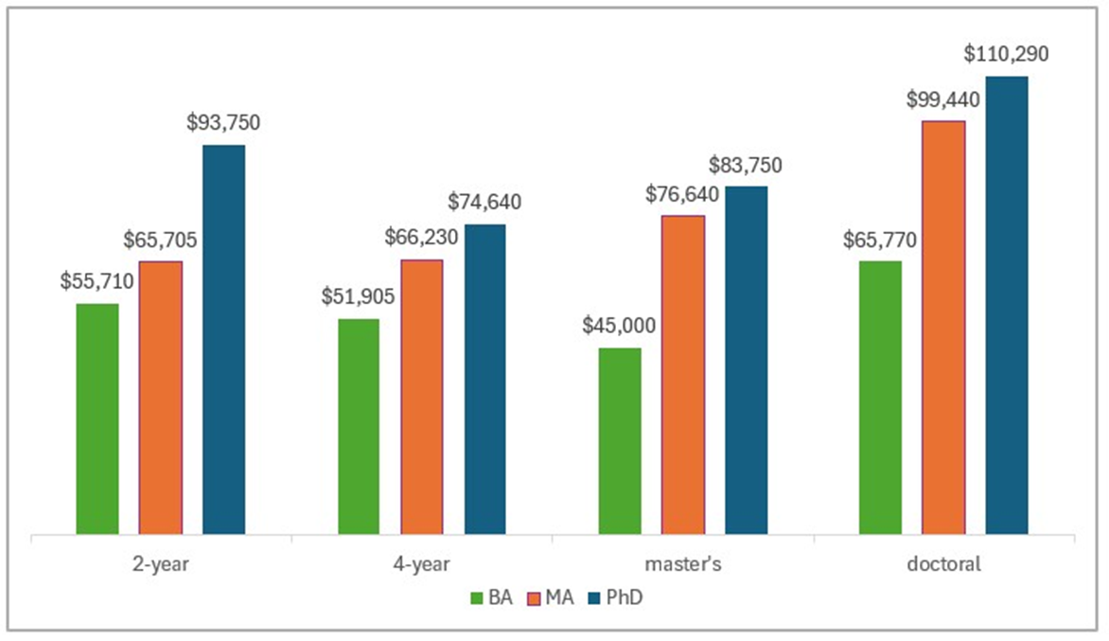Figure 3.7 uses vertical bars to indicate average gross annual earnings at different institution types by degree completed. From left to right within each cluster, green represents the average earnings for professionals with a Bachelor’s, orange for professionals with a Master’s, and dark blue for professionals with a doctoral degree.

Table 3.7: Earnings by degree completed and institution type
most advanced degree completed | Bachelor’s  (green) | Master’s  (orange) | Doctorate  (blue)
2-year | $55,710 | $65,705 | $93,750
4-year | $51,905 | $66,230 | $74,640
Master’s | $45,000 | $76,640 | $83,750
Doctoral | $65,770 | $99,440 | $110,290

Figure 3.8 Earnings by institution type and professional position
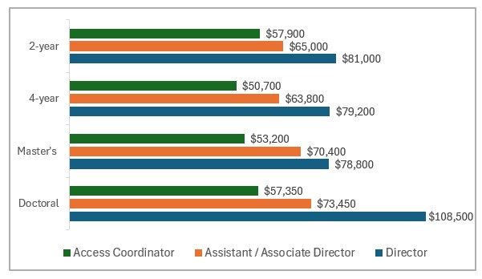Figure 3.8 represents average gross annual earnings for the three most common roles reported in a disability resource office at four different institution types. To discern differences in salary, compare bars of the same color, or in the same position, at different institution types.

Table 3.8: Earnings professional position and institution type
Role | 2-year | 4-year | Master’s | Doctoral
Access Coordinator (n=146) | $57,900 | $50,700 | $53,200 | $57,350
Assistant/Associate Director (n=98) | $65,000 | $63,800 | $70,400 | $73,450
Director (n=237) | $81,000 | $79,200 | $78,800 | $108,500

Benefits

Figure 3.9: Percentage of respondents who report a given benefit
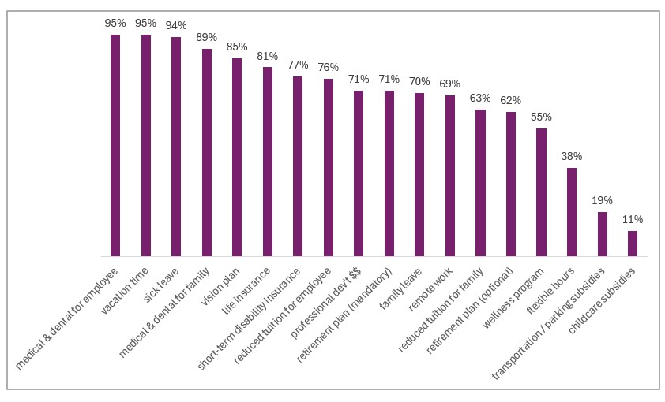Figure 3.9 represents with purple, vertical bars the percentage of respondents who report receiving a given benefit.

Table 3.9: Percentage of respondents who report a given benefit
More than one response is possible.
benefit | percentage | No. respondents
Medical and dental insurance for employee | 95% | 619
Vacation time | 95 | 618
Sick leave | 94 | 615
Medical and dental insurance for family members | 89 | 580
Vision plan | 86 | 559
Life insurance | 81 | 528
Short-term disability insurance | 77 | 502
Reduced tuition for employee | 76 | 500
Professional development funds | 71 | 466
Retirement plan (mandatory) | 71 | 466
Family leave | 70 | 457
Remote work | 68 | 449
Reduced tuition for family members | 64 | 412
Retirement plan (optional) | 63 | 404
Wellness plan | 56 | 363
Flexible hours | 38 | 251
Transportation /parking expenses reduced | 19 | 123
Childcare subsidies | 11 | 74
*Time-sharing position with another staff person | 1 | 5
*I am not eligible for benefits or perks | 1 | 5
*The two least common perks are not reflected in the above figure due to lack of space.

Timely topics: Survey parts 4 & 5
The first timely topic for the 2024 edition of the survey pertains to efforts to undermine and eliminate diversity, equity, and inclusion initiatives in postsecondary education. Survey responses represent a snapshot from early 2025 and may no longer be representative of professionals’ perspectives or experiences. AHEAD has been proactive in addressing respondents’ requests for support and resources (see Figure and Table 4.6), via the Policy Corner in The HUB and a variety of events online and in person at AHEAD 2025 in Denver.
The second timely topic seeks to raise awareness of the AHEAD Professional Competencies among professionals. Findings provide direction for future offerings by AHEAD and may also inform the pursuit of additional training or a promotion that suits interests and skill sets. See the special issue, JPED 36.4 (2023) for more information about the AHEAD Professional Competencies.

Timely topics highlights
- Only 17% of professionals had observed changes that they attribute to legislative efforts. (Figure and Table 4.2)
- 23% of respondents had been asked to implement changes, or observed changes, in accommodations decision making, 7% of whom attribute those changes to legislative efforts. (Table 4.3)
- 57% of respondents were moderately or very concerned that legislative efforts would have a negative impact on their work with disabled people in postsecondary education. (Figure and Table 4.5)
- The top three sorts of support desired by professionals were: policy updates and guidance, accurate information, and legal advice and advocacy.

- Respondents’ self-reported interest and skill level most align around their capacity to engage with disabled people [KA 3.5] and their capacity to model values of diversity, inclusion, and equity [KA 7.1].
- High interest paired with lower confidence in skill level, such as occurs with data and assessment [KA 5.3] and accessible and inclusive course & curriculum design [KA 8.1] suggests an area for future learning content from AHEAD (See Figure 5.1 and Tables 5.1a and 5.1b).

Part 4: Impact of legislative efforts on your work
- While at work, have you been made aware of legislative efforts [to undermine DEI in your state?

Table 4.1: Awareness of efforts
response | percentage | no. responses
Yes | 54% | 338
No | 40 | 251
Not applicable | 5 | 33
Total |  | 622

- Have you observed any changes in staffing or resources in your office or other disability-related resources on your campus that you attribute to the impact of these legislative efforts?

Figure 4.2: Observed changes in staffing or resources
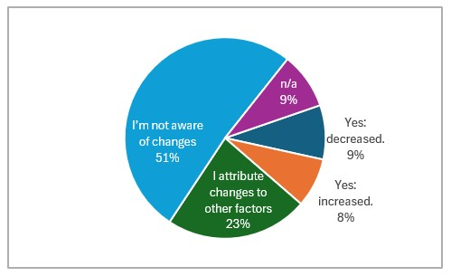

Table 4.2: Observed changes in staffing or resources
response | percentage | no. responses
Yes: staffing has decreased | 8% | 54
Yes: staffing has increased | 8 | 49
I attribute changes to other factors | 23 | 142
I’m not aware of changes | 51 | 318
n/a | 9 | 56
 |  | 619

- Have you been asked to implement changes, or observed changes, in accommodations decision-making that you attribute to the impact of legislative efforts?

Table 4.3: Changes in accommodations decision-making
response | percentage | no. responses
Yes | 7% | 46
Yes, but I attribute changes to other factors | 16 | 96
No | 67 | 411
n/a | 10 | 64
Total |  | 617

- Have you noticed a change in morale or campus climate that you attribute to the impact of legislative efforts in your state?

Table 4.4: Changes in morale or campus climate
response | percentage | no. responses
Yes | 34% | 211
No | 53 | 325
Not applicable | 12 | 76
Total |  | 612

- How concerned are you that legislative efforts will have a negative impact on your work with disabled people in post-secondary education?

Figure 4.5: Level of concern about legislative efforts
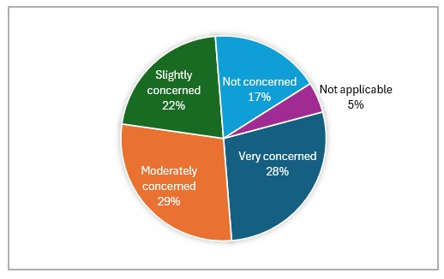
Table 4.5: Level of concern about legislative efforts
response | percentage | no. responses
Very concerned | 28% | 172
Moderately concerned | 29 | 178
Slightly concerned | 22 | 134
Not concerned | 17 | 108
Not applicable | 5 | 30
 |  | 622

- What professional resources can AHEAD provide to support your success given the legislative efforts in your state? Select all that apply.

Figure 4.6: Professional resources from AHEAD
More than one response is possible.
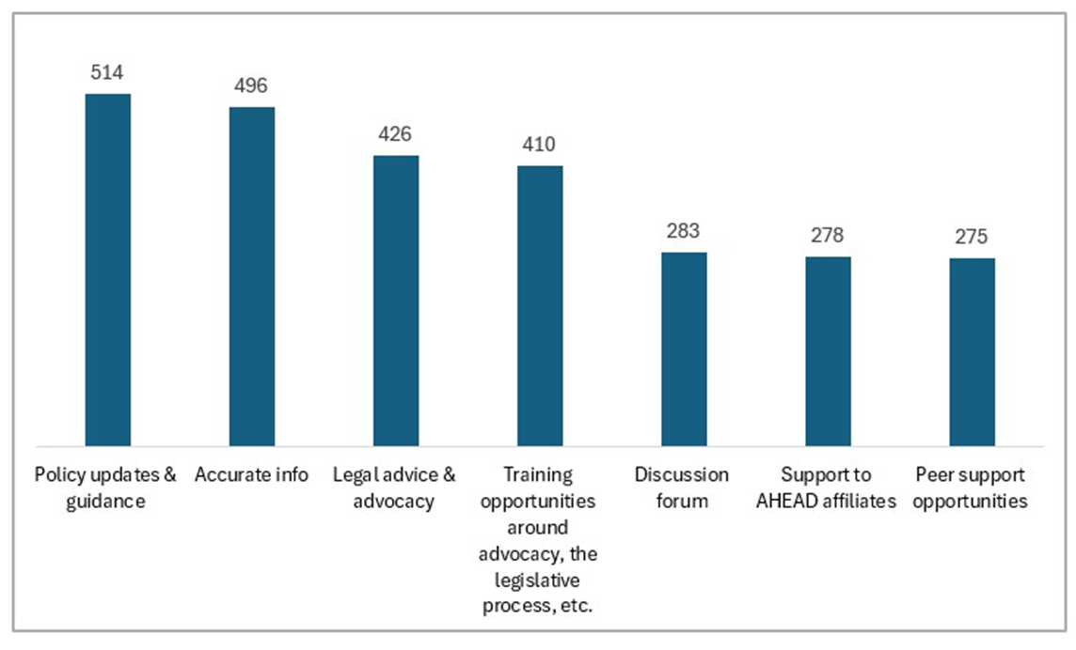

Table 4.6: Professional resources from AHEAD
Resource | no. times selected
Policy updates and guidance | 514
Accurate information | 496
Legal advice and advocacy | 426
Training opportunities re: advocacy, the legislative process, etc. | 410
Discussion forum | 283
Support to AHEAD state affiliates | 278
Peer support opportunities | 275

Part 5: AHEAD Professional Competencies

Figure 5.1a: Self-assessed interest and skill level for select key attributes of the AHEAD Professional Competencies
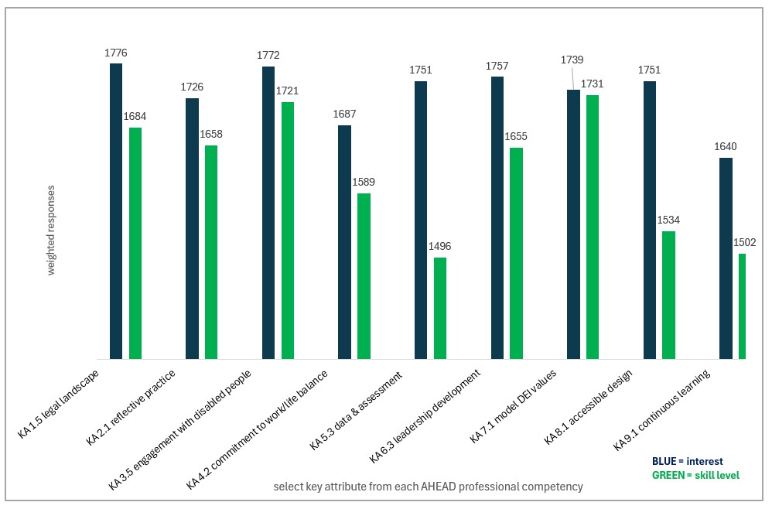Figure 5.1a represents self-assessed interest and skill with regard to 9 key attributes of the AHEAD Professional Competencies. Blue bars represent interest, and green, self-assessed skill level.

Table 5.1a: Number of individual responses - Self-assessed interest and skill level for select key attributes of the AHEAD Professional Competencies
Key attribute (abridged) | Very interested | Very skilled | Somewhat interested | Somewhat skilled | Not very interested | Not very skilled
1.5: Apply knowledge of the legal landscape | 459 | 239 | 126 | 306 | 21 | 49
2.1: Develop a reflective practice | 356 | 191 | 206 | 341 | 40 | 62
3.5: Engage with disabled people | 469 | 306 | 116 | 256 | 17 | 35
4.2: Commit to work/life balance | 376 | 191 | 165 | 305 | 64 | 101
5.3: Gather data to support assessment | 385 | 128 | 190 | 324 | 26 | 140
6.3: Grow in leadership skills | 429 | 193 | 148 | 338 | 26 | 62
7.1: Model inclusive values and culture | 432 | 258 | 137 | 310 | 32 | 27
8.1: Promote access & inclusive design | 390 | 136 | 183 | 332 | 605 | 598
9.5: Support & learn: mentor & be mentored | 288 | 127 | 230 | 324 | 86 | 149

Table 5.1b: Percentage of respondents - Self-assessed interest and skill level for select key attributes of the AHEAD Professional Competencies
Key attribute (abridged) | Very interested | Very skilled | Somewhat interested | Somewhat skilled | Not very interested | Not very skilled
1.5: Apply knowledge of the legal landscape | 76% | 40% | 21% | 52% | 3% | 8%
2.1: Develop a reflective practice | 59 | 32 | 34 | 57 | 7 | 10
3.5: Engage with disabled people | 78 | 51 | 19 | 43 | 3 | 6
4.2: Commit to work/life balance | 62 | 32 | 27 | 51 | 11 | 17
5.3: Gather data to support assessment | 64 | 22 | 32 | 55 | 4 | 24
6.3: Grow in leadership skills | 71 | 33 | 25 | 57 | 4 | 10
7.1: Model inclusive values culture | 72 | 43 | 23 | 52 | 5 | 4
8.1: Promote access & inclusive design | 64 | 23 | 30 | 56 | 5 | 22
9.5: Support & learn: mentor & be mentored | 48 | 21 | 38 | 54 | 14 | 25

