Culturally Competent Support for Autistic African American College Students
Lisa Yates, Lisa.Yates@Mvc.Edu

Resources
- UCLA Tarjan Center
  - ACCESS Webinars and Newsletters
- College Autism Network
  - CANVAS webinars
  - College Autism Summit
- Think College
  - Webinar archive
- Autism Goes to College
  - Documentary film and podcast
- Podcast: Supporting Neurodivergent College Students - Teaching with Kindness

Ohio State Training Modules:
- Project Goal: to develop and disseminate an open-source, self-paced training
- Enhance pedagogy through evidence-based practices and student recommendations

Link and QR code to Ohio State Professional Development Tool

NeuroPREP (UCLA Tarjan Center)
- Designed for faculty by researchers in the field of education using real-world situations, research-informed content, and adult learning principles.
- QR Code to purchase self-paced course access for 90 days ($25)
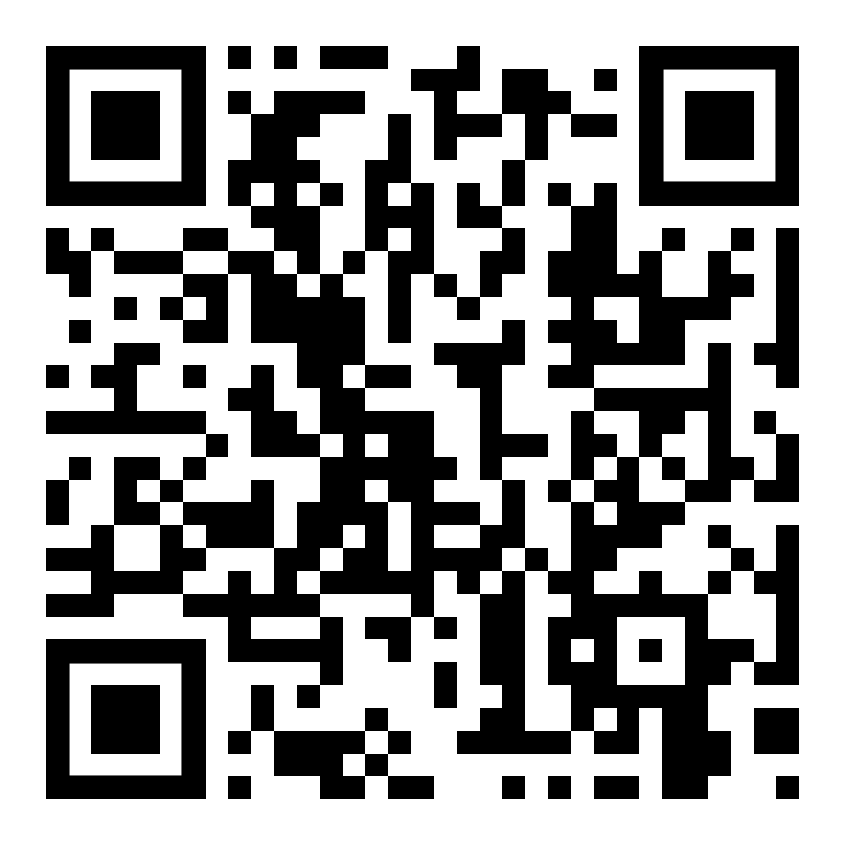
- Read the program description and learn about its development:
Faculty Training in NeuroDiversity
- Four Modules: Neurodiversity, Needs & Strengths, Support Strategies, and Case Scenarios

QR code for NeuroPREP Self-Paced Course:

Resources for cultural competence and Black Autistic support
- UC Berkeley - The Neurodiversity Initiative
- UCLA Fielding Report - Intersection of race, poverty and autism
- HBCU Disability Consortium

Community Resources not focused on Higher Education
- The Color of Autism Foundation
- FACES - Fostering Advocacy, Communication, Empowerment and Support
- BFAST Bridge for Families of Autistic Children and Providers to Access Services Together

