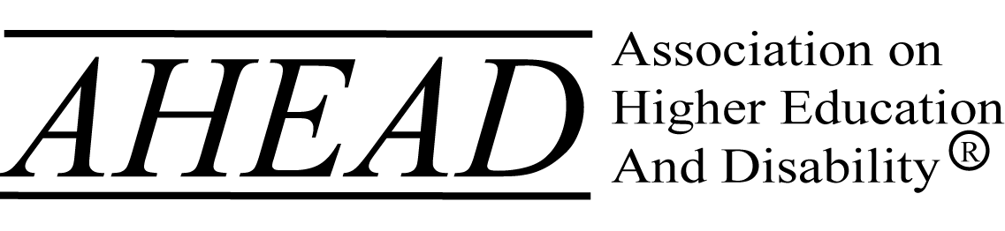______________________________________

Association on Higher Education and Disability
Application for Research Requests of Membership

Please submit this application and all related attachments to Dr. Todd Van Wieren, Chair of the Research Review Panel (toddvw@iup.edu ).

Contact Information:

Name:

Title:

Street Address:

City/State/Zip Code:

Phone:

Email:

AHEAD member: ____yes; ____no

Status:

_____ Postsecondary Disability Services Professional/ADA Coordinator
_____ Faculty Member
_____ * Student
_____ Other (please describe)__________________________________

* Note: Students will need to obtain faculty advisor approval. This includes full-time professionals who are also attending graduate school part- or full-time.

Institutional or Agency Affiliation:

Institution or Agency:

Department:

Faculty Advisor (if applicable):

Attachments:

- Abstract:
Limit to 100 words. Provide a condensed version of the project description that highlights the project’s (a) purpose, (b) methods, and (d) relevance to AHEAD members. Once a project has been approved, the abstract will be posted on AHEAD’s website.

- Description of proposed study (no more than 3 pages):
Please include
- purpose and rationale of the study
- targeted population among the AHEAD membership
- description of study methodology
- explanation of how accessibility of instrument has been assured.
- description of methods employed to maintain confidentiality
- relationship of the study to the mission and goals of the AHEAD organization
- intended timeline for study
- anticipated goal of research project (e.g., dissertation, publication, benchmarking)

- Copy of Survey and/or Interview Questions:
- Provide link to electronic version of survey questions or pdf of survey.
- Attach pdf of interview schedule.

- Approval from Institutional Review Board:
Please attach a copy of the approval from your institution’s human subjects review board. If you are not affiliated with a postsecondary institution, please attach a copy of the approval from an independent review board or an explanation on why an IRB approval has not been secured.

Signatures:

Researcher:

I attest that the information provided is accurate to the best of my knowledge, and agree to abide by the conditions set forth by AHEAD and the institutional/independent human subject review board.

Signature: ________________________________________ Date: _____________

Faculty Advisor (if applicable):

I agree to supervise this student’s research project and to monitor the student’s ethical research practices.

Signature: ________________________________________ Date: _____________

Title: _____________________________ Department: _________________________

Phone Number: _____________________ Email: _____________________________

