Participant Initiated Non-RID Activities 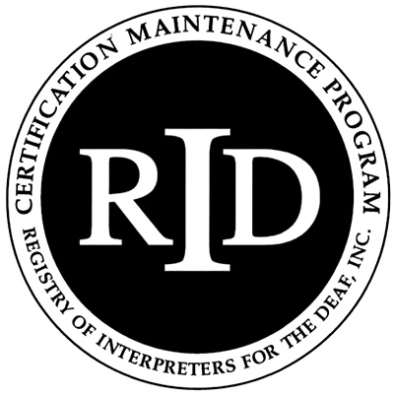

(PINRA)

This form will be used if a CMP Participant plans to attend another organization’s workshop, conference, formal in-service training or activity. The RID Approved Sponsor will determine if the activity is appropriate for CEUs.

Before the start of the activity/conference, this section should be filled out
and signed by both the participant and RID Approved Sponsor:

Participant Name: _____________________________________ RID Member #: _______________

Participant Address ___________________________________________________________________

Email:______________________________________ Phone # ________________________________

Activity/Conference Name: ____________________________________________________________

Activity/Conference Theme or Focus (attach brochure/flyer) __________________________________

Date and Times of activities you will attend: _______________________________________________

Total number of CEUs to be awarded: _______ Circle content area: Professional Studies General Studies
=========================================================================== Name and Code of RID Approved Sponsor ______________________________________________

I certify that this activity/conference represents a valid and verifiable Continuing Education Experience
that exceeds routine employment responsibilities.

Participant Signature: ____________________________________ Date: ___________________

I certify that I received this activity plan prior to the start of the activity/conference and I agree to sponsor this Continuing Education Experience. I will verify successful completion prior to awarding CEUs.

RID Sponsor Administrator Name:___________________________Signature:___________________________

RID Sponsor Code: ___________________________Date:_______________________________

This section should be filled out and signed upon completion of the activity/conference:

Activity Code Number __ __ __ __. __ __ __ __ . __ CEUs Awarded: _______

I have verified that the participant attended this activity/conference and that the activities listed are appropriate educational experiences which should be awarded the number of CEUs denoted above.

RID Approved Sponsor Signature Administrator: ______________________________________ Date:__________

The Participant must send documentation of attendance to the Sponsor upon completion of the activity. The Sponsor must file this form with RID online at www.rid.org within 45 days of the completion of the activity/conference.
Updated January 2008

