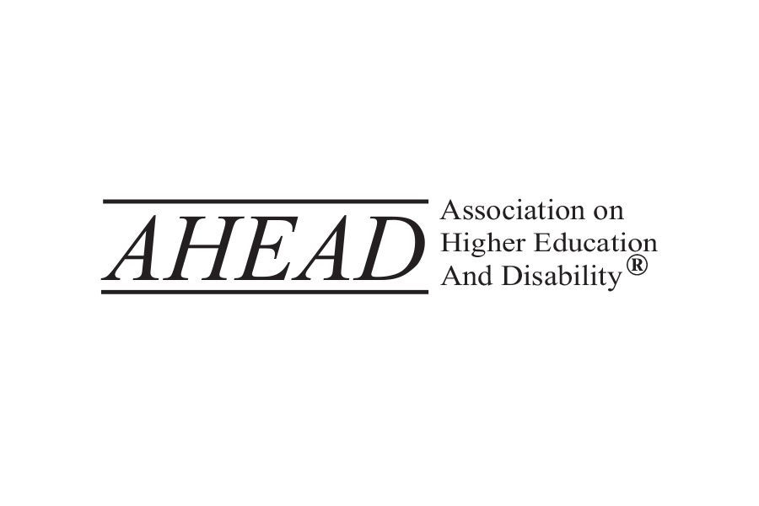

**AHEAD Remediation Activity**

This is the sample document for remediation purposes during AHEAD’s 2025 Conference. This document is intentionally left without alt text as well as proper headings, lists, tables, and accessible links. The first image, above, is the AHEAD logo. The second image is of a graphic of two albino squirrels at the University of North Texas. The presenters will guide participants through establishing headings, properly formatting a list, revising an inaccessible table, creating a meaningful hyperlink, and adding alt text.

Topics

Headings

Headings communicate the organization of the content on the page and provide in-page navigation. For this activity, the “AHEAD Remediation Activity” bold, centered title should be made as the “Title” heading style. “Topics” should be made as Heading Level 1 and then the different topics: Headings, Lists, Tables, and Links should all be Heading Level 2.

Lists

For this activity, please make the list below accessible.

“There are many considerations when working with Alternative Text (Alt Text) including

Decorative Images

Informational

Complex Images”

Tables

Standard Explanation

Keyboard Navigation Make sure it is easy to navigate using a keyboard-only

Captions Make sure captions are 95% accurate

Links

<https://www.w3.org/WAI/standards-guidelines/wcag/>

