 | Continuing Education CEU’s and General  Certificates of Attendance for CRCC  and Other Professional Organizations | 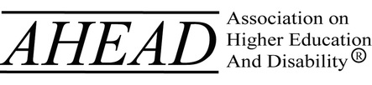

San Diego, California January 26 – 28, 2023

CERTIFICATE REQUEST

Please Print Clearly

Print Your Name:

Email Address: _________________________________________________________________

COMPLETE Mailing Address: _______________________________________________________

Please check one: ☐ HOME Address ☐ WORK / SCHOOL Address

Request: _____ CRCC CEU Verification (For Certified Rehabilitation Counselors)

_____ Certificate of Attendance (for other professional agencies)

Which Session Did You Attend?

Check | Session Title | Total Hours Attended (Max 13 hours) | Verification Signature | Date
 | Institute #1: The ADA Coordinator Role in Higher Education
 | Institute #2: Removing Roadblocks TRiO
 | Institute #3: Disability Law for DSS Directors
 | Institute #4: An Introduction to Managing Accommodations for Students in Health Science

