Exhibitor and Marketing Information

Equity & Excellence: Access in Higher Education
July 17-21, 2023, at the Oregon Convention Center

Presented by The Association on Higher Education and Disability (AHEAD)

Table of Contents

Exhibitor Information
Booth Rental Fees 3
Exhibit Hall Schedule of Events 3
Hotel Information 4
Exhibit Hall Map 5

Sponsor Information
Sponsorship Details 6-7

Advertising Information
Advertising & Marketing 8

Welcome from Jane Johnston, AHEAD Manager of Member Services

Since 1977 AHEAD has been providing invaluable resources to professionals who work in disability services in higher education and beyond. AHEAD’s Annual Conference usually draws approximately 1000 attendees.

All attendees have the same goals and seek to gain knowledge about disability services in higher education. Accessible technology, improving accommodations, postsecondary transition tools, universal design, and legal updates are just a few of the topics our attendees pursue.

You’re invited to join us July 17-21 in Portland, Oregon. We invite you to be creative! Put your company or organization in the spotlight. From sponsoring to exhibiting in person to presenting, you can leave a lasting impression on this important audience.

Feel free to contact me with any questions.

Sincerely,

Jane Ayres Johnston
AHEAD Manager of Member Services
jane@ahead.org / 704-947-7779

Important Deadlines
April 1, 2023 - Last Chance for Early Bird Exhibitor Rate
May 15, 2023 - Advertising and Marketing Applications Due
May 22, 2023 - Final Advertisements Must be Submitted
June 1, 2023 - Exhibitor Applications Must be Submitted

Booth Rental Fees
Early Bird* Regular
$1360 (For profit/Non-member) $1600
$1100 (For profit/Member) $1300
$1100 (Non-profit/Non-member) $1300
$850 (Non-profit/Member) $1000

* To qualify for the early bird rate, return your application with payment by April 1, 2023.

Fee Includes:
One 8’ x 10’ draped booth with one 6’ x 30” table, two chairs, recycle bin, and an identification sign. One person from each organization (primary on-site representative) is given credentials to attend all conference events. Additional persons may be credentialed for the exhibit hall only for $200 each, or are welcome to register as attendees and attend all events for $695. A complete decorator’s kit from the contracted general services company will be provided to all exhibitors in mid-May 2023. Organizations that need additional furniture or services (electrical, internet, etc.) will make arrangements with the designated contractor. Additional costs incurred by exhibitors are the exhibitor’s sole responsibility.

Fee also includes the option to participate in the Online Exhibit Hall. Please email your company logo in high-resolution to jane@ahead.org and after submitting your payment in full it will be posted on the 2023 Exhibit Hall page with a direct link to your website.

Exhibit Hall Schedule of Events
The 2023 Exhibit Hall will be in the Oregon Convention Center. In addition to the schedule below, exhibitors are welcome and encouraged to stay for, and participate in, the entirety of the 2023 Conference that will begin with Preconference Institutes on Monday, July 17 (additional registration required) and end on Friday, July 21.

Wednesday, July 19
6 am - Noon Decorator Move In
Noon - 5 pm Exhibitor Registration and Move In
5 - 5:30 pm VIP Guided Tour
5:30 - 7 pm Exhibit Hall Grand Opening and President’s Reception

Thursday, July 20
9 am - 4 pm Exhibit Hall Open (Activities in the Exhibit Hall include: Poster Sessions, Breakfast, Grab-and-Go Lunch, and Refreshments)

Friday, July 21
9 - 11:30 am Exhibit Hall Poster Sessions and Extended Refreshment Break
11:30 am - 12:30 pm Exhibitor Breakdown
6 - 9 pm Awards Dinner (Exhibitors Welcome)

Hotel Information
Please do not book until announced on ahead.org in March 2023

Headquarters Hotel
Hyatt Regency Portland
375 NE Holladay Street
Portland, OR 97232
Rate: $219 + tax or double occupancy

DoubleTree by Hilton Portland
1000 NE Multnomah Street
Portland, OR 97232
Rate: $189 + tax or double occupancy

Exhibit Hall Map
The 2023 Exhibit Hall will be in the Oregon Convention Center. While every effort has been made to ensure this drawing is accurate; this floorplan representation is subject to alteration and the Oregon Fire Marshall approval and should be referred to for general illustrative purposes only.

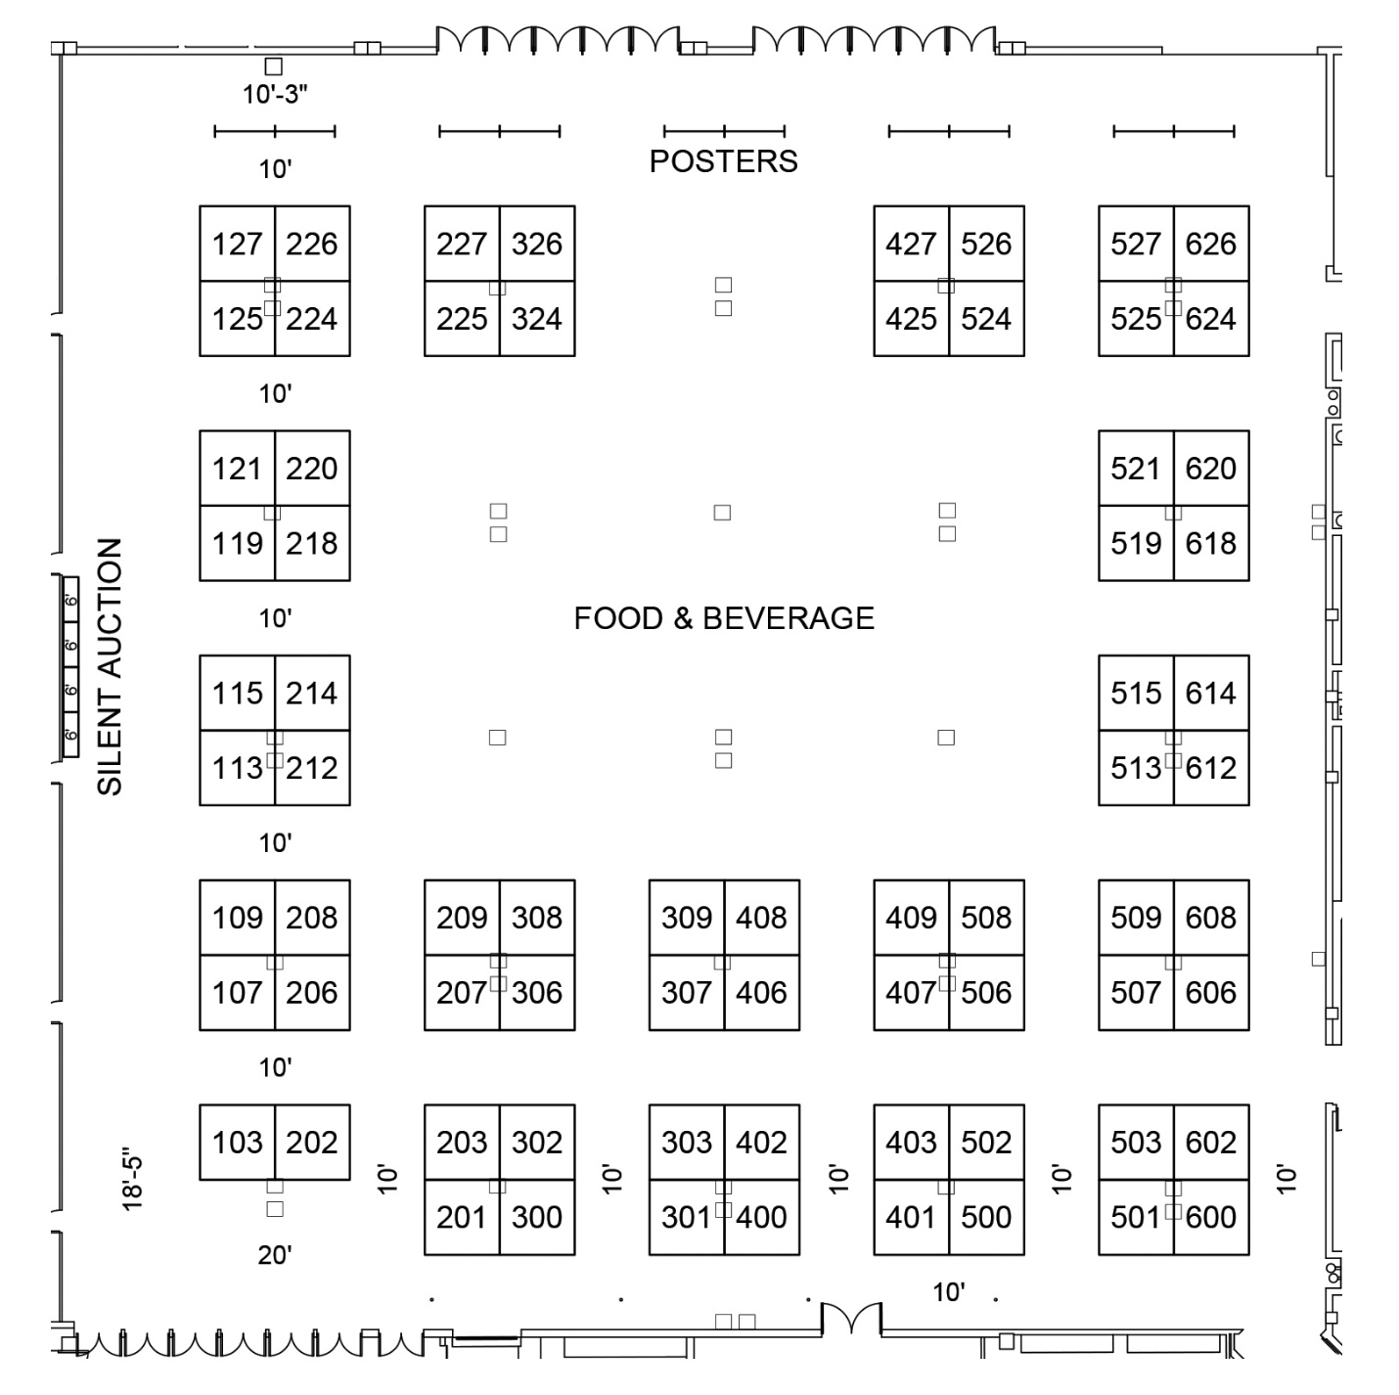

Conference Sponsorship Details
Become a sponsor at the AHEAD Conference and get exclusive access to attendees! Act now to get the sponsorship level best suited for your organization and use this unique opportunity to reach over 1000 new customers. If you have another sponsorship idea, contact Jane Johnston, Manager of Member Services at 704-947-7779 or jane@ahead.org. Most sponsorships include (a) booth space and preferred location in exhibit hall, (b) advertising space in conference program book, and (c) literature distribution in attendees’ registration materials. All sponsorships include printed sponsor logo on all signs, literature, materials, ads related to the applicable event, and participation in the Online Exhibit Hall.

Overall Conference Sponsorship

$10,000 (up to three available) or $25,000 for Exclusive Sponsorship
- Your logo and/or company name prominently displayed on the conference website and in the conference program book
- Two Exhibit Hall booths
- Up to four complimentary conference registrations
- Full-page ad in program book and pre-conference marketing
- Pre- and post-conference mailing list databases of members and attendees
- Partner membership to AHEAD for 2023
- Marketing in the Online Exhibit Hall and conference app

Coffee Break Sponsorship

$4000 (two available)
- Named sponsorship of your designated break, including prominent display of your company name/logo
- Your logo and/or company name prominently displayed on the conference website and in the conference program book
- One Exhibit Hall booth
- One complimentary conference registration
- One half-page ad in the conference program book and pre-conference marketing
- Marketing in the Online Exhibit Hall and conference app

Lanyard Sponsorship

$4000 (One available)
- Your company name/logo printed on conference lanyards
- Your logo and/or company name prominently displayed on the conference website and in the conference program book
- One Exhibit Hall booth
- One complimentary conference registration

Bag Sponsorship

$4000 (two available)
- Your company name/logo printed on conference bags and distributed to all attendees
- Your logo and/or company name prominently displayed on the conference website and in the conference program book
- One Exhibit Hall booth
- One complimentary conference registration
- One half page ad in the conference program book and pre-conference marketing
- Marketing in the Online Exhibit Hall and conference app

Refillable Water Bottle Sponsor

$5000 (one available)
- Your company name/logo printed on conference reusable water bottles
- Your logo and/or company name prominently displayed on the conference website and in the conference program book
- One Exhibit Hall booth
- One complimentary conference registration

Gold-Level Sponsorship

$3500
- One-hour Product Introduction presentation
- Your logo and/or company name prominently displayed on the conference website and in the conference program book
- One Exhibit Hall booth
- One complimentary conference registration
- One full-page ad in the conference program book and pre-conference marketing
- Pre- and post-conference mailing list of members and attendees
- Marketing in the Online Exhibit Hall and conference app

Silver-Level Sponsorship

$2000
- Your logo and/or company name prominently displayed on the conference website and in the conference program book
- One Exhibit Hall booth
- One complimentary conference registration
- One half-page ad the conference program book and pre-conference marketing
- Marketing in the Online Exhibit Hall and conference app

Advertising and Marketing

Advertise in the On-site AHEAD Conference Program
The Conference Program contains information pertaining to sessions, presenters, and activities. All conference attendees, speakers, and primary exhibitor representatives receive a copy at registration. An invaluable tool, the Conference Program is referred to many times during and after the event.

Format for Conference Program: 5.5” x 8.5” Full Color
Art must be in JPEG or PDF format at 300 dpi resolution or higher

Advertising Specifications

AD SIZE RATES DIMENSIONS
Full Page $900 4.5” x 7.5”
Half Page $450 4.5” x 3.5”

Deadline for submitting Advertising and Marketing Application: May 15, 2023
Advertisements must be submitted by May 22, 2023

Advance and Follow-up Marketing: Keys to Success
Exhibitors and advertisers may purchase an AHEAD member mailing list (no emails) at a significantly reduced price of $400 (a $600 value). This benefit is your ticket to successful pre-show marketing, and will be sent to you in early May 2023. Partner members receive a complimentary mailing list once AHEAD has processed your membership application.

All exhibitors and advertisers are also entitled to order a conference attendee mailing list for a cost of $250, which will be delivered in August 2023. Both lists may be purchased for a reduced cost of $500.

