Contact Information
Alisha Bailey, OT/S
(791)771-9212
alisha.baileyot@gmail.com
Ileana Alfonso, OT/S
(610)880-1521
ileana.alfonsoOT@gmail.com
Dr. Erin Wells, OT, OTD, OTR/L
(413) 796-2110
Erin.wells@wne.edu

Introduction
Purpose: Understand the lived experiences of students on campus as it relates to perceptions of inclusivity and accessibility
Research Question: What are the differences in the lived experiences of campus accessibility and inclusivity among students with disabilities and without?
Research Aims: Empower and educate students & highlight need for intentional inclusivity of students with disabilities on campus

Methods
- Qualitative Survey
  - 10 question online qualitative survey with multiple choice responses (Likert scale) & open-ended questions
  - Anonymous survey using google forms
  - Open ended questions thematically coded & multiple-choice survey questions generated frequency statistics via excel
- Participants
  - 110 graduate & undergraduate students at Western New England University
  - 66 students identified without a disability
  - 44 students identified with a disability

Findings

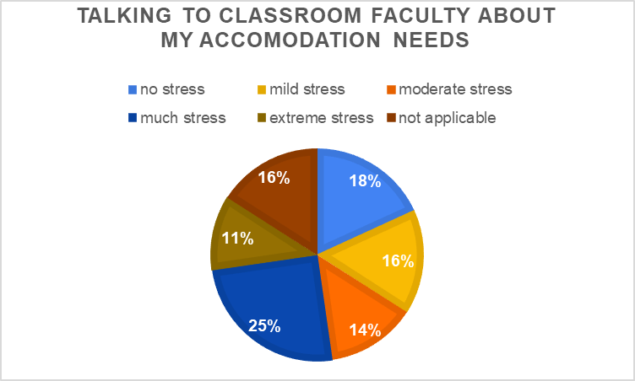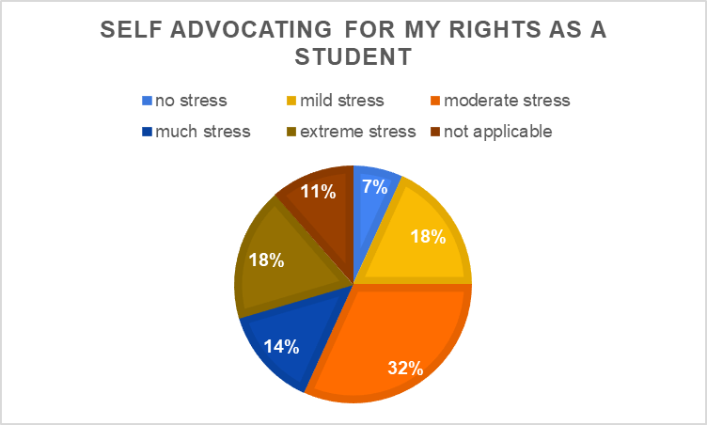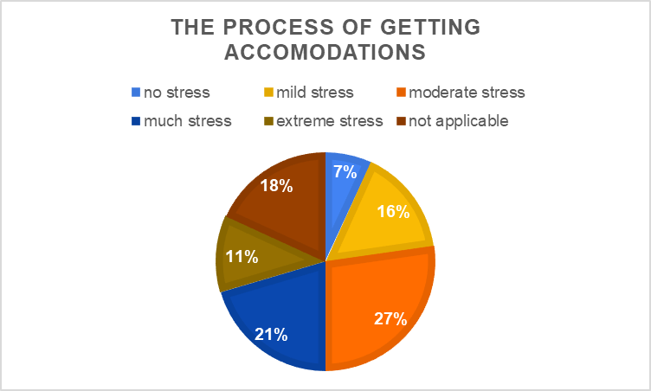

Qualitative Themes:
- Lack of knowledge & understanding of campus accessibility
- Inconsistent implementation of both learning and physical accommodations across campus and classrooms
- Situations requiring self-advocacy cause students with disabilities stress, fear, & anxiety

Discussion
- On average, students with disabilities rated campus inclusivity & accessibility lower than students without disabilities
  - One contributing factor noted includes the lack of knowledge and understanding of campus accessibility
- Inconsistent implementation of both learning and physical accommodations across campus and classrooms contribute to stress
  - 75% of students with disabilities rated the process of obtaining accommodations mildly to extremely stressful
- Situations that require students to self-advocate on campus can cause stress
  - 82% of students with disabilities rated self-advocating for their rights as a student mildly to extremely stressful
  - 84% of students with disabilities rated talking to classroom faculty about their accommodation needs as mildly to extremely stressful
- Limitations:
  - Small sample size & self-reported data may have bias such as telescoping, selective memory, attribution, & exaggeration

Implications
Future Practice and Implementation | Future Research
Implement campus wide educational initiatives on the importance of accessibility, & the process & qualification requirements for accommodations | Utilize data to identify gaps in accessibility for students
Develop a streamlined accommodations process incorporating all departments on campus for consistency and uniformity | Compare the experiences of acquiring accommodations for students with visible vs invisible disabilities
Improve communication strategies between departments/service providers on campus to reduce gaps | Evaluate possible differences in accommodations for graduate vs undergraduate students
Develop training program on self-advocacy for students | Deeper investigation into stressors for students with disabilities
Provide mental health support & guidance for students navigating accommodations process | Further inquiry into faculty implementation of classroom accommodations
Involve students with disabilities in Diversity, Equity & Inclusion initiatives | Examination of universal design and ADA compliance

